Jesus is our True Friend

Teach Children about Visiting in Homes
Choose any of these learning activities.
- Older child or teacher:
Read or tell the story of Jesus and His friend Lazarus (John 11:1-44). This recounts how Jesus visited folk in their home. Jesus loved them and gave them new life.
- Let the children copy or colour the picture on the last page of this lesson.

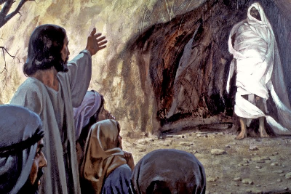
Lazarus came back to life, still wrapped in burial cloths.
- After recounting the story, pose these queries. [Answers appear after each question.]
- Why did Jesus wait for two days before going to see his sick friend?
[See verse 4]
- Why did Jesus say that Lazarus had fallen asleep when he had died?
[Because Lazarus was not going to stay dead. See verse 4]
- What did Jesus do when he saw the tomb? [See verse 35]
- What happens to believers in Jesus when they die? [See verse 25]
- What was Lazarus wearing when he left the tomb? [See verse 44]

- Dramatize parts of the story.
- Arrange with the worship leader to have the children present this brief drama.
- Use your time with the children to prepare it.
- You do not have to use all the parts of the story.
- Let the older children help the younger ones.
Let older children or adults act out these roles:
Narrator. Summarize the story and help the children remember what to say and do.
Jesus
Mary
Martha. Have pieces of cloth to wrap Lazarus and a table to represent the tomb.
Let younger children act out these roles:
Disciples (all the other children)
Thomas
Messenger
Lazarus
Others at the tomb

Part One
Narrator: Tell the first part of the story, John l1:1-16. Then say,
“Hear what Lazarus says.”
Lazarus: “I feel very sick. I think I am going to die.”
Martha: “Messenger! Go quickly to tell Jesus to come and heal his friend.”
Messenger: Run to Jesus and say,
“Jesus, come quickly! Your friend Lazarus is dying.”
Jesus: “This will not end in death. I must wait a few days, so that God will be glorified.” (Sit)
Narrator: “A few days pass.”
Jesus: Stand and say, “Now it is time to go.”
Disciples (Some Say) “Jesus, you must not go to Lazarus’ house!”
(Others say) “The Jews there want to kill you!”
Jesus: “Lazarus is asleep. We will wake him up.”
Walk toward where Lazarus is.
Thomas: “Then let us go and die with Jesus.”

Part Two
Narrator: Tell the second part of the story, John 11:17-28. Then say,
“Hear what Lazarus’ Martha says.”
Martha: Weep and wrap Lazarus in cloth. Then lay him on the floor under a table. Then notice Jesus. Go to him and say,
“Lord, Lazarus died four days ago. If you had been here, Lazarus would not have died.”
Jesus: “Your brother will live again. Do you know I am the resurrection and the life?”
Martha: “Yes, I know that.”
Narrator: Tell the third part of the story, John 11:29-44. Then say,
“Hear what Jesus says.”
Jesus: “Where is Mary?”
Mary: Come running and say, “Jesus, why did you let my brother die?”
Jesus: “I feel very sad. Show me the tomb.”
Mary: Show Jesus where Lazarus lies.
Jesus: Look at Lazarus lying on the ground. Weep and wipe tears from your eyes.
People at the tomb:
(Some say) “Look how much Jesus loved him.”
(Others say) “Yes, Jesus visited his friend Lazarus’ home many times.”
Jesus: Shout loudly, “Lazarus, come out!”
Lazarus: Stand up, wrapped in cloth.
Jesus: “Take the grave clothes off him and let him go!”
People at the tomb:
(Some say) Remove the cloths from Lazarus.
(Others say) “Look, he raised a dead man!”
Narrator or older child: Explain that the drama is over and thank those who helped.
- Pose queries.
If the children dramatize this story for the adults, then let them pose for the adults the same queries that are listed above.
- Discuss:
“What are other examples of ways we serve people by visiting them in their homes?”
(Let the adults or children give examples.)
- Draw a picture of a table with food on it, for the children to copy.
- Let the older children help the younger ones.
- Let them show the pictures to the adults at the worship time or to parents at home.
- Let them explain that the table with food illustrates how the spirit of Jesus comes into our homes to give us new life. We visit others in their homes to tell them about Him.
- Let them explain about Jesus at the door of our hearts, in the memory verse below.
- Memorize Revelation 3:20: “Behold, I stand at the door and knock; if anyone hears my voice and opens the door, I will come in to him and will dine with him, and he with me.”
- Poem. Let three children each recite one of the verses from Psalm 145:15, 16 and 18.
- Let an older child read this prayer:
“Lord, you do wonderful things for people who believe in you. You live with us and give us new life. When we die, you will raise us from death to live with you forever where you are. Help us to show our gratitude by visiting others to serve them.

Download a more complete scripted version to act out of the drama about Lazarus:
http://biblestoryskits.com/020-the-lord-jesus-raises-lazarus-from-the-dead-2/

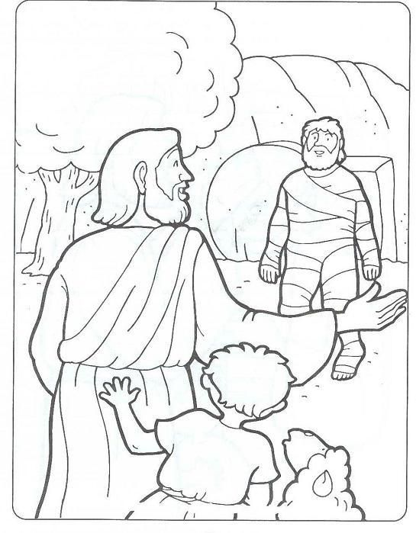
At Jesus’ command, Lazarus came out of his tomb, alive, three days after he died.

