Use the Bible as Jesus Did to Resist Satan
Choose activities that fit the children’s needs and ages.
Dear Lord, please use this study to make it easy for the children to use Your Words as a lamp to light their paths and to obey you.
- Learn the story of Jesus’ temptation by reading it in Matthew 4:1-11.
It shows how to follow God’s will and answer the temptations of the enemy.
Coach an older child to read or tell from memory about Jesus resisting Satan.
After telling the story, ask these questions. [Answers appear after each question.]
- Why was Jesus so hungry? [See verse 2]
- In what three ways did Satan tempt Jesus? [Verses 3, 6 & 9]
- In what way did Jesus respond to each of Satan’s temptations?
[He answered with Scripture, verses 4, 7 & 10]
- Did Jesus have Scriptures memorized? [Yes.]
- How should you be prepared to face temptations and decisions in your life?
[We should follow the example of Jesus. He spent time in prayer and fasting, and he knew and obeyed the Scriptures all his life.]
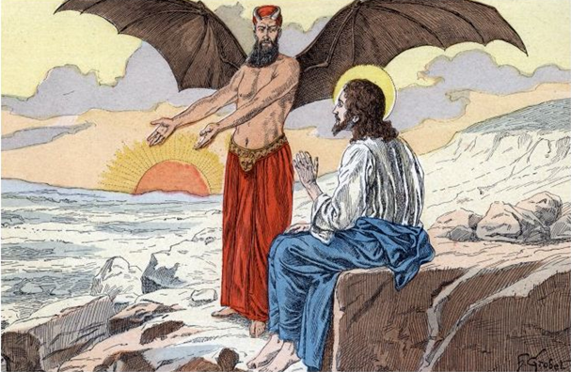
When Satan tempted Jesus to sin, Jesus resisted Satan by speaking words of Scripture.

Explain that Satan still uses the same three ways to tempt people today.
- Satan’s first temptation of Jesus was to turn stones to bread. Satan tempts folks to worry about their physical needs. Jesus taught that it is more important to trust and obey God than to worry about our physical needs.
- Satan’s second temptation was for Jesus to leap from the top of the temple. A lot of people would then admire His miraculous power. Satan tempts folks to impress others, to do things to make others like them or to follow them, even when the things they do are wrong. The Scripture says to make God the most important Person in your life and never let anything distract you from worshiping Him.
- Satan’s third temptation was to rule over the whole world. Satan tempts folks to use power and authority for their own selfish purposes. The Scripture teaches that you must serve God and not try to get him or other people to serve you.
Explain that Christians must answer these temptations just as Jesus did, by citing the Word of God. You must know the Bible well, as Jesus did, so that you can resist the devil’s attacks.
- Dramatize the story of Jesus resisting the devil.
Arrange with the leader of the main congregational worship to present this drama.
Let the older children help the younger ones as they prepare.
Let older children or adults play the parts of Jesus, the Tempter and Narrator.
The Narrator will summarize the story and help the children recall what to say and do.
Let young children play Kings wearing paper crowns and Angels with paper wings,
or simply hold their arms out like wings.
Narrator Tell the story from Matthew 4:1-11. Then say, “Hear what Jesus prays.”
Jesus “Father, I am glad that I have had forty days to talk to you by myself.
I am so hungry, but it was worth it to prepare for the work you have for me.”
Tempter “Listen, Son of God, you do not need to be hungry. Why wait for God to take care of you? Turn these stones into bread!”
Jesus “No! God says that we do not live only by bread. I need God’s Word to live.”
Tempter Pull Jesus up onto a chair. Then say, “Now, look down there. You are on the top of the Temple. Throw yourself down and make God protect you as He promised.”
Jesus “No! I will not force God to act. I will serve Him and do what He has told me, because the Bible says not to put God to the test.”
Tempter Point to the Kings and says, “Look At those kings. You can rule over all of them! All you have to do is forget God and serve me. Then you will become the most powerful ruler!”
Kings Go stand around the Tempter and bow, saying, (Some say) “Hail master!” (Others say) “Give us power!”
Jesus Wait until the Kings leave; then push Tempter away. Say,
“Get away, Satan! Scripture says to worship only God.
I do not do religious things just so that people will like me and follow me.”
Tempter Leave saying, “I will return.”
Angels Go and put your arms around Jesus. Say, “Your Father sent us to care for you.”
- If the children dramatize this story for the adults, then let them also ask the adults the questions listed under #1 above.
- Memorize the names of the books of the Bible, singing their names if possible.
- Draw a simple picture of a person holding a lamp high and walking down a path.
Ancient oil lamp | 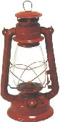  Kerosene lantern
“Your word is a lamp to my feet and a light to my path.” Psalm 119:105
- Children copy the ancient lamp and add dangers near the path (monsters, cliffs, storms, fire).
They may like to copy or colour the picture found on the last page of this lesson.
- Let the children show their pictures to the adults in the worship time, and explain how the Bible is a lamp to guides Christians in God’s path, even when there is temptation and danger.
- Let the children give examples of how God uses His Word like a lamp, and discuss them.
- Ask: “What Scripture has helped you avoid evil?”
- Poem or song.
Let several children recite or sing some verses from Psalm 119:97, 103, 105, 111 & 112.
- Let older children write a poem or song that uses Jesus’ words in Matthew 4:4.
- Memorize together 2 Timothy 2:15: “Be diligent to present yourself approved to God as a workman who does not need to be ashamed, accurately handling the word of truth”
- Let an older child read this prayer:
“Father, Your words are a treasure to us. May your Spirit use them in our minds to protect us from temptation and evil.”

Download a more complete scripted version, to act out the drama about Jesus’ temptation:
http://biblestoryskits.com/003-the-devil-tempts-the-lord-jesus-christ-in-three-diabolical-ways-4/

