Search God’s Word As the Bereans Did
Learn to study and apply God’s word

Anchor command. Make disciples who obey Jesus’ commands above all else. Matt. 28:18-20

Anchor promise. “It is written, ‘Man shall not live on bread alone, but on every word that proceeds out of the mouth of God.’“ Matthew 4:4

Anchor story. The wise and foolish builders. Matthew 7:24-27

Anchor verse. All Scripture is inspired by God and profitable for teaching, for reproof, for correction, for training in righteousness; so that the man of God may be adequate, equipped for every good work. 2 Timothy 3:16-17

Learning goal. Value the wealth of wisdom and redeeming truth in the Bible.

Growth goal. Learners will study God’s Word with the strong intention to put it into practice.

Skill goal. Effectively teach their own disciples and friends the Word of God.
Outcome goal. Many believers will train many others to use God’s Word skillfully.
Basic Study
Prayer: “Our Father in heaven, help us to interpret Your Word accurately, and to store it in our hearts.”
- Learn from the Bereans how to use God’s Word.
Read the story of the Bereans in Acts 17:10-12 and find in it two ways in which the Bereans responded to the gospel.

Plan with coworkers activities to do during the week.
- Have each family read or recall by memory the story of the Bereans, Acts 17:10-12, and talk over how they will apply its lessons as a family.

Plan with coworkers the upcoming worship time
- Help each family to know what the Bereans did, and do the same.
- Have older children teach younger ones
- Those who teach children should read study #26 for children.
- Have the children present what they have learned to the adults.

Advanced Study

Main instruction. Prepare your heart and mind with God’s word.
- Find in 1 Peter 1:14-22 several things that God’s truth should produce in our lives.
- Find in 1 Peter 1:24-25 for how long God’s Word will remain in us.
- Find in 2 Timothy 3:10-17 what Paul wrote to Timothy:
- What things did Timothy observe in Paul’s life that gave Timothy valuable instruction?
See verses 10-13.
- What did Timothy know since his childhood that made certain his salvation by faith in Jesus?
See verse 14-15
- Who inspired the human writers of the Bible? See verse 16.
- In what ways should we use the Bible to help others? See verse 16 again.
- For what purpose does God want you to study and apply His Word? See verse 17.
- Find in 2 Timothy 4:1-5 several tasks for young shepherds. See verses 2 and 5.

Instruct all new believers to read or to listen to the Holy Bible
in a language that they understand.

2. Plan with Co-workers Things to Do During the Week:
- Visit believers to help them study the Bible themselves.
- Help small groups and families in the congregation to study the Bible together.
- Encourage believers to ask one another what they have learned from their study.
- Help believers to memorize several Scripture verses each week.
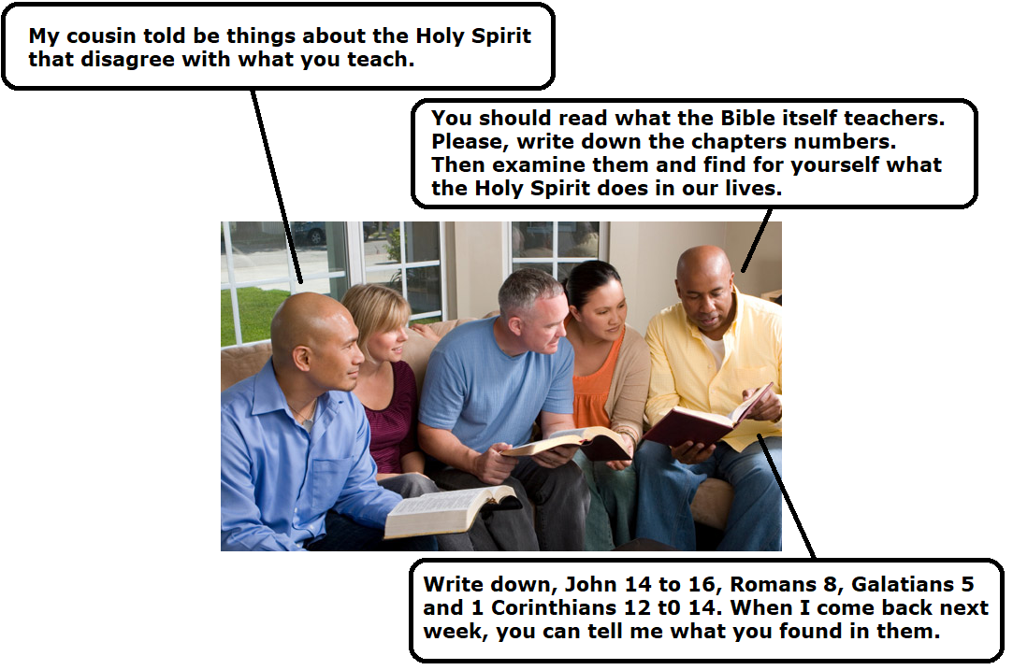

3. Plan with co-workers additional things to do in the upcoming worship time. Suggestions:
- Pray for God to speak through His Word by the power of His Holy Spirit, and to help you put into practice immediately what you hear.
- Read Acts 17:10-12.
- Ask everyone to listen and discover how the Bereans responded to the gospel.
- Explain that they, too, should examine the Word of God as the Bereans did. You should actively mine its gold, rather than listen passively. You should begin to examine the Word eagerly, on your own initiative. Here are some steps to help you:
- Explain how to let the Bible speak for itself. After praying for guidance, do four things:
1) Examine the details of a Bible passage, considering each word and phrase.
2) If the meaning is not clear, then examine the context and setting of the passage:
- To whom was it written?
- Who wrote it and why?
- What do the verses or chapters before and after it say, that clarifies its meaning?
- What is the historical occasion?
- When was it written?
(If it was written before Christ came, in the Old Covenant, then expect to find laws for ancient Israel that do not apply to your congregations in the New Covenant.)
- What is God telling us to do in this passage?
Remember:
3) Extract from these details the main truths and applications.
4) Put into practice what you have found.
- Praise God for having given you the Bible.
- Ask for testimonies and reports from believers about how they have been blessed by studying God’s word.
5) Memorize together 2 Timothy 3:16-17.

Skit about interpreting the Bible
Mr. Tradition: Watch ‘Mr. New Believer’ read a Bible for a moment, then snatch it away from him. Say, “You cannot understand Scripture by yourself. Here are some modern books for you to read instead.”
Mr. New Believer: Pull out another Bible from under your shirt. Say, “No. Keep your books. I have hidden God’s Word in my heart by studying, memorizing and obeying it. So I know that the Holy Spirit uses the Bible to give me life as no other book can.”
Mr. Tradition: “Only priests who have studied modern methods of interpreting ancient documents can understand it.”
Mr. New Believer: “Our group shepherd taught us that any believer can understand God’s Word, if we pray and follow the simple rules of interpretation.”
- Announce the activities that you planned to do during the week, for families and small groups to study the Bible during the week.
- Help one another in groups of two or three. Pray, confirm plans and encourage one another.
- To introduce the Lord’ Supper, if you serve it, read Exodus 12, verses 3, 7-8 and 12. Explain briefly the first Passover, the feast to which Jesus added new meaning when He established this most sacred ceremony. Jesus is the Lamb of God, sacrificed to free us from sin and death.

