God’s People Cross the Red Sea on Dry Land
Dear Lord, help each child to learn that your Word is not simply ideas of men, but that everything we believe grows out of great historical events.
Choose from any of these children's learning activities.
- Let an older child or teacher read or relate by memory about Moses crossing the Red Sea. Exodus chapter 14 tells how God freed his people from slavery by doing great miracles.
After telling the story, ask these questions. [The answers appear after each question.]
- After the Israelites had left Egypt, where did the Egyptians catch up with them?
[See Exodus 14: 9]
- Who promised to fight in behalf of the Israelites? [See verse 14.]
- How did God separate the Israelites from the Egyptians that night? [See 19-20]
- What happened when Moses stretched his hand out toward the sea? [21]
- In what manner did the Israelites cross the Red Sea? [22]
- What happened to the Egyptian soldiers who chased after them? [28]
- Dramatize the story of crossing the Red Sea, from Exodus chapter 14.
- Arrange with the leader of the main congregational worship to have the children present this drama.
- Use some of your time with the children to prepare the drama.
- You do not have to use all the parts.
- Let the older children help the younger ones to prepare.
- The children may like to copy or colour the picture on the last page of this study.

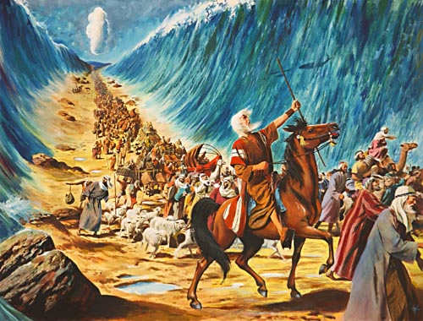
When the L0RD divided the Red Sea, the Israelites walked across on dry ground.
- Let older children or adults play the parts of these people:
Narrator. Summarize the story and help the children remember what to say and do.
Moses. Carry a long stick for a staff.
Pharaoh. Put an inverted sack on his head to represent a crown.
- Let younger children play the parts of these people:
Egyptian Soldiers. Stand on chairs that represent chariots.
Horses. Get down on hands and knees in front of the chariots. Make horse noises.
Israelites. Look bewildered.
Sheep. Go on hands and knees and make sheep sounds.
Red Sea. Raise hands high to represent a wall of water.
Narrator Tell the first part of the story, from Exodus 14:1-20. Say,
“Hear what Pharaoh says.”
Pharaoh “Soldiers, our Israelite slaves ran away. Get your chariots.
Go after them!”
Egyptian soldiers Stand on the ‘chariots.’ Pretend to whip your horses. Tell them, (Some shout) “Hurry! Catch the Israelites.
(Others shout) They are trapped at the sea shore.
(Others shout) They cannot escape.”
Israelites (Some shout) “We are trapped!” “
(Others shout) We will die here!”
(Others shout) “God, help us!”
Sheep Make sheep noises.
Israelites “Look! God’s pillar of fire is going between the soldiers and us.
They cannot see us now in the dark of night.”
Narrator Tell the second part of the story, from Exodus 14:21-31.
Red Sea Stand in two lines to make a path through the sea.
Narrator “Hear what Moses says.”
Moses Point your staff toward the Red Sea and say,
“The Lord will fight for us. Look how the wind is parting the sea.
You will cross on dry ground!”
Red Sea Raise your hands high and face away from the path.
Israelites & Sheep Walk on the path through the sea. Look up on both sides.
Israelites shout,
“Look at the high wall of water on each side of us!” Sheep make sheep noises.
Pharaoh “Look, the wind made a path in the sea. Go after them!”
Egyptian soldiers and Horses
Follow the Israelites. Soldiers jump off their chariots and follow their horses into the sea.
(Some shout) “What is happening?”
(Others shout) “My chariot wheels fell off!”
(Others shout) “My chariot is stuck!”
(Others shout) “The water is coming back! We will drown!”
Horses Make horse noises and fall, dead.
Egyptian Soldiers Fall down and lie still as if dead.
Red Sea Fall on the Egyptian Soldiers and horses.
Israelites “Our God has saved us with his mighty power!”
Narrator or older child. When the drama is over, thank everyone who helped.
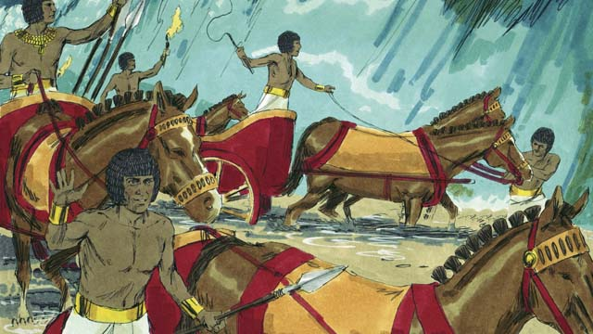
When Egyptians tried to cross the Red Sea, sadly they drowned.
- Draw a simple picture of a chariot.
Let the children copy it. They can show their pictures to the adults at the next worship time and explain that this illustrates how God’s power can defeat any power on earth.
- If the children dramatize this story for the adults, then let them ask the adults the questions that are listed under #1 above.
- Ask the children to relate other examples of ways that the Lord saves his people from the power of evil. Discuss their answers.
- Memorize Philippians 4:13. “I can do all things through Christ who strengthens me.”
- Let three children each recite a verse from Psalm 15:1, 2 and 11.
- Let older children write poems, songs or a drama about how God saved His people from slavery in Egypt, or how He saves us from the slavery of sin today.
- Let an older child read this prayer:
Dear Lord, You are great and powerful. You threw the Egyptian horses and riders into the sea. You heard your people who were suffering as slaves and you rescued them. Thank you that you always hear us when we pray.
Download a more complete scripted version, to act out the drama about fleeing from Egypt:
http://biblestoryskits.com/001-i-am-sends-moses-to-free-the-enslaved-children-of-israel-3/

