Bible Overview

Survey of the 66 Books that Are God’s Word
Anchor command. “Obey my voice, and I will be your God, and you will be my people; and you will walk in all the way which I command you, that it may be well with you.” Jeremiah 7:23
Anchor story. Builders found the book of the law while repairing the temple. 2 Kings 22; 23:1-25;
2 Kings 22; 23:1-25.
Anchor verse. “Open my eyes, that I may behold Wonderful things from your law.” Psalm 119:18
Learning goal. Grasp the scope of sacred Scripture.
Growth goal. Appreciate the depth and breadth of the teaching of God’s word.
Skill goal. Be able to find topics easily in Scripture.
Outcome goal. Believers rightly handle the word of truth.
Spirit of God, let me grasp the different parts of your Word, so I can help your flock apply it wisely.
Basic Study

Observe the powerful impact from reading God’s Word, from the story of finding the book of the law while repairing the temple, 2 Kings 22; 23:1-25.
- How old was King Josiah when he began to reign, with the help of godly advisors?
2 Kings 22:1
- What kind of character did Josiah have? 22:2
- What did Hilkiah, the High Priest, find in the temple while workers repaired it? 22:8
- How did Josiah show his dismay when he heard the words of the Book of the Law? 22:11
- The land was filled with idols and wickedness. Having Read the words of the book, Josiah knew that the Lord would seriously punish the people. What did Josiah do, to bring the people to repentance? 23:1-2
- What did people do in response to hearing the word of God? 23:3
- What did King Josiah have the people do to cleanse the land? 23:4-5
- What sacred feast did King Josiah restore in obedience to God’s word? 23:21-22
- What was written about King Josiah after his death, about his reform? 23: 25

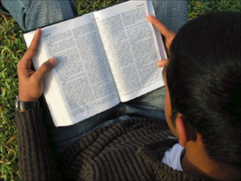

During the week. You and your coworkers make sure all believers are reading their Bibles regularly. If some do not know how to read, then teach them.
During the upcoming worship…
- Tell the story of Josiah, and emphasize the powerful impact that comes from hearing God’s word. Urge the believers to ask questions and discuss the answers.
- Memorize 2 Timothy 2:15 about correctly using God’s Word.
- Thank God for the Bible, and all its valuable teaching.
- Have the children present what they have prepared.
Advanced Study
- The Bible is God’s message in two main parts.
The first main part, the Old Testament; has 39 books written in Hebrew and Aramaic (ancient Syrian, similar to Hebrew). The New Testament has 27 books written in Greek.
The Old Testament prepared the Israelites for Jesus’ coming. It taught them basic spiritual concepts and showed them that they cannot obey God’s holy law by their own effort.
The second main part, the New Testament, records Jesus’ life and deeds, and the deeds of His first followers.
- Types of literature in both the Old and New Testaments
Old Testament
- Books of Moses, Genesis to Deuteronomy:
The basis of God’s covenants, beginning of the world, history of the ancient patriarchs and God’s ancient law in
- Historical: Stories from the ancient nation of Israel. 12 books, Joshua to Esther.
- Devotional and Instructional: Hebrew poetry. 5 books: Job to Song of Solomon.
- Prophetic: Old Testament literary prophets. 17 books: Isaiah to Malachi.
Find in Numbers 12:6–8 how God spoke to Moses.
Find in Deuteronomy 34:10 how God compared Moses to the other prophets.
Find in John 1:17 how God compared Moses to Jesus. Moses was the greatest Old Testament prophet. The other writing prophets mainly explained and applied Moses’ laws.
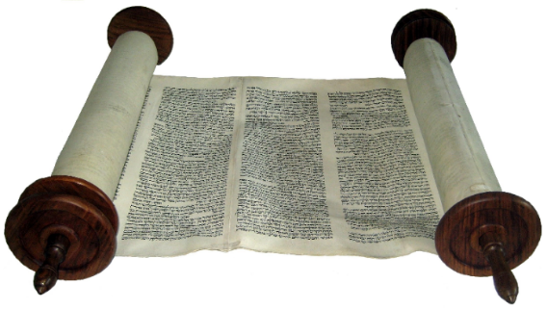
Old Testament books were copied by hand in Hebrew
on scrolls made of animal skin.
New Testament
- Basis of the New Covenant. The work and teaching of Jesus, 4 books: Matthew,
Mark, Luke and John.
- Historical. The apostolic mission and congregations, 1 book: Acts of the Apostles.
- Devotional and Instructional. 21 books: Letters to new congregations and leaders, Romans to Jude.
- Prophetic. The Apostle John’s visions, 1 book: Revelation.

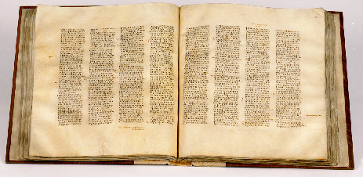
The New Testament books were copied by hand in Greek
on papyrus paper in the form of books.
- Five biblical ‘covenants’ have guided God’s dealings with us humans.
- The Covenant of self-rule by one’s conscience, made with Adam, from Adam to Abraham, Genesis 1 through 12.
- Origin. God told the first man he would die if he ate from the tree of the knowledge of good and evil. Satan told the lie of false religions: “You will not die, but will be like God”
Genesis. 2:16-17 & 3:5
- Results. After Adam disobeyed, people knew good and evil. In every age, throughout both the Old and New Testaments, we read of how Satan urges humans to reach perfection by their own effort, so that they will die, be judged and perish.
- God has always saved all who trust Him, as Abel who offered an innocent victim as a blood sacrifice.
- After the flood, God decreed human government, telling humans to punish murderers with death. Genesis 9:6
- Find in Genesis 2:16–17 what God said would happen, if Adam should disobey him.
- The Covenant of promise to those who have faith, That God made with Abraham goes through the rest of the Bible. Genesis 12
- Origin. Abraham believed God’s promise and God counted his faith as righteousness, Genesis 12:1–3 and 15:1–6.
- Result. God blesses people in all nations through Abraham’s descendant, Jesus. All that follows in the Bible, to its end, is in fulfillment of this promise. Both the Old and New Testaments are based upon God’s covenant with Abraham. Under both the Old and New Testaments, God has saved the faithful by His transforming grace.
- Old Testament rule by law, from Exodus 20 through the rest of the Old Testament.
- Origin. God gave the Old Testament law to the nation of Israel through Moses, on Mount Sinai.
- Results. No person except Jesus ever fully obeyed the Old Testament laws. Sin brought death, not eternal life. The Law of Moses promised only earthly, temporary rewards. It teaches people their need to be forgiven.
- God miraculously led the Israelite slaves out of Egypt, thus forming a new nation redeemed by God.
- The newly freed nation was wandering in the desert and needed laws for good government. Exodus 18 – 20.
- The Covenant of the coming Messiah, made with David. 2 Samuel 7:8–17
- Origin. God promised King David that one of his descendants would rule the nations forever with justice. The word ‘Messiah,’ like the word ‘Christ,’ means the one who was anointed; Jesus was anointed with God’s Holy Spirit.
- Result. Jesus, the anointed descendant of David, fulfilled perfectly all the covenants in both the Old and New Testaments. The Bible mentions Jesus and David more than it mentions any other persons.
- Find in Isaiah 9:6-7 with whose throne God would establish His eternal kingdom. (God revealed this to Isaiah hundreds of years after David and hundreds of years before Christ).
- Find in Matthew 3:16-17 what Jesus’ disciples witnessed that proved that Jesus was a very special person sent from God.
- The New Covenant, a perfect, eternal Kingdom, predicted by Jeremiah, made with all believers, all New Testament books.
- Origin. Jesus formally announced the New Covenant when He instituted the Lord’s Supper. Jesus established it by dying, rising from the dead, ascending to the Father, and sending the Holy Spirit to live in us.
- Results. Everyone who repents and believes in Christ is ‘born again’ into God’s eternal Kingdom. Believers become members of Christ’s universal, mystical Body. They are forgiven because of Jesus’ shed blood. They receive new, holy, eternal life by sharing in His resurrection.
- Find in Jeremiah 31:31–34 how God’s people would someday be guided by a New Covenant.
- Find in Jeremiah 36 how God used men and events to record His Word.

- Plan with co-workers additional activities to do during the week
- Visit any believers who do not yet read the Bible daily and pray with their families. Read the Bible with them, and help them to begin daily, family devotions.
- If the Bible is not yet translated into the language, or people cannot read, then visit them and help them to learn Bible stories that they can repeat to their families and friends.
- Plan with co-workers additional activities for the upcoming worship time
- Explain the five covenants, their origins, results and main ideas, #3 above.
- Announce planned activities.
- To introduce the Lord’s Supper, explain how, starting with Adam and Eve, through the entire Bible, God demands the blood of an innocent victim to cover sin. We believers recall this basic spiritual truth whenever we participate in the body and blood of Christ by the Lord’s Supper, 1 Corinthians 10:16.
- Pray in groups of 2 or 3.
- Those who teach children should read study #27 for children.

