Basic Truths from the Patriarchs
in the book of Genesis
Anchor command. “Let all the earth fear the LORD.” Psalm 33:8-9
Anchor story. Creation and the first man, Adam: Genesis chapter 1:1 – 2:1-3
Anchor verse. “Since the creation of the world His invisible attributes, His eternal power and divine nature, have been clearly seen, being understood through what has been made.” Romans 1:20
Learning goal. Find who the faithful patriarchs were in the book of Genesis.
Growth goal. Appreciate how God has worked out his eternal plan through weak, often disobedient human beings.
Skill goal. Tell others about God’s creation and about the patriarchs from the book of Genesis.
Outcome goal. Believers have a general understanding of what the book of Genesis teaches.
Lord, help us to learn from the patriarchs how people can understand eternal truth.
Basic Study
Learn from Genesis chapter 1 about the creation of our world and of the first man, Adam. He was the first of the patriarchs.
- How light came into being on the first day of creation, Genesis 1:1-5
- How our sky came into being on the second day, 6-7
- What kind of living things appeared on the third day? 8-13
- What appeared on the fourth day? 14-19
- What came to life on the fifth day? 20-23
- What came to life on the sixth day? 24-31
- What did God do on the seventh day? 2:1-3
The first man and woman found abundant food in the garden
where the Creator put them.
Know who the patriarchs were in Genesis, and what each one is known for:
- Adam brought sin into the world.
- Noah obeyed God and built a huge arc that saved his family from the great flood.
- Abraham believed God’s promises, and God made a serious covenant with him.
- Isaac was the promised son, born miraculously, through whom the covenant would be carried out.
- Jacob sought God’s blessing, and was the father of Israel’s 12 tribes.
- Joseph’s jealous brothers sold him as a slave, but he later became their protector.
During the week. You and your co-workers tell the story of creation to anyone who does not know it.
During worship praise God for the beauty of his creation, and thank him for what he provides us every day.
Ask the children to present what they have prepared.
Memorize Genesis 15:6, which refers to Abraham.

Advanced Study
Basic truths from the patriarchs…

Adam sinned when Satan tempted him, in the newly-created world. Genesis chapters 1 through 3. Basic truths:
- Everybody sins, because Adam brought sin and death into the world when he sinned. Read Romans 5:12-21.
- Satan tempted Eve with the diabolical lie that by eating the forbidden fruit she would become wise like God and not die.

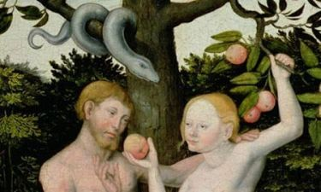
Adam and Eve chose to obey a serpent instead of God.

Noah obeyed God and built the huge floating box called the ‘ark’ in which his family and all kinds of animals were saved from the great flood, Genesis chapters 6–9.
- Basic truth: God punishes sinful men, but saves a remnant that obeys Him. Jesus compares the final judgment on earth to God’s punishment in the time of Noah, Matthew 24:37–42.
- Discussion question: In what ways was Noah’s ark like Jesus’ coming back to life to give us life?
[Answer: Christ gives to us new life. We are His body. We are in him, much as Noah and his family escaped death and punishment by being in the ark.]
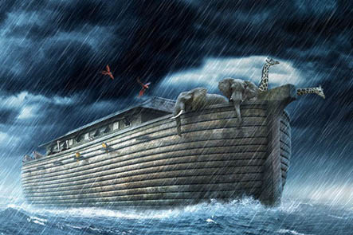
Noah obey God by building a boat to save his family and many creatures.

Abraham believed God’s promises, and God made a serious covenant with him, Genesis chapters 12–26.
- Basic truth: God accepts us because of our faith, as he did Abraham our spiritual father, Galatians. 3:6-3.
- Like Abraham, people of all nations are blessed when they believe God’s promises.
- God promised to bless all nations through Abraham’s descendant (Jesus). Genesis 12:1-7
- Find in chapter 14 how Abraham defeated five pagan kings who had taken captive his nephew Lot.
- Find in chapter 15 how God confirmed His covenant with a surprising ritual.
- Find in chapter 18 how Abraham interceded with the Lord for Lot and his family.
- Find in chapter 19 how God destroyed the wicked city of Sodom.
- Discuss this question: Are people saved because they believe, or are they saved because they do good works that merit salvation?
[Answer: Ephesians 2:8-10 explains that God saves us because of his kindness and our faith, not because of our good works. Good works will come from our faith.]

Isaac was the promised son who was born miraculously to Abraham and Sarah, who had passed childbearing age, Genesis chapters 21-28.
- In chapter 22, God told Abraham to sacrifice his son. God was testing Abraham’s faith. God had promised Abraham that Isaac would be his heir through whom God would someday fulfil His promise.
- Find in chapter 24 how Abraham’s servant went looking for a wife for Isaac, a woman who believed in the One God.
- Basic truth: God always fulfils His promises, even through some people doubt it. When Abraham got tired of waiting for his promised heir, he tried to fulfil God’s promise by his own efforts. This resulted in the birth of Ishmael, a patriarch of the Arab nation which later introduced Islam and the false belief that people can be saved by our own efforts (Galatians 4:21-31)
- In what way did the ram (a male sheep) serve as a picture, or prophetic type, of Christ?
[Answer: The ram was an innocent victim whose blood was shed to save another. This, like many other Old Testament people and events, served as a picture of Christ, long before He came to earth. These examples were to prepare people to receive Jesus when He would come.]

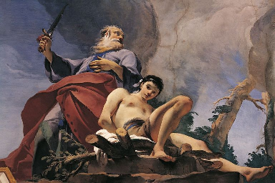
Abraham obeyed God, and his son Isaac was spared.

Jacob sought God’s blessing. God changed Jacob’s name to Israel. His twelve sons’ descendants became the twelve tribes of Israel, Genesis chapters 25–49.
- Find in 25:21–34 and chapter 27 how Jacob deceived his older brother Esau to get his birthright, which guaranteed a double portion of the inheritance, as Deuteronomy 21:15–17 required.
- Basic truth: God’s grace and loving forgiveness does not depend on our good works. Jacob received God’s blessing in spite of his telling lies, as Rom. 9:1–16 explains.
- Discuss this question: What bad things did Jacob do, and what good things?
- [Answer: Jacob took advantage of Esau’s hunger to rob his birthright, which belonged to the oldest son and guaranteed a double portion of the inheritance. He did good things, too; he worshipped God devoutly and worked many years to get his beloved bride, Rachel.]
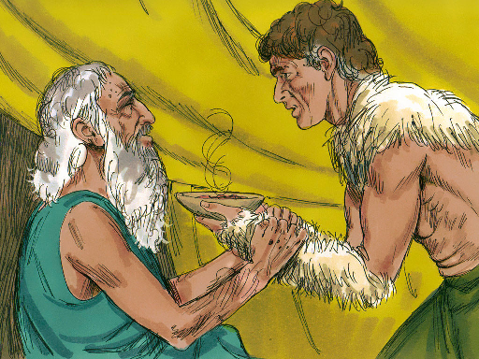
Jacob deceived his blind, old father.

Joseph’s jealous brothers sold him as a slave.
- Genesis chapters 37–50. Joseph’s brothers, after selling him, told their father Jacob that wild animals had killed Joseph. Others falsely accused Joseph and they imprisoned him.
- Genesis chapter 39. Later, God made Joseph to rise to great power in Egypt because of his walk with God. Genesis chapters 40–41. After that, Joseph saved his brothers and their families from famine. Genesis chapters 42–45.
- Basic truth: God saved his people through a kinsman of theirs, a relative who was in a position to do so. Christ is our kinsman, a sinless man who died to save us. Heb. 2:10–18.
- Discuss this question: In what ways was Joseph’s life like that of Christ?
[Answer: Joseph was one of the original “children of Israel (Jacob)” who rejected Him out of envy. His father loved him greatly. He was obedient. His own people sold him (like Judas sold Jesus). He was taken to Egypt. He was falsely accused and put in prison. He rose to a position of power at the right hand of the king. In that position of power, he saved his brothers who had rejected Him. He revealed Himself in a glorious way at a great banquet.]
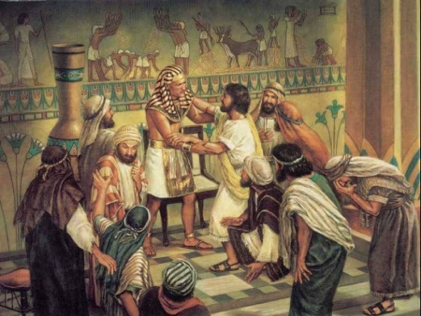
Joseph obeyed God in Egypt, and was able to save his parents and brothers.

Plan with co-workers additional, activities that you and the believers will do next week.
Make plans for your people to go out in groups of two or three and visit their friends and relatives who do not yet know Jesus. Help them to tell the stories about the patriarchs.

Plan with your co-workers additional, optional activities for the upcoming Worship.
Tell to the congregation the history of the patriarchs. Select one or more of the patriarchs whose stories are summarized above, and tell them to the congregation.
Explain the ‘Basic Truths.’ about the patriarchs (above).
Ask the Discussion Questions (above). Do not give the answer until people have said what they think.
Memorize Genesis 15:6.
Let the children present what they have prepared.
To introduce the Lord’s Supper, explain that Joseph gave a banquet for his brothers who had sold him as a slave. They did not recognize him. He forgave them and then revealed who he was. We, too, will feast with Jesus in glory and see Him face-to-face.
Those who teach children should read children’s study #30.

