God’s Death Angel Forces a Bad King
to Free his Slaves
Dear Lord, help the children trust you to free people from the slavery of sin, death and evil spirits.
Choose those activities that fit the children’s culture and ages.
- Let an older child or adult very briefly summarize Israel’s escape from slavery in Egypt,
Exodus chapters 11–15:
- God sent plagues on Egypt to force the King, Pharaoh, to free the Hebrew slaves.
1st plague: God turned the waters of the Nile River and other streams to blood.
2nd plague: Frogs overran the land.
3nd plague: Gnats, everywhere.
4th plague: Flies swarming all over.
5th plague: Deadly cattle disease.
6th plague: Painful sores on the Egyptians.
7th plague: Huge hailstones fall from the sky.
8th plague: Grasshoppers eat up the crops.
9th plague: Darkness covers the land.
10th plague: Death of the eldest son in every home in Egypt, unless God’s death Angel saw the blood of the Passover Lamb daubed on a house’s door posts.
- Pharaoh relents and lets the Israelites leave Egypt, but then changes his mind and has his army pursue them. God frees them by leading them through the Red Sea.
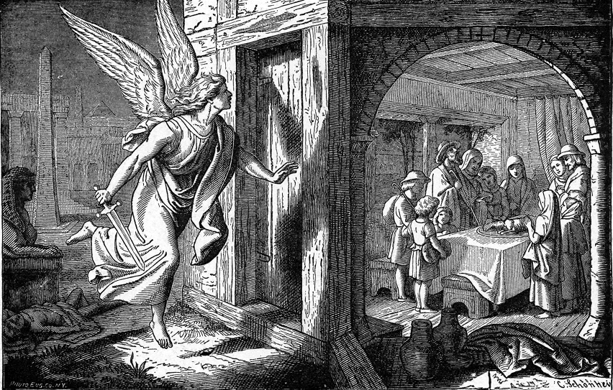
A death angel left alive the eldest son in every home that had blood daubed on its door posts.
- Dramatize parts of Israel’s escape from slavery:
- Arrange with the worship leader for the children to present this drama, or parts of it.
- Rehearse the drama during your teaching time with the children.
- Let older children help the younger ones to prepare.
- You do not have to use all the parts.
- Older children or adults play the parts of Pharaoh, Fearful child, Narrator and Moses.
- Smaller children are Actors who play different parts.
Narrator: Briefly summarize the first part of the story:
“Cruel Egyptians whipped God’s people and forced them to work as slaves.
God heard their groans and sent Moses to tell bad king Pharaoh to free them.
Pharaoh refused, so God sent plagues to force Pharaoh to free them.
Hear what Moses demands of the bad king Pharaoh.”
Moses: “The Most High Lord God of Israel commands you, ‘Let my people go.”
Pharaoh: “Who is your God, that I should obey Him? Egypt’s gods are more powerful!”
Moses: “ Our God will send plagues to prove that He has more power than your idols.”
Narrator “The 1st plague! Ancient Egyptians deified the Nile River, so God turned it to blood.”
Pharaoh “All our streams have turned foul; my people are digging wells to get fresh water.”
Narrator “The 2nd plague! Frogs! Hear what Pharaoh and his people say about the frogs.”
Actors Jump like frogs.
Pharaoh “Frogs everywhere! Even in my bedroom! Get them out!”
Narrator “The 3rd plague! Gnats! Hear what the people say about the gnats.”
Actors Slap your arms, neck and face. Complain about the bugs.
Narrator “The 4th plague! Flies! See what Pharaoh and his people do with the flies.”
Pharaoh & Actors
Swat flies all around you and complain about them.
Narrator “The 5th plague! Deadly cattle disease! See what the cows do.”
Actors Walk on hands and knees and make cow’s noises.
Then roll over with feet in the air.
Narrator “The 6th plague! Sores! See what Pharaoh and his people do about the sores.
Pharaoh & Actors
Some hold their arms, others their faces. Cry out in pain.
Narrator “The 7th plague! Hail! See what the idolaters do when the hail falls.”
Actors Look up and pretend to protect your face from the falling stones of hail. Then fall.
Narrator “The 8th plague! Grasshoppers! See what the grasshoppers do.
Actors Hop around like grasshoppers.
Pharaoh “Stop them! Moses! They are eating all our crops!”
Narrator “The 9th plague! The Egyptians worshipped the sun so God sent darkness!
See what the people do.”
Actors Walk around as though blind. Complain that it is too dark to see. Hold your hands up in front of you to feel the way. Bump into one another and fall.
Narrator Briefly summarize the second part of the story:
”In the last plague a death angel flew over the land and slew the first-born son in every home. Believers marked their doors with lamb’s blood. The angel saw the blood and passed over. They ate a lamb in haste. Jews celebrate this Passover Feast each year to this day.
Fearful child Read or recite by memory the poem, slowly with feeling, A Child’s Fearful Night:

The firstborn moans, “I cannot sleep.
My heart beats fast with helpless fear

Since Moses said tonight’s the night;
Death’s angel passes far and near.

And I, the oldest child, will die,
Unless lamb’s blood has marked our door.

The night is dark, with starless sky.
The air grows chill; winds blow no more.

I hear no sound in any home.
Perhaps the angel will delay.

Oh, there’s an anguished cry! It’s far.
God’s slaying angel’s on his way.

Again I hear death’s shriek! It’s close!
Sad, woeful wails from souls aghast.

But now I hear dad’s sobs of joy.
The angel saw lamb’s blood and passed.
Narrator Briefly summarize the third part of the story:
“Pharaoh let the people go, but changed his mind and sent his army after them. God opened a path through the Red Sea for His people to cross.
The soldiers tried to follow them, but the water returned and drowned them.
Hear what Pharaoh says after the last plague, death of older Egypt’s sons.”
Pharaoh “My oldest son died, so I let the slaves go. But now I change my mind!
After them, soldiers! Get your horses and chariots! Kill every Israelite!”
Actors Run and pretend to be riding horses.
Then cry out that the water is coming back. Fall.
Moses “Praise the Holy One! He freed us from slavery and death
by His mighty power! Amen!”
Narrator Thank everyone who helped with the drama.
- Let the children draw a frog.
Let them show their pictures to the adults during worship and explain that God sent a plague of frogs to force a bad king to free slaves. Some may like to colour the picture at the end of this lesson.

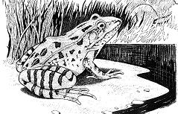
- Let four children each recite a verse from Exodus 15:3-6.
Let older children write poems about how God saved His people 1,500 years before Christ.
- Memorize Psalm 91:1.
- Let an older child read this prayer or pray something like it:
“Dear God. You are all powerful. You free us from the most evil king of all, who is Satan. Free our friends also, we beg you, in Jesus’ all-powerful Name. Amen.”

Download a more detailed drama to act out, of Israel’s miraculous escape from Egypt:
http://biblestoryskits.com/001-i-am-sends-moses-to-free-the-enslaved-children-of-israel-3/

