People Worshipped God
before Jesus Came
Dear Lord, use this lesson to help the children worship you with sincere hearts.
Choose activities that fit the children’s needs and ages.
- Let an older child or adult read or tell, from 2 Chronicles 5, about how the ancient Israelites worshipped in their new temple.
Then ask these questions:
- Whom did Solomon invite to the holy festival in Jerusalem? [Answer: see verse 3]
- What did they sacrifice? [verse 6]
- What was in the Most Holy Place under the wings of the cherubim? [verse 7]
- What was inside of the Ark of the Covenant? [verse 10]

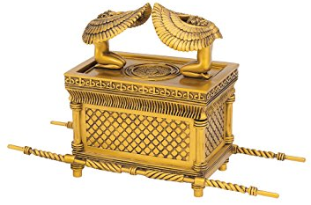
- How did the priests and Levites praise the Lord? [verses 12 & 13]
- What filled the Temple when the priests praised the Lord? [verse 13]

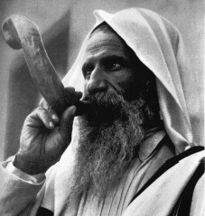
Sounding a ram’s horn is an ancient call to worship.

Explain that since Jesus came and has sent His Holy Spirit to live in us, God’s presence does not dwell in one building but in all the hearts of His people. Animal sacrifices symbolized Jesus. We do not sacrifice animals today, because Jesus is the Lamb of God that took away all of our sin.

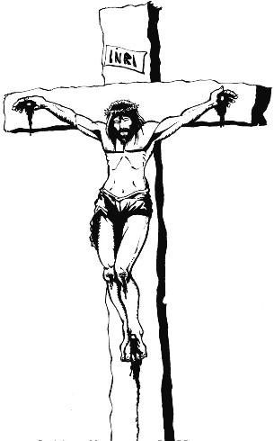
- Let the children mention ways that the ancient Israelites worshiped God.
Then compare those ways with the way we worship God today. Examples:
- The Israelites had a Temple made of lumber and stones; today we worship anywhere.
- The Israelites’ Ark of the Covenant symbolized God’s presence; today God dwells in us.
- The Israelites sacrificed animals; today we have the Body of Christ in the Lord’s Supper.
- The Israelites praised God with music and offerings, which we also do.
- The Israelites avoided idols and evil spirits, which we also avoid.
- Dramatize how King Solomon dedicated the temple, 2 Chronicles 5 - 7:
- Arrange with the worship leader for the children to present their drama or parts of it.
- Let older children help smaller ones prepare their parts.
- Let small children play these parts
Priests (four
Levites
- Let older children or adults play:
Solomon,
Child (boy or girl),
Parent,
Voice of
Narrator.
Narrator: Summarize the story from 2 Chronicles. Then say,
“Hear what a child asks their father.”
Child: Walk, holding Parent’s hand. Say,
“We have walked for two days. Where are we going?”
Parent: “King Solomon invited all Israelites to Jerusalem to dedicate a temple that he built.”
Child: “Look! Those priests are carrying a huge container covered with gold!”
Priests: Pretend to carry the Ark of the Covenant:
Hold the ends of its two long poles on your shoulders.
Walk two in front and two a few feet behind them.
Then pretend to set the ark down.
Parent: “It is the Ark of the Covenant. It holds the Ten Commandments.
They put it in the Most Holy Place in the new temple.
It reminds us of the Presence of Almighty God.” (Bow down.)
Child: “When will they open it?”
Parent: “Never! A man once touched it, and God struck him dead!”
Levites: March, pretending to clash cymbals and blow trumpets.

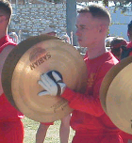
Child: “Look! Musicians have cymbals, harps and trumpets!”
Levites: Chant loudly together, “Praise the Lord! His loving kindness is forever!”
Child: “Look! The house of the Lord is filled with a cloud! The priests have to leave!”
Levites: Look up and around. Raise your hands and walk away, as though blinded.
Parent: “The glory of the Lord has filled the house of God.
Look! King Solomon is praying!”
Solomon: Spread your hands toward heaven and speak loudly,
“O Lord God of Israel. I have built you a lofty house for your dwelling forever. But will you indeed dwell with mankind on the earth?” Even the highest heaven cannot contain you; how much less this house that I built!”
Narrator: “The voice of God answers from heaven.”
Voice of God: “I have chosen Jerusalem that my name might be there. Now, if My people who are called by My name will humble themselves and pray and seek My face and turn from their wicked ways, then I will hear from heaven, will forgive their sin and will heal their land.”
- If the children present this drama to adults, then they can also ask the adults the questions listed above under #1.
- Children draw a harp or some other musical instrument to illustrate how we can celebrate God’s presence with music.
- Let the children show and explain their pictures to the adults during worship.

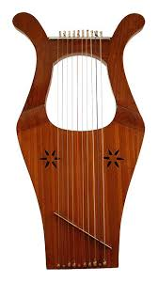
- Let three children each recite a verse from Isaiah 6:1-4:
In the year King Uzziah died,
I saw the Lord seated on a throne, high and exalted,
And the train of his robe filled the temple.
Above him were seraphs, each with six wings.
They were calling to each other:
“Holy, holy, holy is the Lord Almighty;
The whole earth is full of his glory.
At the sound of their voices the doorposts and thresholds shook
And the temple was filled with smoke.
- Memorize: smaller children memorize Psalm 87:3. Older ones, Hebrews 1:1-2.
- Let an older child pray:
“Lord, thank you for revealing your presence to King Solomon and to the people of Israel. Now, because of Jesus, you dwell in each one of us. We rejoice and praise you.”

