A Shepherd-King Sang Songs to God
Dear Lord, please help the children to appreciate the beauty of the poetry in Scripture, and also to be comforted by David’s Shepherd’s Psalm.
Choose activities that fit the children’s ages and needs. Children may like to colour the picture on the last page of this study.
- Let an older child or teacher read the Shepherd’s Psalm (Psalm 23).
It shows how we can praise our Good Shepherd Jesus the way David did, for God’s wonderful care for us.
- Questions about Psalm 23. The answers appear after each question.
When God takes care of us, do we lack anything? [See verse 1]
To what kind of places does he lead us? [See verse 2]
Why does he lead us into paths of righteousness? [See verse 3]
Do we need to fear death? [See verse 4]
Where will we live forever? [See verse 6]
- Sing the Shepherd’s Psalm.
If you know a song with these words, sing it.
Or, you may sing these words to a tune that the children already know or compose.

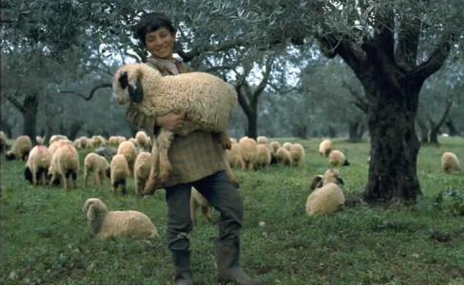
A good shepherd loves his sheep.
- Dramatize this Psalm while you sing the words.
- Arrange with the worship leader for the children to present this brief drama.
- Use your teaching time with the children to prepare the drama.
- Let older children help the younger.
- Let older children or adults play these parts:
Shepherd. Prepare a bowl, bottle, table and shepherd’s staff
(see the picture under #5 below. Use a stick with a branch going out from it).
Narrator. Summarize the story and help the children remember what to say and do.
- Let smaller children play these parts:
Enemies
Sheep. (Crawl on hands and knees, occasionally say ‘baa’ softly).
Narrator: Sing, read or recite Psalm 23 by memory two times.
The second time, speak each verse and pause after it while the children dramatize it.
Narrator: (Verse 1)
Shepherd: Walk around the ‘sheep,’ petting them.
Sheep: Try to get close to the shepherd and smile at him, showing that you are happy.
Narrator: (Verse 2)
Shepherd: Set the bowl down. Then lead the sheep to it.
Sheep: Pretend to drink from the bowl. Then lie down calmly and chew your cud.
Narrator: (Verse 3)
Shepherd: Beckon the sheep to follow you with your hand and walk.
Sheep: Follow close behind the shepherd.
Narrator: (Verse 4)
Enemies: Hide behind chairs and pretend to shoot with bows and arrows at the sheep.
Sheep: Act frightened. Kick, say ‘baa’ and run in circles.
Shepherd: Pull the sheep away from the enemies with the staff.
Then drive the enemies away with your staff.
Do not actually hit anyone. Simply pretend.
Narrator: (Verse 5)
Shepherd: Put a table by the sheep.
Then pretend to pour oil from the bottle over them.
Sheep: Raise your hands slowly up over your heads like a cup overflowing.
Narrator: (Verse 6)
Shepherd: Pretend to open a door and welcome the sheep inside.
Sheep: Go through the door. Then kneel in a circle around Shepherd and raise your hands together toward heaven to praise God.
Narrator: Thank everyone who helped with the drama.
- If the children dramatize this Psalm for the adults…
- Let the children also ask the adults the same questions that are listed under #1 above.
- You can also ask for other examples of how God shepherds his people.
(Let the children and adults give examples.)
- Draw pictures of a shepherd’s staff.
Let the children show their pictures to the adults during worship and explain that the shepherd’s staff illustrates how Jesus, our Good Shepherd, guides us into a better life.
- Let older children write poems or a song about Jesus our Good Shepherd.
Let several children recite verses from Psalm 23.
- Memory work. Older children memorize Psalm 23. Smaller ones learn Psalm 23:1-2.
- Let and older child or adult pray:
“Dear Jesus, you are our wonderful Shepherd. You give us what we need. We trust in you, even when in danger or when we face enemies and death. You comfort us and lead us. You will bring us safely through death into heaven, where we will live with you forever. Come quickly, Lord Jesus.”
