Jesus Stirred People’s Hearts by
Explaining God’s Word
Dear Lord, please help the children’s hearts to be stirred when they learn what ancient prophets foretold about Jesus, just like the disciples on the Emmaus road were stirred.
Choose any of these learning activities that fit the children's ages and needs. Children may like to copy or to colour the picture on the last page of this study.
- Let an older child or teacher read, or tell by memory, a story of Burning Hearts from Luke 24:13-35.
- Explain that Jesus told two men what the Bible foretold about Him; they felt such joy that it was like fire in their hearts. God told His ancient prophets what would happen in the future.

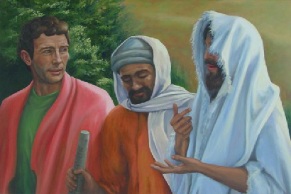
Jesus talks with two travelers on a road to Emmaus.
- Pose these queries [The answers appear after each question.]:
- Did the two men recognize Jesus when they first saw him? [See verse 16]
- Why did the two men look so sad? [Verse 20. Jesus had died. ]
- What did the men say about Jesus? [19-23]
- What did Jesus say about their sorrow? [26]
- What did Jesus explain to the two men? [27]
- When did the men finally recognize Jesus? [30-31]
- Dramatize the story of the disciples walking to Emmaus, from Luke 24:13-35.
- Arrange with the worship leader to have the children present brief drama or parts of it.
- Use your teaching time with the children to prepare the drama.
- Let older children help the younger ones to prepare.
- Let older children or adults portray…
Jesus,
Psalmists (up to 6, read or say by memory verses from Psalm 22 that the drama sites.
Narrator (summarize the story and help the children remember what to say.)
- Let younger children play the parts of
Cleopas,
Companion
Apostles.
Narrator: Tell the first part of the story from Luke 24:13-27. Then say,
“Hear what Cleopas says.”
Cleopas (Speak to Companion as you walk.) “I feel so sad because Jesus died!
Why did God let him die?”
Jesus “Sirs, what are you talking about as you walk?”
Companion “Jesus has died. He was a powerful prophet.
We thought he would be king of Israel, but our rulers had him killed.
Today some women said he was alive again!”
Jesus “Do you not understand? He had to suffer and die.
Listen now to what the Scriptures say about Him.”
Narrator “Jesus quoted scriptures that foretold Jesu’ work,
and their hearts burned within them.
Hear what David foretold in Psalm 22 about Jesus’ death on the cross.”
Psalmists (Psalm 22:2, 8, 17-18):
“My God, my God, why have you forsaken me?”
“All who see me sneer at me.
They mock me with their lips, they wag their heads.”
“They say, ‘Commit yourself to the Lord; let Him deliver him;
Let Him rescue him, because He delights in him’.”
“A band of evildoers has encompassed me.
They pierced my hands and my feet.”
“I can count all my bones. They look, they stare at me.”
“They divide my garments among them.
For my clothing they cast lots.”
Narrator Tell the second part of the story from Luke 24:28-35.Then say,
“Hear what Cleopas says.”
Cleopas (Speak to Jesus.) “Friend, it is late. Walk no farther. Stay here with us.”
Jesus “Let me break the bread. Thank you God for this food.”
(Pretend to break a loaf of bread and hand the pieces to Cleopas and Companion.)
Cleopas Rise up and run to Apostles. Shout,
“It is he! It is Jesus!”
Companion “Let’s go tell his disciples!”
Apostles: (Some say) “Yes, it is true.”
(Others say) “We have seen him, too.”
(Others say) “He is alive again!”
Narrator: Thank everyone who helped with the drama.
- If the children dramatize this story for the adults, then:
- Let them also ask the adults the questions that are listed above, under #1.
- Ask: What are other examples of times that God fills our hearts with joy when we hear about Jesus and his resurrection? (Let the children give examples.)
- Draw pictures of fire inside a heart.
Let the children show their pictures to the adults during worship and explain that Jesus fills our hearts with joy because he is not dead; he is alive and his Spirit lives within us forever.
- Memorize Ezekiel 36:25-26 (let younger children learn only verse 26):
25 I will sprinkle clean water on you, and you will be clean; I will cleanse you from all your filthiness and from all your idols.”
26 I will give you a new heart and put a new spirit within you; and I will remove the heart of stone from your flesh and give you a heart of flesh.”
- Let an older child pray:
“Dear Lord, our hearts burn with joy when we remember your resurrection. You did not stay dead. You are alive! You live in us and give life to us. We yearn to see you with our eyes and live with you forever. Come quickly, Lord Jesus.”

More detailed drama to act out Jesus and the two disciples on the way to Emmaus, 12 minutes:
http://biblestoryskits.com/030-jesus-reveals-what-the-old-testament-says-about-him-on-the-road-to-emmaus/

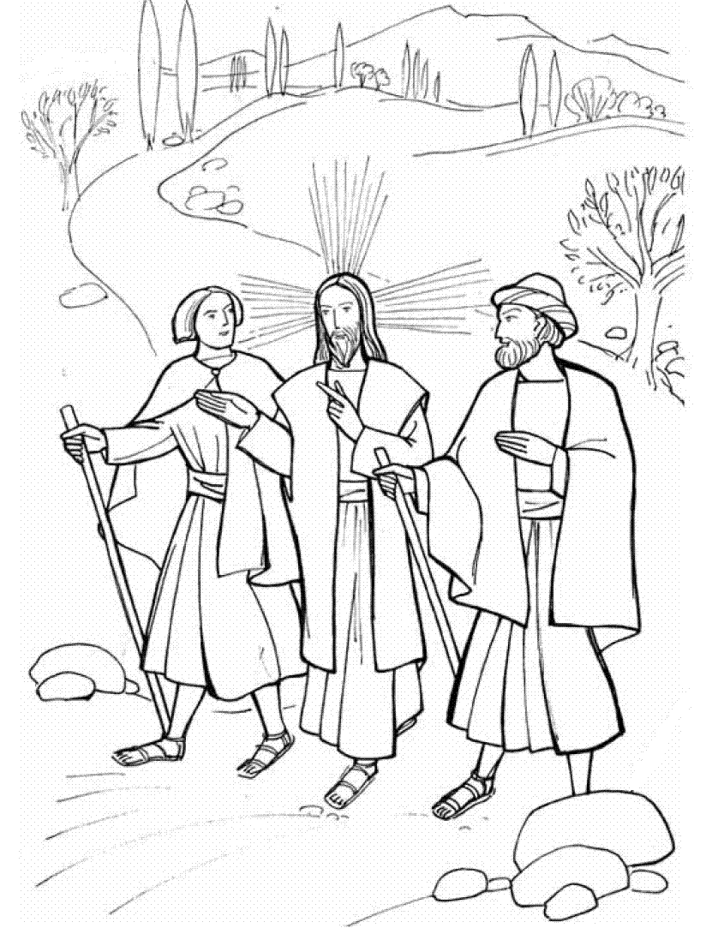
Jesus walked and talked with two men on a road to Emmaus, explaining to them the Scriptures.

