Prophets Foretold Messiah’s Coming
Anchor command. “Repentance for the forgiveness of sins should be proclaimed in his name to all nations.” Luke 24:46-48
Anchor story. Abraham receives God’s promise of a descendent through whom God would bless all families of the earth. Genesis 12:1-5; 15:3-6
Anchor verse. “Beginning with Moses and with all the prophets, he explained to them the things concerning Himself in all the Scriptures.” Luke 24:27
Learning goal. Be familiar with prophecies of the coming Messiah.
Growth goal. Appreciate the wealth of messianic prophecy throughout the Old Testament.
Skill goal. Be able to convince others of the wealth of prophecy concerning Christ.
Outcome goal. Believers share with many their knowledge of the prophecies of Christ.
Heavenly Father, please, help my flock to rejoice in how you fulfilled so many predictions about the coming of Jesus, the Messiah, and help them to hope for his return.
Basic Study
Learn from the story of Abraham’s pilgrimage one of the first prophecies of Christ.
Genesis 12:1-5 and 15:5-6
- By whose orders did Abraham, his family and servants leave his homeland? Genesis 12:1
- God’s covenant with Abraham included several promises. What were they? 12:2-3
- To what distant land did God lead Abraham? 12:4-5
- What was the promise of God that Abraham believed, and God counted his faith as righteousness? 15:5-6
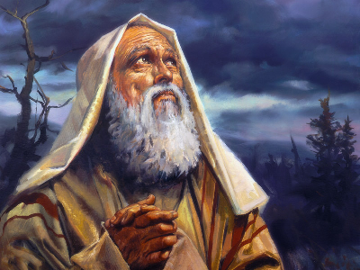
Abraham believed the LORD
During the week…
- While visiting and witnessing, explain to people how the prophets predicted Messiah’s coming and how Jesus fulfilled those predictions.
- Visit believers and seekers who have doubts; encourage them to think about reasons for faith.
- Pray with them for Jesus to bless them and show himself to be good and powerful.
During worship
- Have the believers read together from the Bible several Old Testament predictions and their New Testament fulfilments. Ask each time in what way Jesus fulfilled the prophecy.
- Memorize together Luke 24:27. “Jesus quoted passages from the writings of Moses and all the prophets, explaining what all the Scriptures said about himself.”
- Ask the children to present what they have prepared.
Advanced Study
- Prepare with prayer and the Word to teach messianic prophecies.

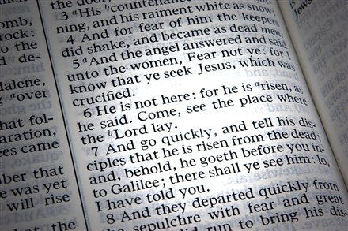

Background Notes
- “Messiah” is a title that Jewish people gave to their kings in Old Testament times. They also used the title Messiah to talk about a great king who would someday come and rule over all the earth. Messiah means “anointed” and is often translated Christ. So, the name Jesus Christ means Messiah Jesus.
- The Jewish people have had nearly 4000 years of history, starting with their ancestor, Abraham. They waited 2000 years for Messiah to come. When he came, many believed in him, but most did not. 2000 years later, many Jewish people today believe that Jesus is their Messiah, but most do not. Many unbelieving Jews are still waiting for Messiah.
- There are many reasons for which we know that the Bible is true and that Jesus is the Messiah. Here are a few reasons:
(1) Jesus did many things that only God can do.
(2) God answers our prayers made in Jesus’ name.
(3) We have seen miracles and visions of Jesus.
(4) Jesus is stronger than all other spirits. (5) Christ gives us joy and peace.
(6) No one else is like Jesus.
(7) The Holy Spirit living in believer’s hearts bears witness to the truth.
Another reason to believe is that the Bible long ago made hundreds of predictions, and many have already come true. In the Old Testament, the prophets made more than 200 predictions about the coming Messiah. In the New Testament, Jesus fulfilled about 150 of those predictions, and he said that he would fulfil the rest of them when he will return to earth, some day.
- Christians are Jews and non-Jews who believe that Messiah has come as promised, and that He is Jesus. Christians also believe that Messiah Jesus will return to earth someday as promised.
- Compare Old Testament predictions with their New Testament fulfilments
Compare…
Isaiah 9:6–7 with Matthew 2:1–11 about a special child who would be born as king.
Micah 5:1 with Matthew 2:1–11 about where the Messiah would be born.
Isaiah 11:1–4 with Matthew 5:1–12 about wisely guiding the meek and the poor.
Isaiah 53:4 with Matthew 8:14–17 about healing people’s diseases.
Deut. 18:15 with John 6:10–15 about miraculously giving bread to people.
Daniel 9:25–26 with Matthew 24:14–25 about persecution after Messiah’s coming.
Zechariah 9:9 with Matthew 21:1–11 about Messiah entering Jerusalem on a donkey.
Jer. 31:31–34 with Luke 22:17–22 about establishing the New Covenant.
Isaiah 53:12 with Luke 22:37 about Messiah’s being numbered with transgressors.
Psalm 22:14–18 with Matthew 27:32–50 about Messiah’s crucifixion.
Zech.12:10 with John 19:34–37 about how Messiah was pierced with a spear.
Isaiah 53:7–8 with Acts 8:29–35 about Messiah’s death as a sacrifice for our sins.
Psalm 16:9–11 with Luke 24:46–48 and Acts 2:22–28 about Messiah’s resurrection.
- Another kind of prophecy includes many Old Testament patterns that are fulfilled by Jesus.
For example, Jesus is called the ‘Final Adam’ in 1 Corinthians 15:45, and there are several important likenesses and contrasts between Jesus and Adam in Romans 5:12-12 and 1 Corinthians 15:20-23, 45-50. Both Jesus and Adam were heads of a new human race, and both brought far-reaching results upon their race because of what they did.
Adam disobeyed the Lord  when Satan tempted him. | Jesus resisted when  Satan tempted him.
- For a special study (which will take a lot of well-spent time) discover the many comparisons and contrasts between Jesus and the men listed here:
- Adam, Genesis chapters 2 & 3),
- Isaac (Genesis 22),
- Joseph (Genesis chapters 37 and 39–48),
- Moses (seen throughout books of Exodus and Numbers),
- Aaron (seen in the books of Exodus and Leviticus),
- Joshua (Joshua),
- Boaz (Ruth),
- David (1 Samuel 16–31 and 2 Samuel chapters 1 through 24),
- Elijah (1 Kings chapters 17 through 19 and 2 Kings chapter 2).
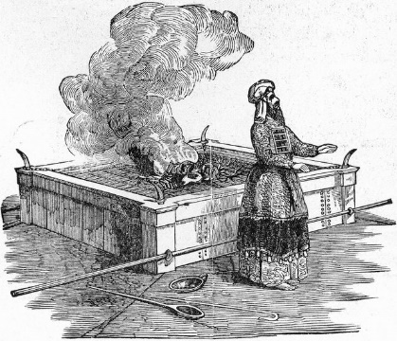  Aaron offered animal sacrifices  that could never take away sins. | 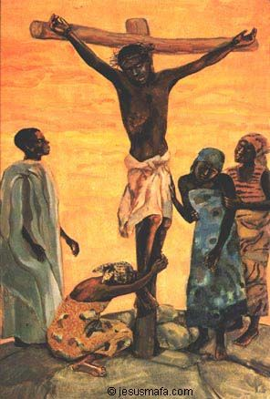  Jesus offered himself as a sacrifice  that takes away the sins of the world.

- Plan with your co-workers additional activities for the coming week.
- In your visiting and witnessing, explain to people how the prophets predicted Messiah’s coming and how Jesus fulfilled those predictions.
- Visit believers and seekers who have doubts, and encourage them to think about reasons for faith. Pray with them for Jesus to bless them and show himself to be good and powerful.
- If the new leaders that you are mentoring have people who need assurance that the Bible is the Word of God, have them also read this study.
- If some of the believers like to read and study the Bible, ask them to discover the likenesses and contrasts between Jesus and Old Testament leaders, from the list above.
- Plan with your co-workers additional activities for the up-coming worship meeting.
- Explain that predictions fulfilled in the past give to us confidence that the rest of the predictions will be fulfilled in the future.
- Explain the likenesses and contrasts between Jesus and at least one of the Old Testament leaders listed above.
- To introduce the Lord’s Table, read aloud 1 Corinthians 11:26. Explain that Christians have been taking the bread and cup together for nearly 2000 years while waiting for Messiah to return and fulfil the rest of his promises.
- Form small groups of two and three to pray together, discuss the ancient prophecies about Jesus, confirm plans, and encourage one another.
- Those who teach children should read study #55 for children.

