Learn Who Jesus Really Is
Dear Lord, please help the children to admire the life that Jesus lived, and to believe that He is the Son of the one true God, who also became human.”
Choose any of these children's learning activities that fit their ages or needs.
- Let an older child tell about Jesus’ final, triumphant entry into Jerusalem, Luke 19:28-40.
This story shows how common people praised Jesus as their promised Messiah and King that would bring freedom and peace to the whole world.
After telling the story, ask these questions. [Answers appear after each question.]
- How did Jesus get a colt to ride into Jerusalem? [See verse 30]
- What did the disciples tell the owners of the colt? [34]
- Matthew 21:8 says that people spread branches before Jesus on the road. In what other ways did they show their joy and their praise? [36-37]
- Who did the people say that Jesus was? [38]
- What did Jesus say would happen if he made the people keep silent?” [39-40]

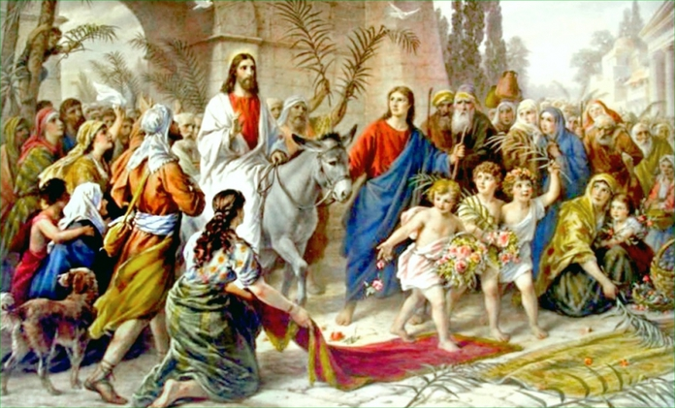
Jesus arrived in Jerusalem just as Zechariah 9:9 had predicted.
- Explain the background of Jesus’ Triumphal Entry:
- Jesus came to Jerusalem the Sunday before his crucifixion.
- Some Christians call that day Palm Sunday, because the people decorated with palm branches His path into Jerusalem.
- Jesus entered Jerusalem one week before He would rise from death.
The most important events of all history happened during that week.
- Some of the leaders and government officials envied Jesus and feared that He would take away their positions of power.
- Many of the people had been healed by Jesus and knew that He was the Messiah that the Old Testament prophets had foretold would come into the world.
- Jesus is God who became human. He is not an angel or something in between God and humans. He is both God and human, the only bridge between heaven and earth.
- Dramatize parts of the story of Jesus’ Triumphal Entry, from Luke 19:28-40.
- Arrange with the leader of the main worship for the children to present this drama.
- Prepare the children during your teaching time with the children.
- Let the older children help the younger ones to prepare.
- If there are not enough people for all the parts, then let Narrator simply say those parts.
- Older children or adults play these parts:
Jesus
Donkey (put your arms up so that your wrists touch the sides of your head, and your hands stick up like long ears. Wiggle these long “ears” when you say “Hee Haw.”
Donkey’s Owner
Narrator (Summarize the story and help children remember what to say and do.)
- Younger children play these parts:
Pharisees (any number)
Disciple
Crowd. (Disciple and children who are Crowd have tree branches and coats or cloths.)
Narrator Tell the first part of the story, from Luke 19:28-35. Then say,
“Hear what Jesus tells his followers.”
Jesus “It is time for me to go to Jerusalem.
Go untie a colt in the next village and bring it here.
Tell the owners that the Master needs it.”
Disciple Go to the ‘donkey,’ pretend to untie it and put a coat on it.
Donkey “Hee Haw! Hee haw!” (Wiggle your “ears”.)
Donkey’s Owner “Wait! What are you doing with my donkey?”
Disciple. “The master needs it.”
Donkey’s Owner Oh. Alright, then take it.”
Donkey “Hee Haw! Hee haw!” (Wiggle your “ears”.)
Disciple Lead the donkey to Jesus.
Jesus (Put one hand on the “donkey”).
Donkey’s Owner “Look! Jesus is mounting my donkey’s colt that has never been ridden!”
Narrator Tell the second part of the story, from Luke 19:36-40. Then say,
“Hear what the Crowd says.”
Crowd Lay down the coats or cloths in front of Jesus. Wave the branches, and then lay them down. Shout,
“Glory to God.” “Hosanna!” “Here comes the King!”
Pharisees (Angrily) “Jesus, tell your disciples to stop shouting such things!”
Jesus “If they remained quiet, then the stones would cry out!”
Narrator When the drama is over, thank everyone who helped.
- If the children dramatize this story for the adults, then let them also ask the adults the same questions that are listed above under #1.
- Let several children recite verses from Psalm 118:22-24, 26 and 28.
Let Israel say,
“His steadfast love endures forever.”
Let the house of Aaron say,
“His steadfast love endures forever.”
Let those who fear the LORD say,
“His steadfast love endures forever.” Psalms 118:2-4

Blessed is he who comes in the name of the LORD!
We bless you from the house of the LORD.

You are my God, and I will give thanks to you;
you are my God; I will extol you. Psalms 118:26-28
- Ask the children to tell other ways in which we can praise Jesus as our Lord and King.
Let the children and adults give examples.
- Draw a picture of a palm branch, and let the children copy it.

The children may like to copy or colour the picture on the last page of this lesson.
- Older children may want to draw a palm tree.
- Let the children show their pictures to the adults at the next worship time, and explain that the branches illustrate how we should praise Christ as Lord and King.
- Memorize John 14:6:
“Jesus said to him, “I am the way, and the truth, and the life; no one comes to the Father but through me’.”
- Let an older child pray:
“Dear Lord, you are our only God. We worship you. Even though some people still do not know who you really are, we know how wonderful you are. That is why we praise you. Help us to tell others about you, so that they, too, will come to praise you.”

A more complete drama to act out, of Jesus’ Triumphal Entry into Jerusalem (5 minutes):
http://biblestoryskits.com/020a-jesus-our-triumphant-king-rides-a-donkey-into-jerusalem-2/print/

