The Acts of the Apostles

Guidelines for Ministry
Anchor command. “Be imitators of me, just as I also am of Christ.” 1 Corinthians 11:1
Anchor story. Apostles are imprisoned for proclaiming about Christ. Acts 5:12-42
Anchor verse. “Every day, in the temple and from house to house, they kept right on teaching and preaching Jesus as the Christ.” Acts 5:42
Learning goal. Discover how the apostles did ministry, during worship and during the week.
Growth goal. Embrace the importance of following the example that the apostles set for us.
Skill goal. Believers intentionally follow the example of the New Testament apostles.
Outcome goal. Congregations discern, commission and send out believers who have an apostolic gift.

Lord, give to us the power of your Holy Spirit that you promised in Acts 1:8, to witness for Jesus.

Basic Study
Learn from this story of the apostles imprisoned for proclaiming Christ. Acts 5:12-42…
- What were the apostles doing that attracted many people? Verses 12-16
- Why did the high priest and his associates jail the apostles? 17-18
- How were the apostles freed from jail? 19-20
- Why were the captain and chief priests perplexed? 21-24
- What did Peter and the apostles tell the Council when the authorities ordered them not to teach in Jesus name? 25-29
- The apostles gave their defence, telling about Jesus, angry the council members. Who among them spoke up in their defence? 30-40
- What was the result of this encounter with the unbelieving authorities? 41-42
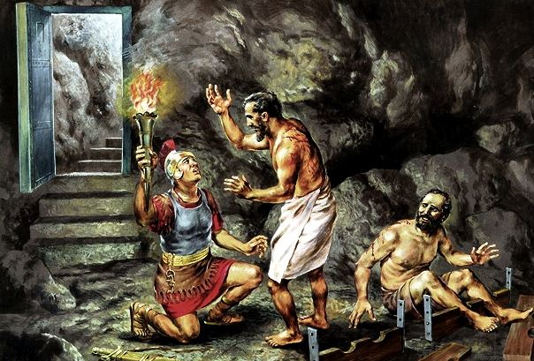
A gaoler asks imprisoned apostles, ‘What must I do to be saved?’
During the week…
- Visit believers who have been timid or have not been actively sharing their faith.
- Believers go witness for Christ to people who do not know Him.
- Help them do this with prayer, in the power of the Holy Spirit, as the apostles did.
During worship…
- Tell the story of the apostles being jailed, Acts 5:12-42, and ask the same questions as above. Urge believers to discuss the answers.
- Pray for the Holy Spirit’s power to work with the same boldness as the apostles.
- Ask the children to present what they have prepared.
- Memorize together Acts 1:8

Advanced Study
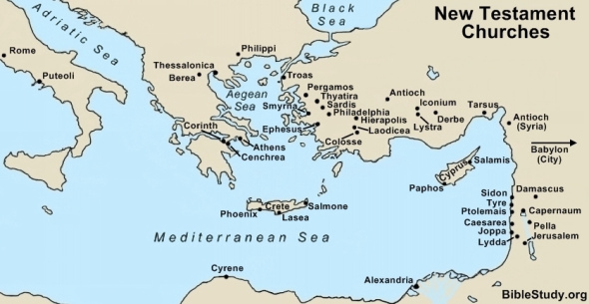
The church began in Jerusalem and spread through the Roman Empire, first amongst Jews, and later amongst Gentiles as far as Asia, Africa and Europe.
- Learn from the book of Acts…
- Read Acts 1.
- Find in Acts 1:8 four places where believers are to proclaim Jesus in the power of the Holy Spirit.
1) Jerusalem corresponds to the community where we live.
What is your “Jerusalem?”
2) Judea refers to people nearby of the same culture.
Where is your ‘Judea?’
3) Samaria means people of a culture similar to yours, nearby.
Who are your “Samaritans?”
4) The ends of the earth include neglected, distant people that God wants you to reach.
- Find in Acts 1:14 what the apostles were doing while waiting for the Holy Spirit whom Jesus promised.
- Read Acts 2. Find things that happened after the Holy Spirit filled the waiting disciples. Why did the Holy Spirit fill them ― was it simply for an exciting experience, or to help them to witness?
- Find in Acts 2:24-32, the main emphasis of Peter’s powerful message, besides Jesus’ death.
- Find in Acts 2:37-47, seven activities that the believers put into practice, at once, in obedience to Jesus’ commands.
- Find in the other chapters of Acts:
Ch. 3: What can we expect God to do when we call on him in Jesus’ name?
Ch. 4: What can we do when hostile authorities threaten us?
Ch. 5: What did God do to people who lied to Him?
Ch. 6: What did the congregation do to take care of needy people?
Ch. 7: After Stephen reviewed Israel’s history, what did he say that angered the leaders, and what did they do to him?
Ch. 8: How did Philip began God’s work in Samaria, and why did Simon offer money to the apostles?
Ch. 9: How did God move the Christian’s worst human enemy to repent?
Ch. 10–11: How did God convince believing Jews that Gentiles also received His Holy Spirit?
Ch. 12: What did King Herod do to James, and how did Peter escape from him?
Ch. 13–14: Who sent Paul to distant lands, who went with him, and how did they organize the new believers?
Ch. 15: How did God help Jews to accept Gentile believers that did not keep the old Jewish law?
Ch. 16: How did the first church start in Europe at Philippi, and what did Paul promise to his jailer?
Ch. 17: In what different ways did the Jews receive Paul’s message?
Ch. 18: How did Paul support himself in Corinth, and what did his employers do for Apollos?
Ch. 19–20: What events occurred in Ephesus, what caused the riot, and what did Paul warn about ‘wolves?’
Ch. 21–28: Why was Paul jailed in Jerusalem, what trials did he suffer, and what occurred on the way to Rome?
- Plan with co-workers additional activities for the upcoming worship time.
- Prepare to Witness. During worship, you will prepare the believers to witness for Jesus with power. Ask them to listen for two things in Acts 1:8 while you or a helper read it:
First, from whom do we receive power to tell others about the risen Christ?
Second, in what four places were the apostles to go and witness with the power of the Holy Spirit?
- Let the people answer the two questions above and talk about them, if they can.
- .Explain the plans you made with co-workers to visit people during the week to tell them about our Lord Jesus. Arrange well for this work. Let the believers talk about whom they will visit.
- Review seven general commands of Christ.
Prepare two helpers to portray doing these commands without speaking
1) Repentance.
On one side of the room, the first helper sneers like Satan and motions with his hands to the other to come to him.
The other walks slowly toward him, looking around him as though he was afraid of being seen. When almost there he stops, puts his hands on his heart and then briefly takes the posture of prayer. Then he turns around and walks back the other way.
Let the people guess what was acted out. Repentance means we have a change of heart, turn around and go a different direction away from sin, toward God.
2) Baptism.
One helper goes through the motions of baptizing the other.
[Let the people guess].
3) Learning and teaching God’s Word.
One holds an open Bible upright to let everyone see as he points to words on the page as though explaining it to another person. [Let the people guess.]
4) Fellowship (loving one another).
One helper embraces another of the same sex, or does what would show Christian love to another person in your culture. [Let the people guess.]
5) Breaking bread (the Lord’s Supper).
One helper acts as though giving bread to the other, then an imaginary cup. The other pretends to eat the bread and drink. [Let the people guess.]
6) Prayer.
The two helpers take a posture of prayer, silently. [Let the people guess.]
7) Giving.
One helper acts like he is giving something to the other, who acts like he is very thankful, but without words. [Let the people guess.]
- Explain what the Apostles did. Choose one or more of the events that you read in Acts, and tell or act out the story for your congregation. It is more powerful if both adults and children to gather help dramatize it. Then ask what the believers learned from it. Ask what they plan to do as a result.
- To introduce the Lord’s Supper, read Acts 20:7. Explain that the believers met to celebrate the Lord’s Supper, on Saturday evening, which, along with Sunday until sundown was by Jewish reckoning the first day of the week, the day of Jesus’ resurrection.
- Pray and help one another in groups of two or three. Confirm the plans to witness and encourage one another.
- Those who teach children should read study #39 for children.

