John Saw the End of the World

Jesus stands ready to welcome all children who believe in Him.

Dear Lord, help the children cherish your promise of heaven.
Choose any of these activities that fit the children’s ages and level of spiritual understanding.
- Let an older child or teacher read or tell by memory the story of John’s visions of heaven, Revelation 20:11 through 21:4, and 21:22 through 22:5.
God revealed what will happen in heaven and on earth at the end times.
Pose these queries [Answers appear after each question]:
What happened to all of the people who had died? [See Revelation 20:12]
What happened to those whose names were not in the Book of Life? [See 20:15]
What did the New Jerusalem, our new home, look like? [See 21:2]
What things will never happen in heaven? [See 21:4]
Why were there no temple, no sun, and no moon? [See 21:22-23]
What two things are in the middle of the great street of the city? [See 22:1-2]

Review:
What things will we see in heaven?
[God, a white throne, sealed books, Jesus, light, people who have died, a beautiful city, a river, the tree of life]
What will we not see in heaven?
[Death, hell, crying, night, sun, moon, sin, sickness]

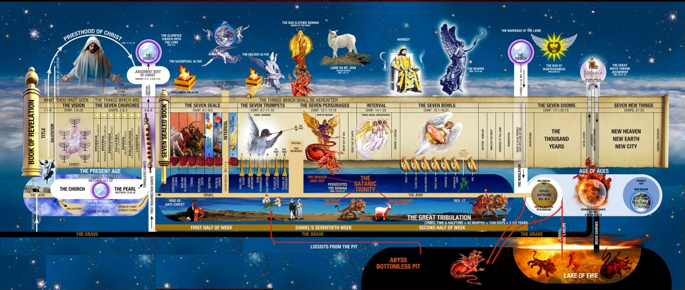
The Book of Revelation paints many exciting pictures of the end times.

- Dramatize parts of John’s visions of Heaven.
Arrange with the worship leader for the children to present this drama.
Use your teaching time with the children to prepare the drama.
You do not have to use all the parts.
Let older children help with the younger ones.
Older children or adults play the parts of Evangelist and Narrator.
Younger children play the parts of Friends.

Narrator: Tell the first part of the visions from Revelation 20:11-15. Then say,
“Hear what an evangelist tells his friend.”
Evangelist: “I have been reading the Book of Revelation.
In the future we will see God who is seated on his great white throne.
Friend #1: “God loves everyone. Will He let everyone into heaven?”
Evangelist: “Only believers whose names are in the Book of Life will enter heaven.
Friend #2: “I love Jesus, but sometimes I do bad things. Will I still sin in heaven?”
Evangelist: “No. God will change you. He writes all that we do in books.
Our bad actions will be judged and left behind.
God will reward us for the good things we have done.”
Friend #3: “What will happen to people who reject Jesus?
Evangelist: “Those whose names are not written in the Book of Life
will be thrown into a Lake of Fire.”
Friend #3: “I want Jesus to write my name in His Book of Life!
Narrator: Tell the second part of the visions, from Revelation 21:1-4. Then say:
“Hear what the evangelist tells his friend.”
Evangelist: “Heaven will be beautiful, like a lovely, happy bride.”
Friend #4: “Maybe God will not let me in. I have much trouble and pain in my life.”
Evangelist: “God will take away all your pain and sorrow. All the bad things of this life will be left behind.”
Friend #4: “I want to go where there is no more pain.”
Narrator: Tell the third part of the visions, Revelation 21:22 through 22:6. Then say,
“Hear what the friend says.”
Friend #5: “Will the Temple for worshiping God in heaven be very big?”
Evangelist: “No, there will be no Temple. God will live with us and be our Temple. His light will shine so bright that there will be no need for a sun or a moon.
Friend #5: “I think there will be no trees or rivers, then.”
Evangelist: “Yes, there is a beautiful river of the water of life and a tree of life right in the middle of heaven.”
All Friends: “We want to go there and be with Jesus! Praise the name of Jesus forever!”
Narrator: Thank everyone who helped with the drama.
- If the children present the drama to the adults, then:
Have then ask the adults the questions that are listed above, under #1.
Also have them ask what other things they hope for in heaven.
- Let the children draw a simple picture of the ‘tree of life’ that grows in heaven.
The children may like to copy or to colour the picture found at the end of this lesson.
Let the children show their pictures to the adults during worship and explain that in heaven healing will come from God, through His Tree of Life.

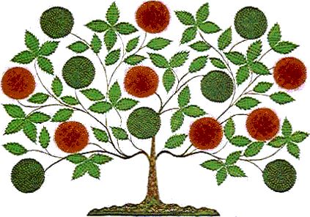

- Let three children each recite one of the verses from Revelation 19:6, 7 & 8.
- Let older children write poems or songs about God’s final judgment and heaven.
- Let older children memorize Revelation 21:3-4. Let younger ones learn verse 4.
- Let an older child pray:
“Dear Jesus, we thank you for giving the vision of heaven to the apostle John.
We do not have to fear the future. Jesus will triumph over sin and Satan.
Heaven will be beautiful. We will see your face and live with you forever.”

A more detailed drama to act out, reliving John’s amazing visions in glory, five minutes:

http://biblestoryskits.com/012-the-apostle-john-sees-the-redeemed-of-all-nations-in-glory-2/

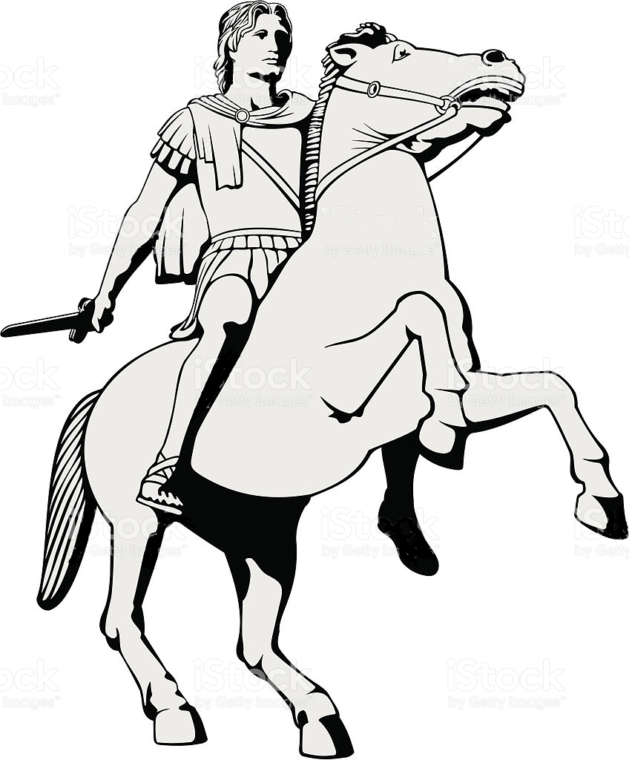
Jesus will one day return to earth as a King mounted upon a white horse.

