Christ Showed to John What Was
Soon to Happen
Anchor command. “Hear the words of the prophecy of this book.” Revelation 22:18-19
Anchor story. John’s visions of heaven and earth. Book of Revelation.
Anchor verse. “Blessed is the one who reads aloud the words of this prophecy.” Revelation 1:3
Learning goal. Grasp the main message of Revelation.
Growth goal. Appreciate what Christ revealed about the future of his people and of this earth.
Skill goal. Relate the key events of the book of Revelation with the power of the Holy Spirit.
Outcome goal. You and your co-workers tell believers and nonbelievers key events to come.

Basic Study
Jesus, you are Lord over all the earth. Help the believers and me to serve you whatever the cost, and to look forward with blessed hope to your coming
Learn from the visions that Christ gave John while John was in exile on the island of Patmos.
- How did Jesus appear to John in this vision? Revelation 1:13-14
- How did John react to this vision of Christ? 1-19
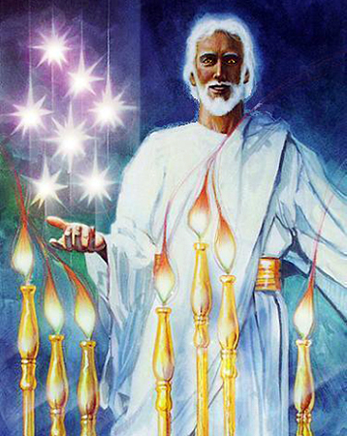
Jesus appeared to John in shining glory.
- To what did Jesus have the keys? 1:18
- What will heaven’s 24 elders do before the throne of Christ? 4:10-11
- John then saw visions of several judgments that God will bring on earth.
Why did the woman in John’s vision cry out in pain? 12:1-2
- What kind of monster attacked the woman that symbolizes both Jesus’ mother Mary and God’s people Israel? 12: 1-6
- Who fought in a great war in heaven, and what happened as a result of it? 12:5-9
- What did a loud voice in heaven shout? 12:10
- What will pass away and be replaced? 21:1
- what will become of people who remain outside of Christ? 20:12-15
- What will it be like for us in heaven? 21:3-4?
During the week meet with people who need to know about their future, and relate key events from Revelation.
During worship
- Relate key events from the book of revelation, above, and ask questions about them. Urge the believers to discuss the answers.
- Ask the children to present what they have prepared.
- Memorize together the words of Jesus in Revelation 22: 13.

Advanced Study

Learn from the Book of Revelation,,,
- The Book of Revelation has many symbols. Most of them come from the Old Testament. The New Testament shows how Christ fulfilled old prophecies.
- The Book of Revelation teaches Christians who suffer that they must remain faithful to Christ, until he returns to earth.

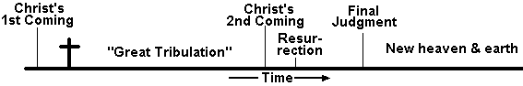
Main events of the Book of Revelation
- To do an in-depth study of the book of Revelation, do the following exercises for each day of the week:

First day
Find, in these messages about Christ in heaven:
1:1–9 What Christ did for us on earth.
1:10–19 What Christ does for us in heaven.
2:1–3:22 What Christ says to believers on earth. (7 churches)
4:1–5:14 What believers say to Christ in heaven.

Second day
Find, in these messages about living for Christ:
6:1–17 What is decided in heaven happens on earth. (7 seals)
7:1–8 What believers do for Christ on earth. (12 tribes)
7:9–8:6 What Christ does for believers in heaven.

Third day
Find, in these messages about justice from God:
8:7–9:21 Terrible things that will happen on earth. (7 trumpets)
10:1–11:2 Wonderful things that will happen in heaven. (7 thunders)
11:3–14 What evil people do to faithful believers on earth. (2 witnesses)
11:15–19 What heaven does to evil people.

Fourth day
Find, in these messages about spiritual conflict:
12:1–2 Conflict between good and evil in heaven.
12:13–17 Conflict between good and evil on earth.
13:1–10 Political power against believers on earth. (2 beasts)
13:11–18 Spiritual power against believers on earth.

Fifth day
Find, in these messages about suffering as Christians:
14:1–5 Suffering believers who arrive in heaven.
14:6–12 Powerful angels who come from heaven to earth.
14:13–18 What God decides in heaven.
14:19–20 What God does on earth. (7 angels)
Find, in these messages about Christ’s return (Fifth day continued)
15:1–8 How God will decide judgment in heaven.
16:1–21 How God will bring judgment to earth.
17:1–18:3 How powerful nations will fall on earth. (7 kings)
18:4–8 How God will condemn the powerful from heaven.
18:9–24 How God’s will bring final punishment on earth.
19:1–10 How God’s will bring final victory from heaven.

Sixth day
Find, in these messages about Christ’s eternal kingdom:
19:11–18 How Christ will reign as King in heaven.
19:19–21 How Christ will become victor on earth.
20:1–3 How the power of heaven will bind Satan.
20:4–10 How the power of Christ will reign on earth. (1st resurrection)
20:11–17 How God will judge all wicked from heaven. (2nd death)
21:1–8 How God will rewards all righteous on earth.

Seventh day
Find, in these messages for people today:
21:9–27 Promises of heaven for believers.
22:1–5 Warnings for the wicked on earth.

Plan with your co-workers activities for the coming week.
- Read through the Book of Revelation and find how the book helps us to see into heaven and to live on earth.
- Visit believers who are suffering or tempted, and read to them these seven reassuring prophecies in Revelation 2:10; 3:10; 7:14; 13:10; 14:12; 20:4; and 21:7.
- Explain that Christians always have problems, but Christ will reward us, if we remain faithful to him.
- If you train new leaders, then explain to them these guidelines for interpreting the book of Revelation.
- Explain that the book provides pictures and images that help us to know that God is in charge of the world, even when we must suffer for Christ.

Plan with your co-workers the up-coming worship.
- Explain how to interpret the book of Revelation. Many of its divisions are symbols that are not to be interpreted literally; they are to give us strong impressions of the truths that they symbolize. Let the believers discuss how the book applies to them.
- Have the children present the things that they have prepared.
- To introduce the Lord’s table, read Rev. 1:17 & 18 and explain that Jesus’ death and his resurrection provide for us life now and forever, and that breaking bread together helps us to remember these truths.
- Form small groups of three or four to hear each other’s needs, to encourage them to remain faithful, and pray for one another.
- Those who teach children should read study #43 for children.

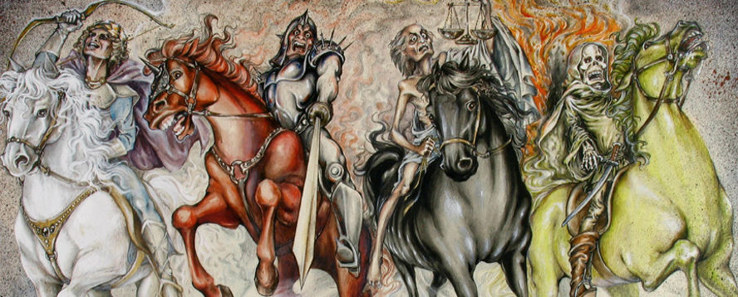
Vision of four horsemen bring woe upon the earth.

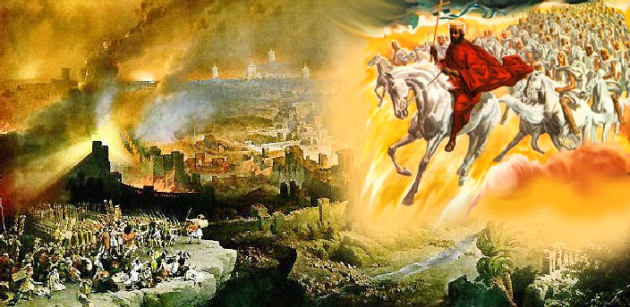
The Word of God comes riding upon a white horse.

