We Obey Jesus

Teach children to be obedient followers of Jesus.

Our Father in Heaven, please use this study to help the children to love Jesus and to obey Him. In Jesus’ holy name. Amen

Choose children's learning activities that fit their ages and needs.

- Let an older child or teacher read from Matthew 7:24-29 a story about wise and foolish builders.
- Ask the children to listen to what happened when two men responded differently to the teachings of Jesus.
- Ask these questions. [Answers appear after each question.]
Which people are like the wise builder? [See verse 24]
How should we respond to Jesus’ words?
[We should put them into practice by doing what Jesus said to do, verse 24.]
Which people are like the foolish builder? [26]
What made the foolish man’s house fall? [27]
Why were the crowds surprised at the way that Jesus taught?
[28-29. Jesus taught with authority.]

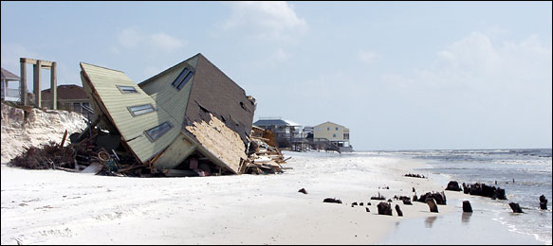
A man built his house on sand. What happened to it in a storm?
Another man built his house on rock. What happened to it in a storm?

- Dramatize the story of the two builders, Matthew 7:24-29.
- Arrange with the leader of the congregational worship to have the children present this drama. Use your time with the children to practice the drama.
- Older children or adults play these parts:
Narrator (Summarize the story and help the children remember their lines.}
Jesus
Younger children play these parts:
Wise builder (have a few blocks, rocks, or bricks)
Foolish builder (have a few blocks, rocks, or bricks)
Storm (Any number of children)
Narrator Tell the first part of the story from verses 24-25. Say,
“Hear what Jesus says.”
Jesus “If you put into practice what I say, you will be like this wise builder here.”
Wise builder Set building blocks on top of each other. Say,
“I build on this solid rock. I am obeying Jesus.”
Storm Blow on the building blocks.
(Do not make them fall, as a wise man’s house stays standing in a storm).
Narrator Tell the second part of the story from verses 25-29. Say,
“Hear what Jesus says.”
Jesus “If you only listen to what I say, you will be like this foolish builder.”
Foolish builder Go a short way aside. Lay building blocks on each other. Say,
“I am only listening to Jesus. I am building on sand. It is easier to prepare.”
Storm Blow on the foolish man’s building blocks and push the blocks over. Say:
“How amazing! Jesus expects people to obey him!
The other teachers only expect people to listen to them talk.”
Narrator Thank everyone who helped with the drama.

- Children might like to copy or colour the picture found at the end of this lesson.
- If the children dramatize this story for the adults, then let them also ask the adults the questions that are listed above, under #1.
- Have children tell some things Jesus has commanded us to do that we should obey.
Let the children give examples.

- Let older children write a song, story or poem.
Or, let them draw pictures illustrating what Jesus said, “If you love me, obey my commands” (John 14:15).

- Draw a Picture of a house on a rock. Let the children copy it.
- Let the older children help the younger ones.
- The children can show their pictures to the adults at the next worship time and explain that this illustrates how to put Jesus’ words into practice. Believers must not merely listen to Jesus’ words; they must do what he said.
- Memorize Luke 11:28.

- Four children each recite one of the verses from Psalm 18:2, 7, 15 and 16.
Let them recite this for the adults, also.

- Let an older child pray:
“Lord, we love to listen to your words. We also love to put them into practice.
We want to be like the wise builder and build our lives on you, our Solid Rock
Thank you, Jesus, for giving us eternal life that no storm or trouble can ever take away.
In Jesus’ name, Amen”

A more detailed drama of the wise and foolish builders, five minutes.
http://biblestoryskits.com/006a-jesus-tells-how-to-build-our-spiritual-foundation/print/

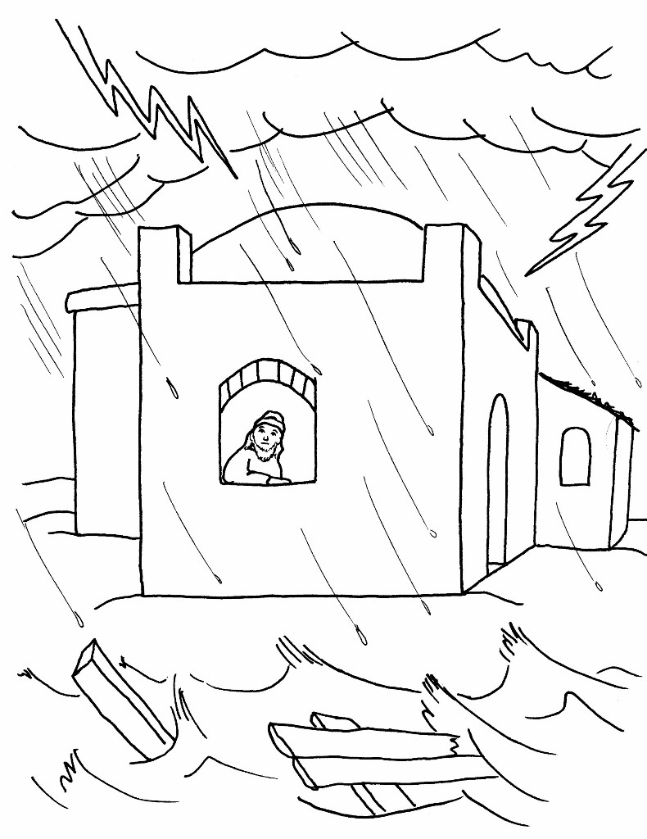
Those who obey Jesus are like a wise man who built his house upon rock.
When storms came, he remained safe in his house.

