Make Disciples in the Way Jesus Said
Anchor command. Make disciples who obey Jesus’ commands. Matt. 28:18-20.
Anchor story. Jesus’ gives his final Great Commission before ascending to glory. Matt. 28:16-20.
Anchor verse. “If you love me, you will keep my commandments.” John 14:15
Learning goal. Memorize Jesus’ Great Commission by heart.
Growth goal. Obey Christ’s general commands out of love.
Skill goal. Make disciples who obey Christ’s general commands above all else.
Outcome goal. All who learner instructs are being and making disciples that obey all of Jesus commands in love.
Basic Study
Our Father in heaven, help me and those whom I lead to obey our beloved Lord and Saviour Jesus Christ, and to make disciples who love Him and obey His commands above and before all man-made rules.
Learn from the story of Jesus giving his Great Commission. Matt. 28:16-20
- What did Jesus’ disciples do when they first saw him on the mountain? Verses 16-17
- With how much authority did Jesus give this final command? 18
- What two things must Jesus’ followers do to make disciples of Christ? 19-20

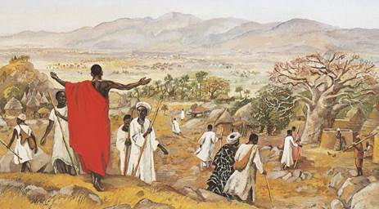

Memorize Jesus’ Great Commission:
“All authority has been given to me in heaven and on earth. Go therefore and make disciples of all the nations, baptizing them in the name of the Father and the Son and the Holy Spirit, teaching them to observe all that I commanded you; and lo, I am with you always, even to the end of the age.” Matt. 28:18-20
- With what authority does Christ command his followers to make obedient disciples?
- What is the main emphasis of Christ’s Great Commission, to learn or to obey?
- Whom are Christians to make obedient disciples of Jesus?
- For how long will Jesus accompany his followers as they make disciples?
Memorize Jesus Great Commission (above).
Memorize also Jesus’ seven general commands that sum up all that he commanded.
1. Repent, believe, and receive the Holy Spirit.
(Mark 1:15; John 3:16; John 20:22)
2. Be baptized.
(Acts 2:38; Matthew 28:18-20)
3. Love.
(Love God, neighbours, believers, the needy and enemies (forgive them),
Matt. 22:36-40; John 13:34-35, Luke 10:25-37; Matt. 5:43-48.)
4. Break bread.
(Lord’s Table, Matthew 26:26-28; John 4: 24)
5. Pray.
(Pray using Jesus’ name, privately and as family devotions, heal in Jesus’ name, and do spiritual warfare, John 16:24.)
6. Give
(of our treasure, time and talents, Luke 6:38; Matt. 6:1-4)
7. Make disciples.
(Witness for Christ, shepherd his flock, apply the Word, train leaders, and send missionaries.)
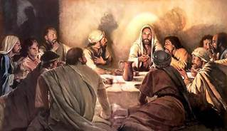
Plan with co-workers the upcoming worship.
- Explain the importance of Jesus’ final, general instructions, or Great Commission.
- Help the believers to memorize the seven basic commands of Jesus (above).
- Explain that these commands are the foundation for all our teaching and ministry.
- Ask the children to dramatize the parable of the wise man who built his house on the rock Jesus, Matthew 7:.24-27.
- Ask for reports from workers who have recently taught believers to obey Jesus’ commands.

Form groups of two or three to pray, confirm the plans and encourage one another.
- To introduce the Lord’s Supper, you might read Acts 2:46. Explain that it is a basic command of Christ. The first believers obeyed Jesus as they broke bread in their homes.
Advanced Study

Discover how Peter and the other apostles made new believers into bold disciples.
Read this review of the birth of the first Christian church:
Jews from all over the Roman Empire heard Peter tell about Christ in Jerusalem on the day of Pentecost. Many as were hostile, but Peter told them: “Men of Israel… Jesus of Nazareth was a man accredited by God to you by miracles… and you, with the help of wicked men, put him to death by nailing him to the cross… But God raised him from the dead… God has made this Jesus, whom you crucified, both Lord and Christ” Acts 2:22-36.
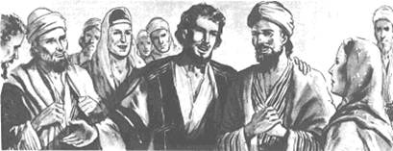
3,000 Jews repented that day, were baptized and were added to the first Christian church, Acts 2:38–41. Amazingly, before Acts chapter 2 ends, those thousands of new believers began obeying all of Jesus’ commands! How did that happen so quickly?
Let us explore what Peter and his companions did to make obedient disciples, so that we can do the same...
Seven weeks before Pentecost, Jesus had risen from the dead, appeared many times to His Apostles for forty days, and gave to them His final instructions. Ten days before Pentecost, Jesus’ Apostles saw him ascend into the sky.
Jesus commanded many things. We can group all his commands under the seven general commands that the first 3,000 new believers began obeying at once, in Acts chapter 2. The only command not mentioned by name in Acts 2 is love, which they showed by their fellowship and sharing.
Like Peter, good disciple-makers teach obedience to all Jesus commands. Complete obedience makes a flock strong, like an unbroken chain.

Tic any of the seven general commands of Christ that your flock needs to obey better:
[ ] Repent, believe and receive the Holy Spirit
[ ] Be baptized
[ ] Celebrate the Lord’s Supper
[ ] Love, which includes serving the needy and forgiving
[ ] Pray, which includes healing and spiritual warfare
[ ] Give
[ ] Make disciples, which includes evangelizing, shepherding and starting new churches.

Additional learning exercises:
- Find in Acts 1:14 what Jesus’ followers were doing when God began His powerful work on the day of Pentecost.
- Find in Acts 2:1-24 what the Holy Spirit enabled the apostles to do, that convinced the Jews who heard Peter’s speech.

Plan with Co-workers Things to Do During the Week
- Ask a creative person to write a song about Jesus’ basic commands, to help folks remember them.
- Visit and instruct any believers who are not yet obeying all of Jesus’ basic commands.
- Explain to them that these commands are the foundation for all ministries.
- Explain that even though men can praise God with their lips night and day, if they do not obey Jesus’ commands in love, then God does not accept their praise, Matthew 14:1-8.

Those who teach children should read study #47 for children.

