Jesus Is the Best Model for Children to Follow
Lord, you have always loved the children everywhere.
Help us to be as compassionate and merciful with them as you are, and to learn from them.

Children’s Prayer
Dear Jesus, we thank you for loving us children, and for showing people how to treat us with kindness. Help us to serve you and do what you say.
- Find how much Jesus cares about children.
Read Mark 10:13-16 or relate it by memory for the children.
If possible, have an older child read it or tell the story.
Ask the children:
- Why did people bring their children to Jesus? (Let the children answer.)
- Who told the people to take the little children away?
- How did Jesus feel when he saw children being sent away?
- What did Jesus say about the children?
- How important is it to welcome children into the worship of Jesus?

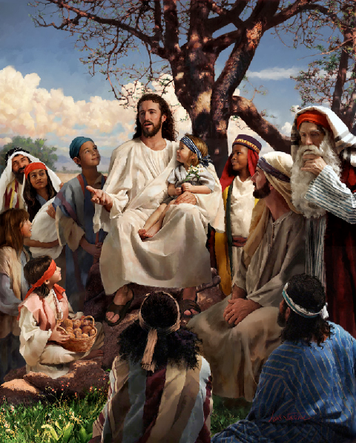

“Jesus took the children in his arms, put his hands on them
and blessed them.” (Mark 10:16)
- Let the children draw a picture of a happy baby to illustrate that Jesus cares about children.
- Let the older children help the younger ones.
- Show the pictures to parents and explain that Jesus loves the little children.
- Children might like to copy or to colour the picture found at the end of this lesson.
- Relive the events of when parents brought children to Jesus.
- Children: Pretend that you are Jesus’ disciples.
What reasons would you tell the parents to prevent them from bringing their children to Jesus? Examples:
“Jesus is too busy.”
“These children are too young to understand his words.”
“You are showing disrespect to our great teacher.”
- Children: Now pretend that you are parents.
Tell reasons you would say for bringing children to Jesus.
- Children: Now pretend you are the children whom Jesus received.
What would you say about Jesus?
- Dramatize the story of the children coming to Jesus (Mark 10:13-16).
- Arrange with the main worship leader to present this brief drama to the adults.
- Older children help younger children prepare.
- Older children or adults play these parts.
Parents
Narrator
Jesus (Seated to one side of the room)
The drama will carry more authority if a few men act as parents.
- Younger children play these parts:
Disciples
Children

Parents: Take Children by the hand and walk toward Jesus. Say,
“Come. Let us see Jesus.”
Narrator Read Mark 10:13.
“They were bringing children to him so that He might touch them;
but the disciples rebuked them.”
Disciples (Stand by Jesus and speak angrily to the parents are bringing children)
“Go away. Jesus is too busy to be bothered with little children.”
(Continue to argue angrily; use your own words.)
Parents (Argue angrily)
”You are keeping our children away from the Lord.
Our children need his attention just as much as the rest of us.”
(Continue to argue angrily; use your own words)
Jesus (Speak forcefully)
“Let the little children come to me, and do not hinder them,
for the kingdom of God belongs to such as these.”
Disciples (Some say) “Lord, you are too busy!”
(Others say) “You cannot waste your time with tiny children!”
(Continue to say such things using your own words)
Jesus (Speak forcefully)
“I tell you the truth; anyone who will not receive the kingdom of God
like a little child will never enter it.”
(Embrace the children.)
Narrator Read Mark 10:16:
“He took the children in His arms and began blessing them,
laying His hands on them.”
Finally, thank everyone who helped with the drama.

- If the children present this drama during the worship time…
- Let the children ask the adults the same question as under #1 above.
- The children might also ask other questions that they prepare, about Mark 10:13-16.
- Poem.
- Have three children each recite a verse from Psalm 127: 1, 4 and 5:
“Unless the Lord builds the house, its builders labor in vain.”
“Sons are a heritage from the Lord, children are a reward from him.”
“Like arrows in the hands of a warrior are sons born in one’s youth. Blessed is the man whose quiver is full of them.”
- Let older children write poems, songs or short stories about…
people loving children, or
older children helping younger children.
- Memorize Mark 10:13-15.
Let younger children memorize Jesus’ words only in Mark 10:14:
“Permit the children to come to me; do not hinder them;
for the kingdom of God belongs to such as these.”

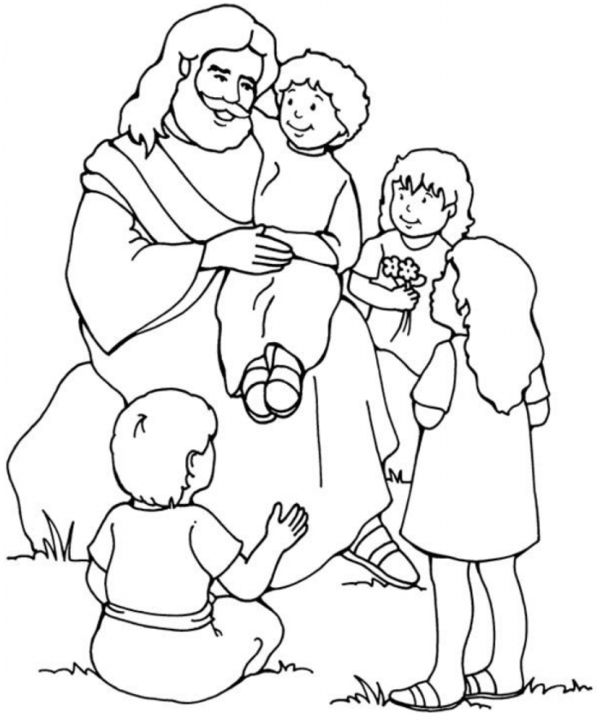
Jesus always welcomed children, and he still does.

