Jesus Found a Thief in a Tree

Help Children to Repent
Father, we thank you that you love us so much. You came to save us even when we were lost sinners. You forgave us, and you fill us with joy, because of your forgiveness. We always want to thank you and show you our gratitude. We want to show you our love by loving other people, too.
Choose among these activities those that fit the children’s ages and needs.
- Older child or teacher: read the story of Zacheus in Luke 19:1–10.
It tells how a man who had stolen money repented when he met Jesus.
Ask: (Answers appear after each question.)
- What job did Zacheus have?
(See verse 2. Tax collectors often charged people too much money for their taxes.
They kept the extra money and got very rich. They were thieves.)
- Why did Zacheus climb a tree? (Verse 3)
- How did Jesus show that he forgave Zacchaeus for being a thief?
- (Verse 5. Jesus went to his house to eat.)
- How did Zacheus feel when Jesus talked to him? (Verse 6. He was glad.)
- Zacheus knew that Jesus had forgiven him. What did he do in gratitude? (Verse 8)
- Whom did Jesus come to save? (Verse 10)

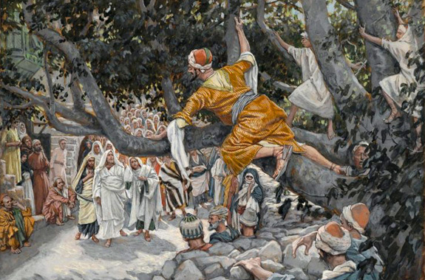
Zacchaeus climbed into a sycamore tree, in order better to see Jesus.
- Draw a picture of a bag of money, and let the children copy it.
Change the “$” symbol to that of the local currency. Children may like to copy or to colour the picture found at the end of this lesson.
Let them show their pictures to the adults during worship, and explain that this illustrates how God changes our hearts, so that loving him becomes more important than money.

- Dramatize the story of Zacheus.
Arrange with the worship leader for the children to present this brief drama during worship.
Use some of your time with the children to prepare the drama.
You do not have to use all of the parts.
Let older children help prepare the younger ones.
- Older children or adults act these parts:
Narrator. Summarize the story and help the children to remember what to say and do.
Jesus.
Zacheus. Hold a bag of stones or paper representing coins.
- Younger children portray People.

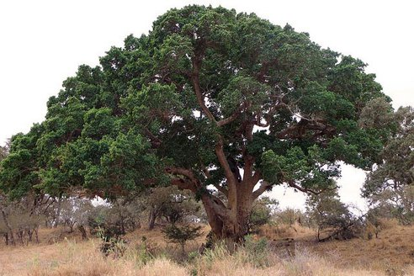
Sycamore tree branches often grow over paths where folk walk.

Narrator: Tell the first part of the story (Luke 19:1–6). Then say,
“Hear what the people say.”
People: (Some say) “Jesus is coming!”
(Others say) “Look at Zacheus. He is climbing a tree!”
(Others say) “He stole my money when he collected my taxes.”
(Others say) “That short, little man is very bad!”
(Others say) “I hope Jesus will punish him!”
Zacheus: Climb up on a chair.
Jesus: Look up and say,
“Zacheus, come down. I will eat at your house today.”
Narrator: Tell the second part of the story (verses 7–10). Then say,
“Hear what Zacheus says.”
Zacheus: Come down from the chair and say,
“Jesus is coming to my house! He forgives me! I am so happy!
I will give back more than what I stole!”
Pretend to hand coins from a bag to the People. Say,
“I will help the poor! Here, I give you this money. Here, take it.”
Jesus: “This is the kind of person I have come to save.
Zacheus was lost, but now he is saved!”
People: (Some say) “Look at the money Zacchaeus gave me!”
(Others say) “How did Jesus change such a thief?”
(Others say) “I want God to forgive my sins, too!”
Narrator: Thank the children and anyone else who helped with the drama.

- If the children dramatize this story of Zacheus for the adults, then let them also ask the adults the questions that are listed under #1 above.
- Ask the children:
“What are other examples of ways that we show our gratitude to God for his forgiveness?” (Let the children give examples.)

- Memorize Isaiah 1:18.
“Come now, and let us reason together,” Says the Lord,
“Though your sins are as scarlet, they will be as white as snow;
though they are red like crimson, they will be like wool.”

- Recite Hebrew poetry:
Let three children each recite one of the verses from Psalm 51:1, 7 and 13.

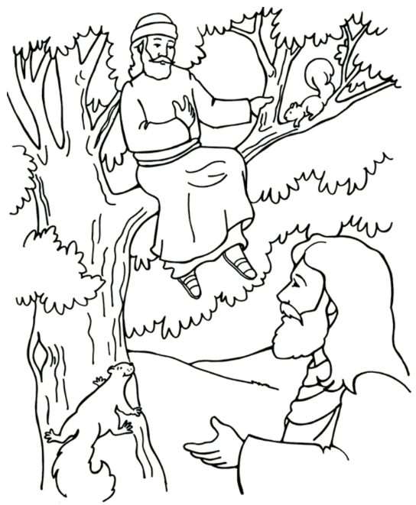
Zacchaeus repented of his wrongdoing, when Jesus came into Zacchaeus’ house.

