God Saved Faithful Noah from Punishment

To accompany teaching on Baptism
We praise you, Father, because by Jesus you have given us a safe shelter from God's righteous punishment, just as you did for Noah, his wife and his children. In Jesus' Name, Amen.
Choose teaching activities that fit the ages and needs of the children.
- Find in Genesis chapters 6, 7 and 8 things about the flood that you consider to be important.
- In 6:5-9, what kind of man was Noah?
- In 6:5-7, why did God destroy with a flood the humans He had created?
- In 6:13-22, how did Noah respond to God's command to build a big boat, called an ark?
- In 7:8-9, what did God bring into the ark besides Noah's family?
- In 8:14-22, what did Noah do that pleased God, after the flood?
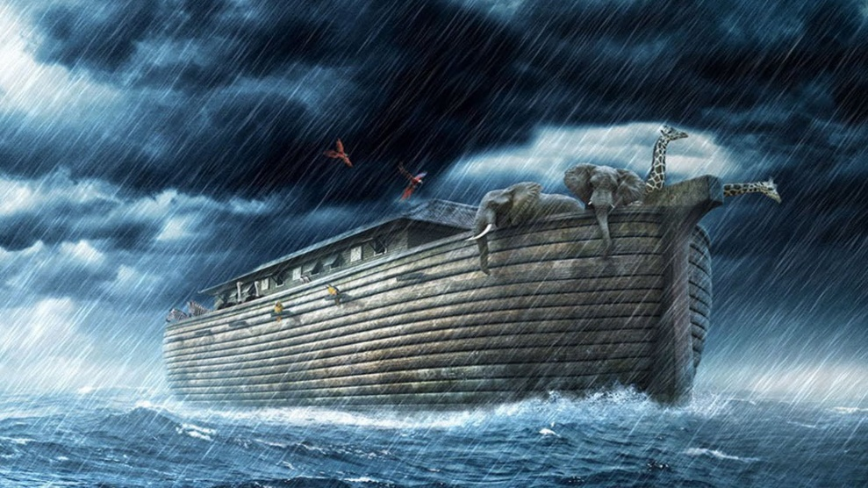
When a great flood came, Noah, his family, and many beasts
were kept safe in a boat that he built.
- Tell the story of Noah and the flood.
You might prepare an older child to do this.
- Dramatize Noah and the animals entering into the ark.
- Arrange with the worship leader to present this drama to the adults.
- Let older children help the younger ones prepare.
- Let the children mention some animals that Noah put into the ark.
(Cows, sheep, monkeys, tigers, dogs, cats, donkeys, kangaroos, rabbits, etc.)
- Have pairs of children choose what animal they will represent.
- Let an older child play Noah, and herd the animals into the ark. They come by twos.
Let Noah tell them, "Hurry! Get in the big boat because a flood is coming!"
- As each pair of animals enter the ark, let them go on hands and knees
or hop if they are rabbits or kangaroos.
- Let the children make the sounds of the animals they represent:
Donkeys bray.
Lions roar.
Tigers growl.
Sheep bleat.
Oxen moo (make horns on their heads with pointing fingers), etc.
Elephants walk bent over, one arm hanging and swaying back and forth like an elephant's trunk.
- Let the children guess what the animals are that the other children portray,
by the way they walk and the sounds they make.
- Pose to the children the queries about the story that are listed under #1 above.
- Let children draw pictures of the animals they played in the drama.
Have older children help the younger ones.
Show the pictures below to the children as example of animals that they can draw.
Tell them that they can draw these animals or any others as they wish.
Some children might like to copy or to colour the picture that is found on the last page of this lesson.
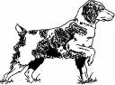 | 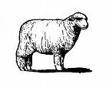 | 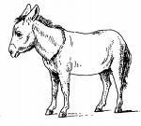
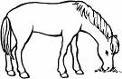 | 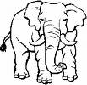 | 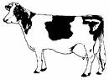
 |  | 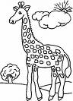

- Have four children each recite one verse from Psalm 32, verses 1, 3, 5 and 7:
“Blessed is he whose transgressions are forgiven, whose sins are covered.
“When I kept silent, my bones wasted away through my groaning all day long.
“Then I acknowledged my sin to you. I said, "I will confess my transgressions to the Lord and you forgave the guilt of my sin.
“You are my hiding place; you will protect me from trouble and surround me with songs of deliverance.”
- If you present the story of Noah and the animals to the adults, then have adults guess what the animals are.
- Also, have the children ask the adults some of the questions under #1, above.
- Let the children draw a picture of an ark on water.
- Ask the children in what ways the ark illustrates how God saves us believers from our sin through Jesus Christ. In what ways is Jesus like the ark?
- Write a short poem or song about Noah and the ark.
Have the children tell or sing what they have written, to their parents at home, and to the adults during worship,’’
- Memorize together Acts 2:38.
“Peter said to them, ‘Repent, and each of you be baptized in the name of Jesus Christ for the forgiveness of your sins; and you will receive the gift of the Holy Spirit’.”
- Let older children write a short story.
- Write about a child whose bad friends try to get him to go with them to steal things from a store. He refuses. They are angry with him and call him bad names.
- They go to the store and police catch them robbing it and lock them in jail.
- The first child visits them and takes them food.
- Let the children add details and finish the story any way they want. The story should illustrate, or serves as an example, how sin must be punished, but Jesus saves us from God's punishment.

More detailed drama, how God saved Noah and his family from a flood, 5 minutes:

http://biblestoryskits.com/005-noah-gods-wrath-and-refuge-in-verse/

