Witness for Jesus in the Power of
the Holy Spirit
Anchor command. “Always be sober-minded, endure suffering, do the work of an evangelist,
fulfill your ministry.” 2 Timothy 4:5
Anchor story. Peter and John witness for Jesus in the face of opposition, Acts chapter 3
Anchor verse. “You will receive power when the Holy Spirit has come upon you, and you will be my witnesses in Jerusalem and in all Judea and Samaria, and to the end of the earth.” Acts 1:8
Learning goal. Know what the New Testament teaches about witnessing for Jesus.
Growth goal. Appreciate the Holy Spirit’s power that comes with the basic gospel message.
Skill goal. Relate the gospel message effectively with the Holy Spirit’s anointing.
Outcome goal. Believers witness to many others for Jesus, in the power of the Holy Spirit.

Basic Study

Dear Lord, help the believers in my flock to use the power that you give them to witness to their friends and relatives, like Peter and the other apostles did
Learn from Peter and John when they were arrested for witnessing for Jesus, Acts chapter 3.
- What did the beggar hope to receive from Peter and John? 3:1-3
- What did Peter and John do for the beggar instead of giving him alms? 4-8
- What was the reaction of the people who saw this? 9-11
- What did Peter remind explain to the people so that they would not think that the man was healed by the power of Peter and John? 12-16
- What did Peter tell the people to do so that their sins would be wiped away? 19
[Peter then told how several Old Testament prophets had foretold Christ, his death and resurrection, and his salvation. The authorities jailed Peter and John, but later freed them, because all the people had seen the miracle of the healing of the crippled man.]
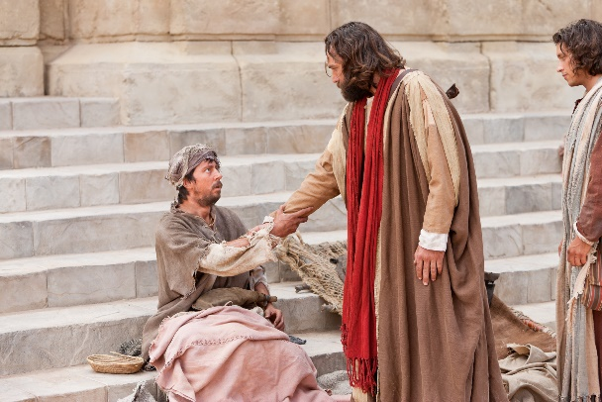
Peter and John heal a beggar in Jesus’ Name
During the week… Pray for power to witness as Jesus said, and visit people who do not yet know Him.
- Pray for people who are lost without Christ.
- Visit believers and ask them who their friends and relatives are, whom they should tell about Jesus. If they want help in doing so, then offer to accompany them and help them to get started.
During worship
- Tell The Story of Peter and John for healing the blind man, and ask the above questions about it. Urge believers to discuss the answers.
- Ask the children to present what they have prepared.
- Memorize Acts 4:33.

Advanced Study
- Seven helps to witness with power
Eyes. Find in John 4:35-39 what God wants us to see.
Lips. Find in Luke 24:46-48 what we are to tell about Jesus.
Hands. (Bible). Find in 2 Tim. 2:2 what we are to do with God’s Word.
Find in Matt. 28:18-20 what we are to teach disciples to do.
Heart. Find in 1 Corinthians 13:1-3 what makes our work effective.
Find in Heb. 11:6 what we need for God to work.
Find in 1 Thessalonians 5:17 what we should do all the time.
Find in Acts 1:8 from whom we are to get power and why.
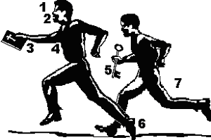
Hand. (keys). Find in Matt. 16:13-19 what Jesus promised to Peter.
Find in Matt. 18:18 who else received this promise.
Find in John 20:22-23 what God does through us.
Feet. (shoes). Find in Eph. 6:15 what kind of shoes God provides.
Find in Isaiah 52:7 why feet are poetically called ‘beautiful.’
Helper. Find in Acts 11:12 how many helpers Peter had.
Find in Acts 13:2-5 how many helpers Paul had.
Find in Luke 10:1 how many travelled together.

Answers
Eyes. Focus on fields that are ready to harvest, that is, people who will repent and believe.
Lips. Proclaim Jesus’ death and life-giving resurrection, and forgiveness to all who repent.
Hands (Bible). Pass on to others what we have heard, and teach believers to obey Jesus.
Heart. Do everything with love, faith and prayer, in the power of the Holy Spirit.
Hands (keys) Jesus promised Peter keys to His kingdom, a symbol of power to forgive sins. Jesus promised this same power to His other disciples. Jesus promised this power to forgive sins, to believers who are filled with the Holy Spirit.
Jesus himself used the ‘keys’ to loosen a paralytic’s sins when He saw the faith of that man’s four friends who had lowered him through the roof so that Jesus could heal him (Mark 2:1-12). Because of their faith Jesus forgave his sins.
We, too, can use the ‘keys’ when we believe with the power of the Holy Spirit that someone will receive Jesus and His forgiveness. Another person’s conversion starts when a believer witnesses for Jesus with power. Then, of course, that other person must also exercise their own faith to complete their conversion.
Feet. Our feet must be shod with the ‘preparation of the Good News,’ which means that we bring to people a joyful message of peace and joy.
Helpers. a) Peter had six helpers when he went to tell the Gentiles about Jesus.
b) Paul and Barnabas, along with their helper John (Mark) were sent from Antioch to other nations.
c) Christ sent out the seventy in pairs (groups of two). Jesus and His apostles normally worked as a small group, not alone.

Where Scripture mentions being filled with the Holy Spirit, or receiving His power, the purpose is to enable believers to do some very practical work for God. For example, the Holy Spirit came upon Samson and he slew a lion, which began a series of events that led to the freeing of Israel from their enemies. The purpose being filled with the Holy Spirit is never simply to provide people with an unusual emotional experience. The only time in Scripture that worshippers jumped and shouted, God had Elijah slay them (1 Kings 18:25-40).
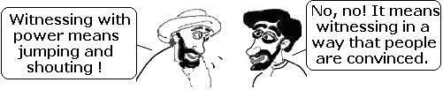
Filling of the Holy Spirit

Plan with your co-workers additional activities for the upcoming worship time
- Explain the seven helps to witness with power (above).
- To introduce the Lord's Supper, read John 21:9-14 and explain that Jesus now bids us to eat with him and with each other.
- Let believers report about how they have recently witnessed for Jesus with power.
- Form groups of two or three: pray for one another, plan and encourage one another.
Those who teach children should read study #53 for children.

