How Sin Entered the World
Anchor command. Consider yourselves to be dead to sin, but alive to God in Christ Jesus. Therefore do not let sin reign in your mortal body so that you obey its lusts. Romans 6:11-12
Anchor story. Adam and Eve, Genesis 1:26-28; 2:18-25; 3:1-24
Anchor verse. Romans 5:12. “Just as through one man sin entered into the world, and death through sin, and so death spread to all men, because all sinned.”
Learning goal. Know what Adam and Eve did to bring about the fall of all mankind.
Growth goal. You, your family and friends know the account of Adam and Eve and their fall.
Skill goal. Believers accurately and powerfully recount the historical account of original sin.
Outcome goal. Believers crucify the works of the flesh and their desire to sin that they have inherited from Adam.

Basic Study
Lord Jesus, You died to deliver us from the consequences of our sin. Please, help us to face up to our sinfulness and to live by your victory over sin. Amen.
Learn from the account of Adam and Eve, Genesis 1:26-28; 2:18-25; 3:1-24…
- In whose image was Eve created? Genesis 1:26-28
- Describe how God created Adam’s wife Eve, 2:18-25.
- Describe how the serpent deceived Eve, 3:1-6.
[According to Ezekiel 28:12-17 and Revelation 12:9, when Satan first appeared to Eve, he was a dragon with feet, and perfect in beauty.]
The devil tempted our first parents by through a creature called serpent or dragon.
- Describe what Adam and Eve became aware of at once when they disobeyed God. 3:7
- Describe the curse that God put upon Adam and Eve, and the human race. 3: 13-24.
During the week… you and your co-workers visit new believers and explain how sin originated
During worship tell the story of Adam and Eve, Genesis 1:26-28; 2:18-25; 3:1-24, and ask the above questions. Encourage the believers to discuss the answers.
Ask the children to present what they have prepared.
Memorize 1 John 2:28: Now, little children, abide in Him, so that when He appears, we may have confidence and not shrink away from Him in shame at His coming.

Advanced Study
- Learn how, like Adam, we have all sinned and our sin made us guilty, caused shame, and held us in bondage.
The Bible teaches that everybody is born with sin, all are sinners, and every one of us commits sins (1 John 1:8-10).
Find in Genesis 3:1–9 where sin came from:
- What lie did the devil tell to our first ancestors? [Verses 4 & 5]
- What punishment did God announce against the devil? [Verses 13–15]
- What punishment did God announce against our ancestors? [Verses 16–19]
God banished Adam and Eve from his garden.
Find in Psalm 51:1–5 what King David said about his sin:
- What did he recognize to be his need? [Verses 1 & 2]
- What did he say about his sins? [Verse 3]
- Against whom did he commit sin? [Verse 4]
- When did he become a sinner? [Verse 5]
- Find in Hebrews 12:1–4 how dangerous our sin is:
- How apt are we believers to commit sins? [Verse 1]
- What did Jesus endure on the cross because of our sins? [Verse 2]
- What can happen to us because of other sinners? [Verse 3]
- Why do we sometimes yield to sin? [Verse 4]
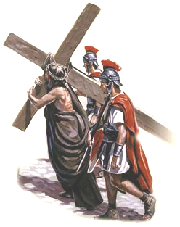
Jesus suffered and died as a sacrifice for our sins.
- Our sins bring three terrible results: guilt, shame and bondage:
- 1) Guilt. We are guilty before God.
- Like a criminal who is tried in a court of law and condemned by a judge, so we must give an account to God for our sins. Fortunately, Christ took our sins to the cross where he died in our place. Thus, God forgives all the sins of those who trust in Jesus.
- 2) Shame. We suffer shame before God.
- Like a person who has been caught in the act of doing something shameful, so we humans can suffer great shame before God when he will reveal all the sins of everyone at the Final Judgment. But — thanks to God — Jesus Christ suffered public shame in our place, so that, when he returns, we will not be put to shame.
- 3) Bondage. We come into bondage to sinful practices.
- Like an alcoholic who cannot stop drinking, and whose family is destroyed by his drinking, so we all become addicted to sinful things like alcohol, drugs, magic, false gods, immoral activities, and illicit relationships. But God be praised! When Jesus died on the cross for us, he destroyed the power of the evil one and provided freedom from our bondages.
- Plan with your co-workers additional activities for the coming week.
Discuss together your congregation’s member’s need to be forgiven and freed.
Which members need to embrace God’s forgiveness of the sins they have committed? Go visit them, help them to confess their sins, serve communion to them, and pray with them to know forgiveness.
Which members still feel ashamed of their former way of life? Go visit them, explain how Jesus was put to shame for them, and pray for them to overcome their shame.
Which members need to overcome addictions? Go visit them, help them to renounce their bad habits, assure them of your continued watch-care and pray for their freedom.
- Plan with your co-workers additional activities for the up-coming worship.
Explain what David said about his sin and ask the second set of questions listed under # 1, above.
Explain briefly the truths from Romans 3:19–23, 1 John 5:16–19 and Hebrews 12:1-4 mentioned above, and ask the same questions.
Let believers who recently found freedom from bad habits or demons give testimonies.
Read or act out Acts 19:11–20. Then explain how the people confessed their sins and abandoned their bondage to magic. Thus, they were forgiven, overcame their shame, and were freed from their bondage to evil spirits.

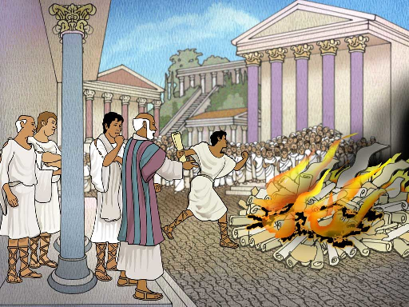
At Ephesus, those who repented and believed burned their scrolls about magic.

To introduce the Lord’s Table, read Genesis 3:6-10 and verse 21. Explain that Adam and Eve tried to cover their shame with fig leaves. But God clothed them with animal skins because our sins must be hidden from God’s sight with the blood of an innocent victim. The animal sacrifices foretold Jesus the Lamb of God who took away all sins.
Form small groups of two and three. Let them confess any public sins and pray for each other’s forgiveness and freedom.
Memorize together Isaiah 1:18.

