Jesus’ Resurrection Gives Life
to Believers
Anchor command. “Thus it is written, that the Christ would suffer and rise again from the dead the third day.” Luke 24:46
Anchor story. Jesus proves that he is “The Resurrection and the Life” by raising Lazarus from the dead. John 11:1-53.
Anchor verse. “[God] raised [Jesus] from the dead and seated him at his right hand in the heavenly places.” Ephesians 1:18-20
Learning goal. Discover what Scripture teaches about Jesus resurrection and what it does for believers.
Growth goal. Cling to God’s promises that we believers will be raised in Christ, as part of his eternal Body.
Skill goal. Tell others about Jesus’ resurrection in a convincing way that they can repeat it to others.
Outcome goal. Believers are strengthened in their spirit and encouraged, knowing that in Christ they are already risen in God’s sight.
Choose any or all of these learning activities.

Basic Study
Dear Lord Jesus, help us to appreciate how your powerful resurrection assures us of our being raised with you, as part of your eternal Body.

Learn eternal truth from the account of Jesus raising Lazarus from the dead, John 11:1-53.
- What message did Mary and her sister Martha of Bethany send to Jesus? Verses 1-3
- What did Jesus tell his disciples about Lazarus? 11-14
- What did Jesus promise Martha about her dead brother Lazarus? 21-23
- What was the assurance that Jesus gave to Martha? 24-27
- What did Jesus do when they showed him Lazarus’ tomb? 31-35
- What did Jesus do that proved that he had the power to raise the dead? 43-44

During the coming week, visit believers who have recently lost a loved one, or are themselves facing death, and assure them of their resurrection in Christ.
Note: believers have already been raised in the sight of God, the eternal I AM. Ephesians 2:6)

During worship, relate the account of Jesus raising Lazarus, and its assurance for believers, that Christ will also raise us from the dead.
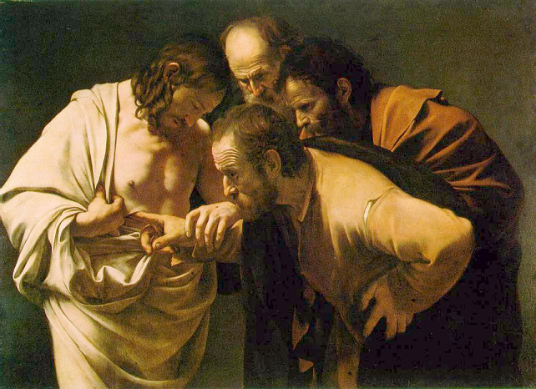
After Jesus rose bodily from death back to life, he appeared to hundreds who knew him,
proving that it was he and that he was alive.

Advanced Study

Learn eternal truths from the accounts of Jesus’ resurrection and his assurances of our resurrection.
- Find in John 5:25-29 who will be raised from the dead, and two different resurrections.
- Find in Psalm 16:10 a prophecy of Christ’s resurrection.
(The word sheol found in some Bibles means grave or death).
- Find in 1 Peter 3: 18-21 how Noah’s Ark resembled Christ, in whom believers rise from the dead.
- Find in 1 Corinthians 15…
- To how many people did Christ appear after rising from the dead? Verses 15:3-6
- How did the Apostle Paul describe the contrast between Adam and Jesus? 20-23, 45
- In what ways do our resurrection bodies differ from our earthly bodies? 39-44
- Find in Revelation 21:1-6 what it will be like for us in heaven.
- Find in Revelation 22:1-5 several wondrous things that we will experience in glory.

Plan with your co-workers additional, optional activities for the upcoming worship.
- Prepare and act out one of these 5-minute dramas about Jesus’ resurrection:

http://biblestoryskits.com/028-jesus-rises-from-the-dead-as-seen-by-angels/

http://biblestoryskits.com/029-jesus-appears-to-many-after-rising-from-death/
- Let the children present what they have prepared.
- Gather in groups of two or three and pray, praising God for his promise to raise us from the dead to be with Christ forever in glory.

Those who teach children should read study #56c for children.

