Congregations Cooperate in Vital Projects
Anchor command. “Through love serve one another.” Galatians 5:13
Anchor story. Nehemiah rallies the Jews to rebuild Jerusalem’s demolished walls.
Nehemiah chapters 1 and 2 with 4:11-21
Anchor verse. “Let us arise and build.” Nehemiah 2:18
Learning goal. Find in the example of Nehemiah how to mobilize to work efficiently for the Lord.
Growth goal. Believers see that God’s work is much more than what is done during worship.
Skill goal. Leaders mobilize workers to implement worthy projects during the week.
Outcome goal. Believers carry out evangelistic and pastoral endeavors in the power of the Holy Spirit.

Basic Study

Dear God, please use this study to inspire
the congregations of our region to work together.
Learn from the story of Nehemiah rebuilding Jerusalem’s walls…
- How fervently Nehemiah prayed to God, to launch the rebuilding project. Nehemiah 1:3-11 & 4:11-21
- The king gave Nehemiah permission to go and rebuild Jerusalem’s walls. When Nehemiah arrived, who began to oppose him? 2:10
- Before beginning the project, what did Nehemiah do to find out how to go about it? 2:11-16
- Nehemiah assured the builders that God was with them, and they had a mind to work. What was their response? 2:17-18

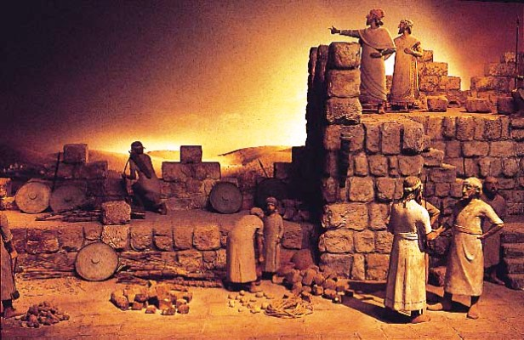
Jews who returned from Babylon rebuild Jerusalem’s wall

- What did the builders enemies plan to do? 4:11
- What did the Jews who lived near the walls fear? 4:12
- What did Nehemiah have the builders do, to protect themselves? 4:13-20
- What two things did the workers hold, one in each hand? 4:17
- Nehemiah portioned out the work so that each worker had his own responsibility, and built according to his particular skill. How does this compare with the way believers are to use their different spiritual gifts (1 Corinthians 12:4-11)?
During the week…
- Ask questions to find out needs of your community and of congregations in other places.
- Meet with leaders of other flocks; plan to work together and send help to other needy places.
- Follow Nehemiah’s steps to organize and complete a great project for God.
During worship
- Relate the story of Nehemiah rebuilding Jerusalem’s walls, and ask the same questions as above. Urge the believers to discuss the answers
- Ask the children to present what they have prepared.
- Memorize together 2 Chronicles 7:14.

Advanced Study
Nehemiah organized the Israelite clans to rebuild Jerusalem’s walls; each clan had its own area of responsibility. Nehemiah first surveyed the damage and made plans, then provided armed protection.
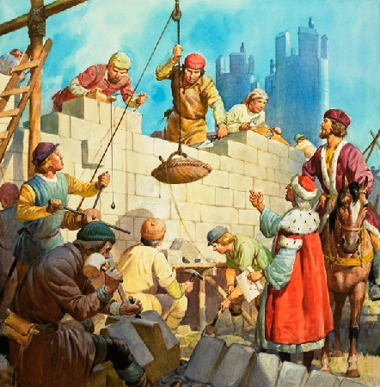
Nehemiah led everyone to work in well-coordinated harmony

Prepare yourself with prayer and God’s Word.
Find in 2 Chronicles 36: 15-23 what happened many years before Nehemiah’s time to the city of Jerusalem, and why.
Many years later the Israelite captives in Babylon began to go back home with the help of the Persian king Cyrus. Nehemiah took six steps to begin rebuilding Jerusalem’s walls.

Step 1) Define the need and the objective.
- In Nehemiah chapter 1, Nehemiah faced up to the suffering in Jerusalem.
- Nehemiah first learned about the damage in Jerusalem by asking questions. How did he respond to what he heard? (See verse 4)
- Nehemiah confessed the sins of his people that had brought so much trouble to his country. Whose sins did he include? (See verse 6)

Step 2) Pray for wisdom as you investigate the facts.
- In chapter 2, Nehemiah prepared himself to help the people of Israel.

Step 3) Delegate well-defined responsibilities.
- In chapter 3, Nehemiah managed a huge task, so that everyone could participate according to their ability.

Step 4) Handle opposition and injustice firmly.
- In chapter 4, Nehemiah met opposition. He prayed. Everyone worked hard. He gave attention to the weak areas. He urged workers to trust God, and each one to do their own part. He and his men set an example of complete dedication.
- In chapter 5, this godly leader brought justice to God’s people.
- Nehemiah and the people stopped several injustices voluntarily (See verse 7 and 15).

Step 5) Stand firm against lies and criticism.
- In chapter 6, Nehemiah and the workers persevered in this project, which glorified God.
- Nehemiah avoided being distracted and intimidated by his enemies. (See verses 11-14.)
- The wall had been broken down for almost 100 years. In how many days was the wall rebuilt with God’s help? (See verse 15.)
- What did this teach their enemies about Israel’s God? (See verse16)

Step 6) Give the glory to God for the completed project.
- In Nehemiah 8:2-12 and 9:1-5 God poured out many blessings on his people.

Plan with co-workers the upcoming worship time.
Pray during the worship. Confess sin to God. Ask Him to show you the needs of others. Ask God to unite Christians from different flocks, to work together to serve Him.
Praise God for ways that Christians have worked together to serve the needs of people outside of their own flock. Ask for testimonies and reports of work done last week.
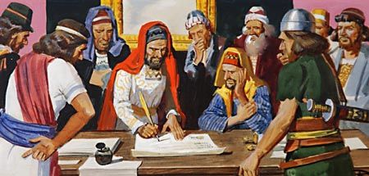
Nehemiah’s enemies plotted to get the government to stop his work
Dramatize the way that Nehemiah dealt with opposition to his project.
Nehemiah: “God will help us rebuild the walls of our city.”
Sanballat: Sneak up behind Nehemiah, who turns suddenly.
Say “Stop your work. It is too much for you.”
Nehemiah: “God gave me this task to complete. Go away.”
Sanballat: “You can never succeed. Come with us.
We need you for a very important meeting.”
Nehemiah: “We are doing a great work. I cannot stop. Why should the work cease while I go to a meeting?”
Sanballat: “You are taking too much risk here!”
Nehemiah: “God will protect us.”
To introduce the Lord’s Supper read Nehemiah 2:1-5. Explain that Nehemiah brought a cup to the king, but as we come to the table of the Lord, our king Jesus brings His cup to us. His blood brings us forgiveness of sins and a relationship with God our King.
Announce the activities that you planned to do during the week, to pray and organize people so that they can serve God together to meet whatever challenge they have found.
Help one another in groups of two or three. Pray, confirm plans to work with other congregations in projects that are needful, and encourage one another.
Those who teach children should read study #63 for children.

