We Confess to God the Bad Things
that We Have Done
The Ministry of John the Baptist
Dear Lord, help each child to confess their sins to you, so that you will break their chains of sin, free them from shame and bad habits, then cleanse the conscience of each girl and boy. Hear us, forgive us, and bring peace to our hearts.
Choose activities that fit the ages and needs of the children.
- Let an adult or older child tell how John the Baptist helped people to confess their sins to God and be forgiven.
To prepare to teach, read Matthew 3:1-12 and Luke 3:10-18.
After telling the story, ask the children:
Where did John the Baptist teach the people? [Matthew 3:1]
What did John tell the people to do? [Matt. 3:1]
What two things did they do to show that they had repented? [Matt. 3:6]
What does ‘repent’ mean? [Turn from our sins and obey God]
What did John call those who thought they were too good to need to confess their sins?
[Matt. 3:7-11. He called them snakes, refused to baptize them, and warned them of coming judgment.]
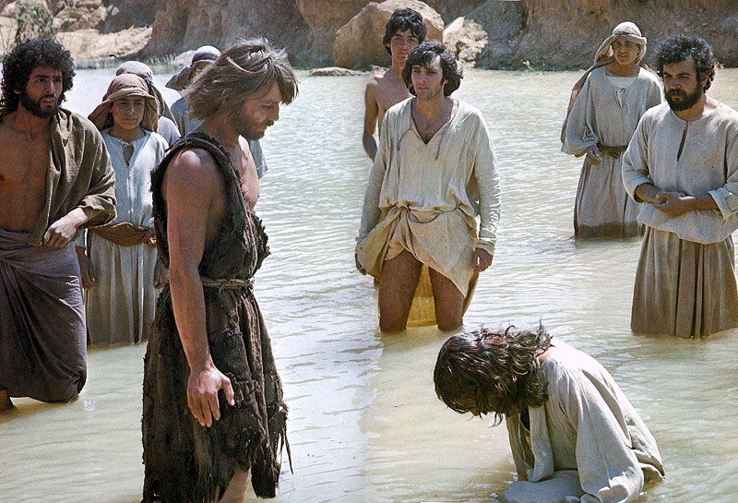
John would baptized everyone who confessed their sins.
Whom did John mean when he said, “He who is coming after me is mightier than I?”
[He meant Jesus]
What did John say that Jesus would do?
[Matt. 3:11-12. Jesus would baptize people who repent with the Holy Spirit,
and bring judgment and punishment on those who do not repent.]
What did John tell the crowds to do to show that they had repented [Luke 3:10-11]
What did John tell greedy tax collectors to do after he baptized them? [Luke 3:12-13]
What did John tell soldiers to do? [Luke 3:14]
- Dramatize parts of the story of the people who confessed their sins:
Arrange with the worship leader for the children to present the drama to the adults.
Rehearse the drama during your teaching time with the children.
Let older children help younger ones to prepare.
Adults or older children play these parts:
Pharisee
John (the Baptist, not the Apostle)
Narrator
Girl.
Smaller children play these parts:
Tax collector
Soldier
People from Judea (any number).
Narrator Tell the first part of the story, from Matthew 3:1-12. Then say,
“Hear what a repentant girl from Jerusalem says.”
Girl “We who live in Judea and Jerusalem have done many bad things.
But we want to change and obey God. I confess my sins.”
John “God has forgiven you. Come and be baptized.”
People from Judea (Some say) “Why are so many people going out to see John the Baptist?”
(Others say) :Let’s go and see.”
Pharisee [Speak proudly.]
“We Pharisees are religious leaders and live good lives.
We will receive baptism because we have earned God’s favor
by doing good works!”
John "You brood of vipers, who warned you to flee from the wrath to come?
Go and bear fruit that shows that you have changed and obey God!”
Narrator Tell the second part of the story, from Luke 3:10-18. Then say,
“Hear what a greedy tax collector says.”
Tax collector “We have done selfish and bad things.
What should we do?”
John “Collect no more money than what you have been ordered to.
You have confessed your sins. God has forgiven you.
Come and be baptized.”
Soldier "And what about us soldiers, what shall we do?
We also have sinned much.”
John “Do not take money from anyone by force, or accuse anyone falsely,
and be content with your wages.
You have confessed your sins. Come and be baptized.”
People from Judea “Praise God for his wonderful grace and forgiveness!”
Narrator Thank everyone who helped with the drama.

- If the children present this drama to the adults, then let them ask the adults the questions under #1 above.
- Draw pictures of a fire that the children can show to the adults during worship.
Let them explain that when Jesus raises the dead, it will be like harvest time:
the wheat is separated from the chaff. The wheat is gathered into the barn,
but the chaff is burned up. Believers will live with Jesus forever.
Some children might like to copy or colour the picture found at the end of this lesson.
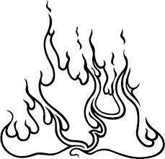
- Three children recite these verses from Psalm 51:
Wash me thoroughly from my iniquity
And cleanse me from my sin.
For I know my transgressions,
And my sin is ever before me.
Against You, You only, I have sinned
And done what is evil in your sight,
Behold, I was brought forth in iniquity,
And in sin my mother conceived me.
Purify me with hyssop, and I shall be clean;
Wash me, and I shall be whiter than snow.
Create in me a clean heart, O God,
And renew a steadfast spirit within me.
- Let older children write poems or a song about confessing our sins and being forgiven.
- Memorize Psalm 51:10":
“Create in me a clean heart, O God, and renew a steadfast spirit within me.”
A more detailed drama, about John the Baptist and his baptism of repentance:
http://biblestoryskits.com/002-john-baptizes-jesus-and-the-three-that-are-one-take-part/

