The Spread of Christianity between
400 and 1600
Anchor command. “I testify to everyone who hears the words of the prophecy of this book: if anyone adds to them, God will add to him the plagues which are written in this book; and if anyone takes away from the words of the book of this prophecy, God will take away his part from the tree of life and from the holy city, which are written in this book.” Revelation 22:18-19
Anchor story. God prepared Martin Luther to initiate the Protestant Reformation.
Anchor verse. “Fight the good fight, keeping faith and a good conscience, which some have rejected and suffered shipwreck in regard to their faith.” 1 Timothy 1:18-19
Learning goal. Find how God has used godly reformers through the Middle Ages to keep his church true to its original foundation.
Growth goal. Appreciate how God kept the torch of truth burning throughout centuries of ignorance and conflict.
Skill goal. Correct false teaching firmly, without being combative and argumentative.
Outcome goal. Believers have the same zeal and purpose as Martin Luther and other reformers, to keep the church and its doctrine true to God’s revealed truth.
Lord Jesus, help us to learn from history how you bless peoples and nations.

Basic Study
Learn from the historical summary of Martin Luther and the Protestant Reformation.
In the 16th century, Christians in Europe gave much devotion to saints, images and relics, and had very little knowledge of the Word of God. The Pope began building St. Peter’s magnificent cathedral in Rome. To raise the needed funds, he authorized representatives to travel throughout Europe offering indulgences for those who contributed. Those indulgences granted less time spent suffering in purgatory. Martin Luther, a well-educated, deeply conscientious and fearless German monk, found the Church’s teaching about indulgences and purgatory to be contrary to Scripture.
Luther challenged Tetzel, a representative of the Roman Pope, to a public debate, and nailed 95 theses (discussion points) to the door of the Wittenburg town church, on October 31, 1517. Enterprising printers distributed copies of Luther’s challenges throughout Germany and beyond. This sparked widespread controversy, fueled by several reformers that held to the truth of Scripture.
Luther did not intend to bring about division in Christ’s church, but merely to reform it. However, the Roman catholic Pope excommunicated Luther, which separated Luther’s followers, called Protestants, from the Roman Catholic Church.
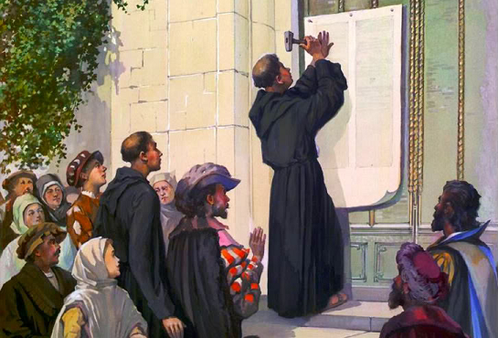
Martin Luther nails to a door his 95 theses for debate.
At great risk to his own life, Luther continued to defend his biblical views. While hiding from officials who would have taken his life or imprisoned him, he translated the Bible into the German language so that the people could read God’s word. Before this, only priests had access to Bibles, and they were in the ancient Latin language, which the common people did not understand.
Because so many Christians had become separated from the Roman Catholic Church, it began its own Counterreformation to oppose the Protestants. This had some good results within the Roman church; it eliminated some offensive abuses and focused more strongly on the gospel of Christ.
Three foundational Christian truths came out of the Reformation:
Salvation is only by faith on man’s part;
Salvation is only through grace on God’s part,
God’s Infallible truth for mankind is found only in Scripture.
Remember: “By grace alone, through faith alone, according to Scripture alone.”
During this week
- Prayerfully discern any errors in Christian teaching or practice that are prevalent in your area, plan how you and the believers will emphasize God’s truth in a positive way.
- Meet with novice shepherds whom you train and teach them about church history from this study or about another topic that they need. Use the Paul-Timothy Leadership Training menu.
During the coming worship
- Tell the story of Martin Luther and lead believers in prayer, asking God to keep his church free from error and focused on the risen Christ.
- Ask the children to present what they have prepared.
- Memorize together Matthew 10:32.

Advanced Study

Prepare yourself with prayer and the Word to teach your flock about the ancient history of Christianity.
Find in Acts 19:11-28 what happened when Christianity confronted idolatry.
- What did God do to honour Jesus? [See verses 11 & 12]
- What happened when unbelievers tried to use Jesus’ name to cast out demons? [13–17]
- What should believers do who used to practice magic? [18–20]
- What will pagan priests and religious people try to do? [21–28]

Christianity from AD 400 to 800
As Asians moved westward, pagan peoples invaded the Roman Empire, weakening it. This had several effects on Christianity:
- Pagans learned the good news and many became believers.
- Monasteries, not churches, became centres of faith and learning.
- The Celts in Ireland started monasteries that focused on Christ; they also sent workers who evangelized across Europe.
- The Celts practiced and taught literacy, translating the Bible and other books.
- Christian communities were started in South Asia.
- Nestorian Christians established monastic schools in Central Asia.
- Roman emperor Charlemagne promoted Christianity and justice in the 8th century.
- Nestorian Christianity prospered in China until the year 845.

Find in Matthew 24:6-14 what Jesus said his followers would face in the world.
- What would happen between nations? [See verses 6 & 7]
- What would happen to Jesus’ followers among the nations? [9]
- What would many people do who have heard about Christianity? [10]
- What would cause many people to turn away? [11 & 12]
- What would most Jesus’ true followers have to do during those times? [13]
- And what would happen to the gospel? [14]

Christianity from AD 800 to 1200
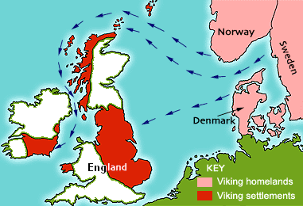
Viking raiders destroyed much of European Christianity. However, many Vikings heard the gospel from their captives, and later became Christians
Vikings from the North invaded the centres of wealth in Europe, destroying the monasteries. Later, Islam invaded Asia and Europe. This had several effects on Christianity:
- Vikings took many Christian captives and learned the gospel from them.
- Christianity again began spreading through Europe.
- Many kings and people groups became Christians, at least in name.
- Christianity was more widespread across Asia than in Europe.
- Islam tolerated Christianity for a while, but has severely suppressed it to this day.
During this age, Nestorian Christians became effective missionaries to many Asian peoples and nations, because they did these things:
- Most of their mission workers were self-supporting businessmen and merchants.
- They depended on God to give visions and work miracles to convince unbelievers.
- They set up educational and medical services in many places.
- They set up monasteries in dangerous places.
- They provided on-going training and oversight to shepherds and flocks.
However, much of the Nestorian’s work was later destroyed because of these errors:
- They failed to translate the Bible into local languages.
- They did not allow local people to lead their own churches.
- They did not allow local Christians to worship with their own cultural forms.
- Many who call themselves Christians were unconverted, nominal church members who lived for wealth and power.

Christianity from AD 1200 to 1600
Christian leaders in Europe and Asia did not allow the Bible to be translated, read by ordinary people or obeyed. This had several bad effects on Christianity.
- Kings and popes mixed politics with religion to increase their wealth and power.
- Between 1095 and 1350, Europeans conducted crusades against Muslims, Jews and Asian Christians, slaughtering many and seizing their land.
- Much of Central Asia converted to Islam when defeated in war.
- Nestorian Christianity in China was wiped out by the Ming dynasty from AD 1368.
- Muslim emperor Tamerlane (1336-1405) wiped out most of Christianity in Asia.
- Martin Luther, starting in 1517, challenged both Kings and Roman Catholic hierarchy, in order to restore the church to its original biblical foundation.
- Franciscan and Dominican Christians sought peaceful ways to do mission among Muslims.

Plan with your co-workers additional activities for the up-coming worship.
Explain how believers shared the Good News in the middle 400 years of Christian history (AD 1200 – 1600).
Let believers testify about how God has helped them remain true to him during times of persecution or rejection.
To celebrate the Lord’s Table, read Revelation 20:4 and briefly explain that Jesus was a martyr and all who die for him will reign with him.
Let small groups of two and three plan, pray and encourage one another.
Those who teach children should read study #67 for children.

