We Serve Others Because We Love Them
Know the Difference between those that Jesus
called ‘Sheep’ and ‘Goats’
Our Father in Heaven, please use this study to encourage the children to serve others in love.”
Choose any of these children's learning activities.
- An older child or teacher tells the story of the sheep and the goats, Matthew 25:31-46.
It tells how God decides whether or not people belong with Him.
After telling the story, ask:
Who will judge people and separate them like sheep and goats? (Answer: verses 31- 32)
What did the ‘sheep’ do to show their love for God? (35)
How did the ‘goats’ treat people who were in need? (42)
Whom do we really serve when we help other people in need? (40)
What will happen at the judgment to those who do not love others? (46)
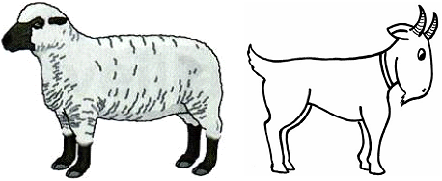
- Dramatize parts of the story of the sheep and goats from Matthew 25:31-46.
Older children or adults play these parts:
Jesus
Narrator (Summarize the story and help the children remember what to say.)
Younger children play these parts:
Sheep
Goats
People (who need help).
Narrator Tell the first part of the story (Matthew 25:31-40). Say,
“Hear what people say”
People (Some say) “Please help me.”
(Others say) “I am hungry.”
(Others say) “I need clothes.”
(Others say) “I am thirsty.”
(Others say) “I need a place to sleep.”
(Others say) “I am sick.”
Narrator “Hear what the sheep say.”
Sheep “Come. We will help you, because we love Jesus.”
Jesus “I will now separate the sheep from the goats.
Sheep, come here with me.
You are blessed, because you fed me and clothed me and helped me.”
Sheep “When did we do that? We never saw you in need.”
Jesus “Whatever you did for one of these poor people, you did for me”.
Narrator Tell the second part of the story (Matthew 25:41-46). Say,
“Hear what people say.”
People (Some say) “Please help me.”
(Others say) “I am hungry. “
(Others say) “I need clothes.”
(Others say) “I am thirsty.”
(Others say) “I need a place to sleep.”
(Others say) “I am sick.”
Goats “Go away! I will not help you.”
Jesus “Goats, go away from me!
You did not help me when you saw me in need.”
Goats “When did we see you in need?”
Jesus “Whenever you neglected someone in need, which is how you treated me, also.”
Narrator Thank all who helped with the drama.

- Arrange for the children to present the drama during the worship time.
- Ask the adults the questions that are listed under #1, above.
- The children present anything else that they have prepared.
- Ask the children in what ways we can serve God by serving people in need.
Let them give examples.
- Draw a picture of a bowl of food.
Let the children show their pictures to the adults at the next worship time,
and explain that this illustrates how we serve God by serving one another in love.
Some children might like to copy or colour the picture found at the end of this lesson.
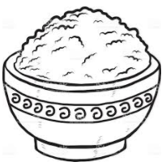
- Memorize 1 John 4:19-20.
- Let three children recite these verses from 1 Corinthians 13:1, 4-5 and 6-8:
If I speak in the tongues of men and of angels, but have not love, then I am only a resounding gong or a clanging cymbal
Love is patient, love is kind. It does not envy, it does not boast. It is not proud. It is not rude, it is not self-seeking. It is not easily angered, it keeps no record of wrongs.
Love does not delight in evil but rejoices with the truth. It always protects, always trusts, always hopes, always perseveres. Love never fails.
- Optional activities for older children:
Write a poem, song or short story, or give an example of what they have seen happen, that shows how people serve the needy in love.
They might do this at home, or during the week in small groups.
- An older child prays:
“Lord, we thank you for showing to us what true love is. Help us to love each other like you love us. We want to show our love to you by serving other people who need help. Help us to remember that when we serve others, we are showing you our love for you.”
A more detailed drama, dealing with Jesus separating the sheep from the goats:
http://biblestoryskits.com/021-jesus-parts-sheep-from-goats-that-lack-practical-love-3/

