Show Compassion to Others
Anchor command. “Whoever has the world's goods, and sees his brother in need and closes his heart against him, how does the love of God abide in him? Little children, let us not love with word or with tongue, but in deed and in truth.” 1 John 3:17-18
Anchor story. Jesus compares how two wealthy men dealt with debtors. Matthew 18:21-35.
Anchor verse. “In Joppa there was a disciple named Tabitha (which translated in Greek is called Dorcas); this woman was abounding with deeds of kindness and charity, which she continually did.
Acts 9:36
Learning goal. Grasp God’s standard for showing compassion to less fortunate people.
Growth goal. Churches mobilize many to serve the needy and the sorrowful.
Skill goal. Leaders thoroughly integrate mercy and pastoral ministries.
Outcome goal. Believers are serving the discouraged and the needful with loving compassion.
Heavenly Father, we need you to enable us to forgive and help others, including our enemies, as you have forgiven and helped us.
Basic Study
Learn from Jesus’ story of two debtors, Matthew 18:21-35.
- How many times should a believer forgive an offender? (Verses 21-22)
- Describe the two different ways in which the King and his very wealthy slave treated those who owed them money.
- What is God’s very stern warning to those who refuse to forgive others? (Verse 35)
- Take a moment to consider prayerfully whom you should forgive.
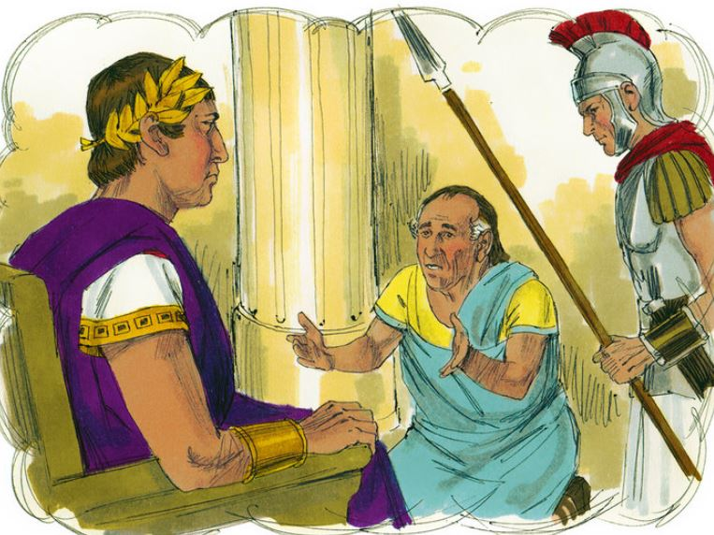
A king forgave a man his great debt, who refused to forgive another man a small debt.
During the week…
- You and your coworkers visit any who are in need or are discouraged, to help them.
- Visit nonbelievers as well as believers.
During worship…
- Relate Christ’s parable of the two moneylenders and the two debtors, above.
Ask the same questions about it as above.
- Make specific plans for the believers to visit and serve neighbors who are needy or discouraged.
- Pray for God to fill you with his compassion, and the power to put it into action.
- Let the children present what they have prepared.
- Memorize 1 John 3:18.
Advanced Study
- Explore the biblical instruction about showing compassion.
- Learn from Acts 4:34-47 what Barnabas did when there were needy believers.
- Find in Acts 49:24-27 what Barnabas did when people feared Saul (later called Paul).
- Find in Acts 15:1-4 what Paul and Barnabas did when Jewish Christians wanted Gentile Christians to adopt Jewish customs.
- Find in John 13:34 & 35 what Jesus commanded all of his followers to do.
- Find in Matthew 20:1-16 what our attitude should be toward new believers, even though we have worked harder for Christ and suffered more for Him than they have.
- Find in 1 Corinthians chapter 13…
Of what value are our gifts if we do not practice them in love?
What are the things that love is?
What are the things that love is not?
What things does love do?
What things does love not do?
- Find in Luke 23:33 & 34 and Acts 7:58-60 what both Jesus and Stephen prayed, that shows believers what to do concerning their enemies.
- Find in Romans 14:1-5 how believers should regard others who have different opinions about how to serve the Lord Jesus.
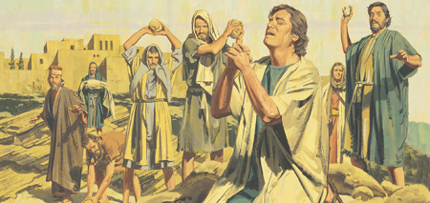
Whilst angry religious men were stoning Steven to death, he prayed God to forgive them.
- Additional activities to do during the week.
- Visit any believers who may be unforgiving preventer towards those who have wronged them, and pray with them to forgive their offenders.
- Discuss with your co-workers in advance, how you will gently counsel believers who say such things as…
“So-and-so helped someone else to get a good job, but he has never done anything like that for me.”
“So-and-so’s offended me with his teaching years ago, and I will never go back to that congregation.”
“I do not like the way So-and-so leads the group, letting ignorant people say silly things.”
“I do not want to be around those new-comers with their strange accent and shabby clothing.”
- Additional activities that you might do during worship:
- Have someone read this poem or another poem of your choosing.
The evil one declares his scorn,
“Deep gloom will soon make its impression!
I lust to see men grow forlorn
and wallow deep in sad depression!”
Sweet melodies to demon's ears
are men's sad moans and painful sighs.
Hell's Joker smiles to see their tears,
and laughs when their enjoyment dies.
- Form small groups to…
Pray for each other to resist Satan’s attempts to sadden and discourage.
Confess failures one to another
Pray for enemies
Encourage one another.
- To introduce the Lord’s Table, read or tell the story from John 6:1-14 about how Jesus miraculously provided food for hungry people.
Explain how he still provides spiritual food and drink for believers.
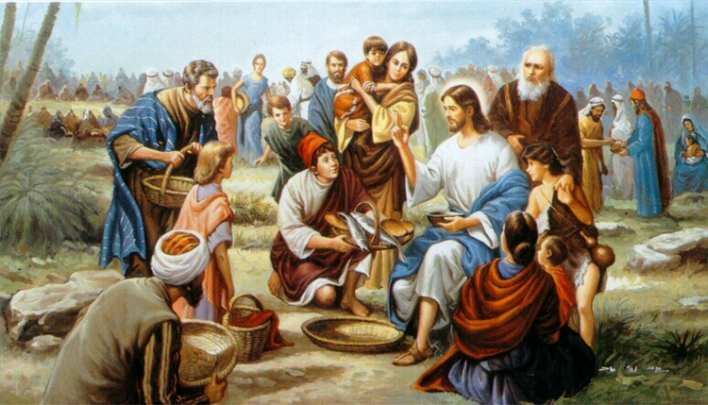
Jesus multiplied bread to provide much food to a crowd of hearers.

Consider together the “One-Another Commands” of the New Testament.
1) Love
Love one another: John 13:34-35; 5:12 & 17; Romans 12:10; 1 Thessalonians 4:9; 1 John 3:11,14 & 23; 4:7, 11 & 12; 2 John 1:5; 1 Peter 1:22
Love one another to fulfil the law: Romans 13:8
Increase our love one for another: 2 Thessalonians 1:3
Abound in love for another: 1 Thessalonians 3:12
Love each other deeply, to cover a multitude of sins: 1 Peter 4:8
2) Fellowship and reconciliation
Have fellowship one with another: 1 John 1:7
Forgive one another: Ephesians 3:13; 4:32; Colossians 3:13
Greet one another with a holy kiss (an embrace in some cultures): Romans 16:16; 1 Corinthians 16:20; 2 Corinthians 13:12; 1 Peter 5:14
Wait for one another to break bread: 1 Corinthians 11:33
Bear one another’s sufferings: 1 Corinthians 12:260
3) Serve
Serve one another with the gifts each person has received: 1 Peter 4:10
Serve one another in love: Galatians 5:13
Be kind to each other: 1 Thessalonians 5:15
Care for one another: 1 Corinthians 12:25
Bear the burdens one for another: Galatians 6:2
Wash one another’s feet as a sign of humbly serving: John 13:14
Work with one another: 1 Corinthians 3:9; 2 Corinthians 6:1
4) Teach
Teach one another: Colossians 3:16
Instruct one another: Romans 5:14
Even new believers can teach to others what they have learned.

5) Encourage
Encourage one another: Colossians 3:16; Hebrews 10:25
Exhort one another: Hebrews 3:13
Speak the truth to one another: Ephesians 4:25
Lay down our lives one for another: 1 John 3:16
Spur one another to love and good deeds: Hebrews 10:24
6) Pray, confess and edify
Pray for one another: James 5:16
Confess our sins one to another: James 5:16
Edify (strengthen, build up) one another: 1 Thessalonians 4:18 & 5:1 & 11
Edify one another, each one with a hymn, a word of instruction, a revelation, a tongue or its interpretation: 1 Corinthians 14:26
Glorify God together: Romans 15:6
7) Build unity with humility
Honour one another: Romans 12:10
Be of one mind one with another: 2 Corinthians 13:11; Romans 12:16; 15:5
Do not criticize one another: Romans 14:13
Do not speak bad one of another: James 4:11; 5:9
Submit to one another: Ephesians 5:21
Be clothed with humility toward one another: 1 Peter 5:5
8) Live in harmony
Have patience one with another: Ephesians 4:2
Live in peace one with another: Matthew 9:50
Receive one another with hospitality: Romans 15:7; 1 Peter. 4:9

