A Young Widow Finds a Loving Family
The story of Ruth
Lord, help the children to love their relatives like Ruth, Naomi and Boaz did.
Choose any or all of these learning activities.
- Prepare to teach one of the greatest stories about love.
Read the Book of Ruth, chapters 1–4.
Boaz’ love for Ruth illustrates how Christ loved and redeemed us who believe in Him.
You might spend more than one weekly session on the story, or deal only with parts of it.
Let older children or a teacher tell by memory the story of Ruth.
You might let three or four children each relate the main events of a chapter.
Chapter 1. Explain:
An Israelite man left Israel to live in Moab with his wife Naomi and their two sons. The sons both married Moabite women, Ruth and Orphah.
All three men died, leaving three widows. Naomi had to return to Israel to seek food.
Ruth and Orphah wanted to go with Naomi, but she told them to go back to their parents’ homes.
Orphah wept and returned to her parents, but Ruth showed love and loyalty as she clung to her widowed mother-in-law, Naomi, begging to go to Israel with her.
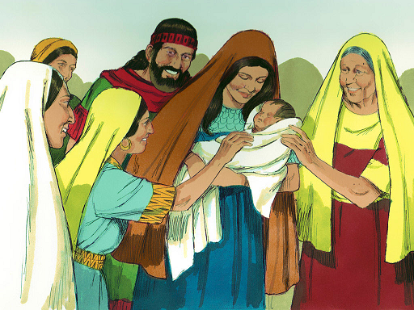
Widow Naomi brought Widow Ruth to her home in Israel, where Ruth worked hard to find food,
till Boaz married her and she bore Baby Obed, an ancestor of King David.
Chapter 2. Explain:
Wealthy Boaz showed a noble heart as he treated Ruth with compassion and respect, while she gleaned grain in his fields for her and Naomi to eat.
Israel’s ancient law allowed poor people to glean what the harvesters left behind.
Ask:
- Where did Ruth get grain for her and Naomi to eat? (Answer: See Ruth 2:3)
- How hard did Ruth work in the fields? (Verse 7)
- Did Boaz mistreat Ruth, because she was poor and a foreigner? (14-15)
- What did Ruth do to help her poor mother-in-law, Naomi? (18)
Chapter 3. Explain:
- Ruth showed courage asking Boaz, a relative, to defend her rights by marrying her.
- Ancient custom required the closest male relative to avenge or rescue a victim of violence, of poverty or of dying without an heir.
- Boaz is an example of Jesus our redeemer, who rescued us from Satan.
Chapter 4. Explain:
- Boaz dealt wisely with a relative who was more closely related to Ruth, so that this relative would let Boaz marry her.
- Boaz and Ruth showed love by marrying, and by letting Naomi help raise their child.
- Ruth became the great grandmother of David, a great king and an ancestor of Jesus.
- Dramatize parts of the story of Ruth.
Arrange with the leader of the main congregational worship for the children to present this drama. Let the older children help the younger ones prepare.
Children need not memorize the lines unless they want to.
They may read them, as the aim is not to perform but to relive sacred events.
Older children or adults play these parts:
Ruth
Naomi
Narrator (summarize the story and help children recall what to say and do.)
Younger children play these parts:
Orphah
Workers, who can hold leaves or sticks that represent the stalks of grain.
Narrator Briefly tell the First Part of the story from Ruth chapter 1. Then say:
“Hear what Naomi says to Ruth and Orphah.”
Naomi “Our husbands are dead. I go to Israel to seek food.
Go back to your families.”
Orphah “Oh, please do not leave us!”
(Hug Naomi and weep, then walk away.)
Ruth (Kneel and beg Naomi)
“Where you go, I will go, and where you live, I will live.
Your people shall be my people, and your God, my God.
Where you die, I will die.”
Narrator Briefly review the Second Part of the story from Ruth chapter 2. Then say:
“Hear what Ruth says to Naomi.”
Ruth “Mother, we need food.
I will go gather the grain that the harvesters leave behind.”
(Walk toward the workers; pretend to pick up stalks of grain from the ground.)
Boaz “Workers, who is that woman picking up grain in my field?”
Workers “She is Ruth, a poor foreign widow. She works hard and seldom rests.”
Boaz (Go to Ruth.)
“Ruth, I have heard of your kindness to Naomi.
Stay in my fields to gather grain,
and eat the food that I provide for my workers.”
Boaz (Go to the workers.)
“Let Ruth gather grain. Do not bother her.
Be sure to let some grain fall on purpose where she can gather it.”
Narrator “Hear what Ruth says to Naomi that evening.”
Ruth “Mother, look at all the grain that I gathered from Boaz’ field!
This is yours!”
Naomi “Daughter, Boaz is a close relative.
He has been kind to us as poor widows. May God bless him!
Do not go to any other fields during this harvest time.”
Narrator Very briefly review the rest of the story of the book of Ruth:
repeat the explanations for chapters 3 and 4, under #1 above.
Thank those who helped with the drama.
- If the children dramatize this story for the adults, then let them also ask the adults the questions listed under #1 above for Chapter 2.
- Draw a picture of stalks of grain that grows locally, and let the children copy it.
Let the children show their pictures to the adults during worship time and explain that it illustrates how both Ruth and Boaz cared for family members by sharing blessings with them.
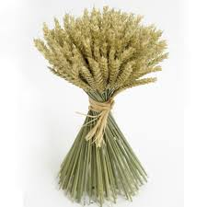
- Discuss other examples of how God uses family members to care for us.
Let adults and children give examples.
Also ask: Of what great family has God made us a part forever?
- Let four children each recite a verse from Proverbs 31:10, 15, 20 and 30.
- Let older children write a poem or song with words from Ruth 1:16-17.
- Memorize Ephesians 6:1-3
- let an older child pray:
“Lord, we thank you for our families. Help us to honor our parents and serve one another like you served us. Please, bring our family members to know you as Savior.”

A more detailed drama about Ruth, Naomi and Boaz, dealing with loving families:
http://biblestoryskits.com/002-love-draws-ruth-a-pagan-moabitess-to-the-god-of-israel-2/

