Good Dorcas Died and Was
Restored to Life
Dear Lord, help the children to show their love for needy people in practical ways.
Choose any or all of these children's learning activities.
- An older child or teacher reads or tells by memory the story of Dorcas, Acts 9:32-42.
It shows how the first Christians cared for the poor.
After relating the story, ask these questions. [Answers appear after each question.]
- What kind of person was Dorcas? [See verse 36]
- What did the believers do when she died? [See verse 38]
- Who was in the room crying? [See verse 39]
- How did poor people feel about Dorcas? [See verse 39]
- What did Peter ask the people to do, before he raised Dorcas from death? [See verse 40]
- What was the result of this miracle? [See verse 42]
- Let the children color the picture found at the end of this lesson.

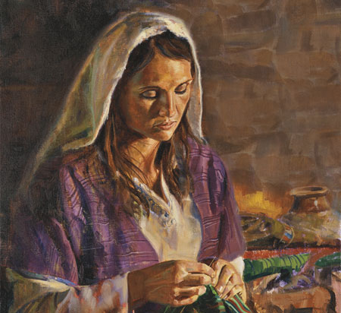
Dorcas love Jesus and spent her time and money to make clothes for other poor women.
- Do a role play about serving the needy.
- Let the children act out how they will show love for needy people in practical ways.
- Name some children to play these roles of needy persons:
You do not have to do all the parts.
1) Hungry widow
2) Lonely orphan
3) Sad prisoner
4) Tired traveler
5) Sick neighbor
6) Lost child who cannot find the way home
- Have each needy person tell the believers what their trouble is.
Then let the children say what they will do when they meet such people.
- If the children cannot think of good examples, then suggest things like these:
1) Give a widow food.
2) Find a home for an orphan.
3) Visit and cheer up a prisoner.
4) Provide a place to sleep for a traveler.
5) Pray for the sick and give them care.
6) Take a lost child home.
- Dramatize parts of the story of Dorcas, from Acts 9:32-42.
- Arrange to have the children present this drama.
- If time is limited then skip the less important parts of the story.
- If there are not enough children, then ask adults to help.
- Practice until everyone knows what to do and say.
- Let the actors say the words and do the actions of persons in the Bible,
when the narrator comes to that part of the story.
- Let the older children help prepare the younger ones.
- Older children or adults play these parts:
Peter,
Narrator
Dorcas who pretends to have a needle, thread, and cloth.
Younger children play these parts:
Disciples in Joppa where Dorcas lived
Widows
Narrator Read or tell by memory Dorcas’ story from Acts 9:32-42.
Then say, “Hear what Dorcas says to some widows.”
Dorcas (Pretend to sow a piece of cloth with a needle and thread, then look up.)
“Oh, hello friends! Look. I sewed these clothes for you.
I knew you needed them.”
Widows (Some say) “Oh, thank you, Dorcas.”
(Others say) ”You are always so kind with those in need.”
Dorcas Hold your head and say,
“I feel sick now. I must lie down.”
(Lie down on chairs if they are available.)
Disciples Go to Peter and say,
“Peter, please come! Dorcas died!”
Peter Hurry to where the widows are crying around Dorcas.
Ask the widows to leave the room.
Pray for God to restore her. Then say,
“Dorcas, get up.”
Dorcas Sit up and look around.
Widows and disciples
“Praise God!”
Narrator Thank all who helped with the drama.
- If the children dramatize this story for the adults, then let the children ask the adults the questions under #1 above.
- Draw a dress for the children to copy.
Let them show the picture to the adults during worship time, and explain that it illustrates what Dorcas gave to people who needed help.
- Ask the children to mention other ways to serve the needy.
Let children and adults cite examples.
- Let four children each recite a verse from Proverbs 11:16, 24, 25 & 28.
- Memorize Matthew 25:40, in which Jesus speaks of those who served the needy:
“The King will answer and say to them, 'Truly I say to you, to the extent that you did it to one of these brothers of mine, even the least of them, you did it to me’.”
- Let older children write poems, songs or dramas about serving the poor.
- Let an older child pray:
“Lord, help us to care for orphans, widows and all people who are in need. Help us to love them like you love them. Show us how to serve them like Dorcas did.”

A more detailed drama: the first Christians cared for people who were needy:
http://biblestoryskits.com/005-jerusalems-believers-name-deacons-to-serve-the-needy-3/

