Churches and Cells Serve One Another
Anchor command. “Through love serve one another.” Galatians 5:3-13
Anchor story. Macedonian churches served needy churches in Judea. Romans 15:25-28 and 2 Corinthians 8:8
Anchor verse. “Speaking the truth in love, we are to grow up in all aspects into Him who is the head, even Christ, from whom the whole body, being fitted and held together by what every joint supplies, according to the proper working of each individual part, causes the growth of the body for the building up of itself in love.” Ephesians 4:15-16
Learning goal. Find what God teaches about the duty of believers and congregations to serve one another.
Growth goal. Strongly desire to serve believers of other congregations more groups.
Skill goal. Arrange edifying interaction between congregations and cell groups.
Outcome goal. Churches and cell groups actively cooperate and serve each other.
Dear God, please use this study to inspire the congregations of our region to work together.

Basic Study
The churches of Macedonia served the churches of Judea. Romans 15:25-27
- The believers in Jerusalem were suffering from severe poverty. From what churches was the apostle Paul taking a contribution for those who are suffering in Jerusalem?
2 Corinthians 8:8
- Were the Macedonians who gave generously wealthy or poor? 2 Corinthians 8:1-4
- What had the Macedonians given to the Lord, before they gave to other needy churches? 2 Corinthians 8: 5
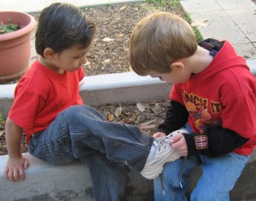
No one is too young to help their neighbour.
During the week…
- Ask questions to find out needs of your community and of congregations in other places.
- Meet with leaders of other flocks; plan to work together and send help to other needy places.
During worship
- Tell what the Macedonians did for the far away Jewish churches. Ask the same questions as above, and urge believers to discuss the answers
- Pray for other churches in the area.
- Ask the children to present what they have prepared.
- Memorize together 2 Chronicles 7:14.

Advanced Study
- Churches and cells cooperate in regional projects, in the way Nehemiah did.
- Nehemiah organized the Israelite clans to rebuild Jerusalem’s walls; different clans cooperated; each had its own area of responsibility. Nehemiah first surveyed the damage and made plans, then provided armed protection.
- Find in 2 Chronicles 36: 15-23 what happened previously to the city of Jerusalem, and why.
- Over 70 years later the Israelite captives in Babylon began to go back home with the help of the Persian king, Cyrus. Nehemiah took six steps to begin rebuilding Jerusalem’s massive walls.
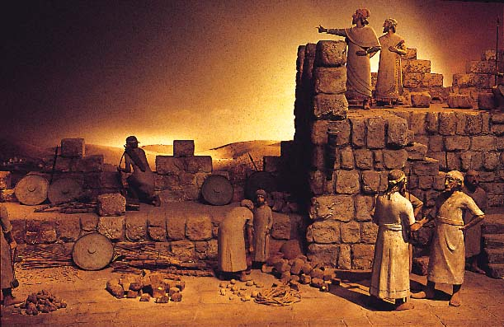
Nehemiah and Israelites plan together to rebuild their city wall
Step 1) Define the need and the objective.
Find in Nehemiah chapter 1 how Nehemiah faced up to the suffering in Jerusalem.
Nehemiah first learned about the damage in Jerusalem by asking questions. How did he respond to what he heard? (See verse 4)
Nehemiah confessed the sins of his people that had brought so much trouble to his country. Whose sins did he include? (See verse 6)
Step 2) Pray for wisdom as you investigate the facts.
Find in chapter 2 how Nehemiah prepared himself to help the people of Israel.
Step 3) Delegate well-defined responsibilities.
Find in chapter 3 how Nehemiah managed a huge task, so that everyone could participate according to their ability.
Step 4) Handle opposition and injustice firmly.
Find in chapter 4 how Nehemiah met opposition.
(He prayed. Everyone worked hard. He gave attention to the weak areas. He urged workers to trust God and do their own part. He and his men set an example of complete dedication.)
Find in chapter 5 how this godly leader brought justice to God’s people.
What injustices did Nehemiah and the people stop voluntarily? (See verses 7 and 15.)
Step 5) Stand firm against lies and criticism.
Find in chapter 6 how Nehemiah’s and the workers’ perseverance in this project glorified God.
How did Nehemiah avoid being distracted and intimidated by his enemies? (See verses 11-14.)
The wall had been broken down for almost 100 years. In how many days was the wall rebuilt with God’s help? (See verse 15.)
What did this teach their enemies about Israel’s God? (See verse 16)
Step 6) Give the glory to God for the completed project.
Find in Nehemiah 8:2-12 and 9:1-5 the blessings that God poured out on his people.

- Plan with co-workers additional activities for the upcoming worship time.
Pray and confess sin to God. Ask Him to show you the needs of others. Ask God to unite Christians from different flocks, so that they work together to serve Him.
Praise God for ways that Christians have worked together to serve the needs of people outside of the flock. Ask for testimonies and reports of work done last week.
Tell or act out parts of the story of Nehemiah.
Prepare a helper to relate Nehemiah chapters 1 & 2. First ask everyone to listen and learn the steps Nehemiah took to discover his people’s needs and to prepare himself for the task. After telling the story, ask the believers what they discovered.

Dramatize the way that Nehemiah dealt with opposition to his project.
Nehemiah: “God will help us rebuild the walls of our city.”
Sanballat: Sneak up behind Nehemiah, who turns suddenly.
Say “Stop your work. It is too much for you.”
Nehemiah: “God gave me this task to complete. Go away.”
Sanballat: “You can never succeed. Come with us.
We need you for a very important meeting.”
Nehemiah: “We are doing a great work. I cannot stop.
And why should the work cease while I go to a meeting?”
Sanballat: “You are taking too much risk here!”
Nehemiah: “God will protect us.”
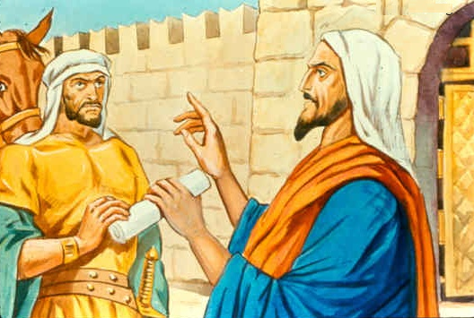
Sanballat seeks to frighten Nehemiah to stop his work.
Announce the activities that you planned to do during the week, to pray and organize people so that they can serve God together to meet whatever challenge they have found.
Help one another in groups of two or three. Pray, confirm plans to work with other congregations in projects that are needful, and encourage one another.
To introduce the Lord’s Supper read Nehemiah 2:1-5. Explain that Nehemiah brought a cup to the king, but as we come to the table of the Lord, our king Jesus brings His cup to us. His blood brings us forgiveness and a relationship with God our King.

