A Woman Meets Jesus at a Well

Lord Jesus, Help us teach Children Always to Be Ready to Tell Others about Jesus.
Choose from among these learning activities for children those that best fit their needs and local customs.
- Let an older child or teacher read or tell the story of the Samaritan woman, John 4:4-42.
This story recounts how Jesus was ready to tell to every person whom he met the good news of God’s love, forgiveness, and eternal life.
After relating the story, ask these questions. [An answer appears after each question.]
What was Jesus doing at the well? [See verse 6]
Why was the woman surprised when Jesus asked for a drink? [See verse 9]
What kind of water did Jesus offer to give to the woman? [See verse 14]
Is there a special place where people must worship God? [See verses 21 and 24]
Who did Jesus say that he was? [See verse 26]
What does Jesus mean when he says that the fields are ripe for harvest?
[Answer: Many are ready to receive the good news of Jesus, but we must tell it to them.]

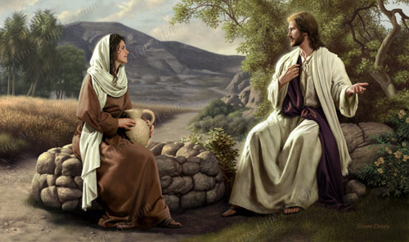
Jesus explained to a sinful woman how he could give her ‘living water.’
- Some children might like to copy or colour the picture found at the end of this lesson.
- Dramatize parts of the story.
Arrange with the main worship leader to present this brief drama.
Use your time with the children to prepare the drama.
You do not have to use all of the parts.
Older children or adults portray:
Narrator. Summarize the story and help the children to remember what to say.
Jesus. Sit next to something representing a well.
Samaritan Woman. Carry a jug.
Younger children portray:
Disciples. Carry food.
Samaritans
Jesus Sit next to the ‘well.’
Narrator Tell the first part of the story from John 4:1-26. Say,
“Hear what the disciples say.”
Disciples (One says) “Jesus, you are tired.”
(Others say) “The trip has been long.”
(Others say) “Stay here by the well and rest.”
(Others say) “We shall go into the Samaritan village and get food.”
Samaritan Woman Walk toward Jesus carrying the jug on your head, held by one hand.
Jesus “Please give me some water.”
Samaritan Woman Act surprised. Lower the jug and say,
“You are a Jew!
Why do you ask me, a Samaritan woman, for a drink?”
Jesus “I can give to you living water that will keep you from ever being thirsty again.”
Samaritan Woman Act surprised. Say,
“How can you do that?”
Jesus “I am the Messiah, the chosen one of God.”
Samaritan Woman (Slowly walk away from the well.)
Narrator Tell the second part of story from John 4:27-38. Say,
“Hear what the disciples say.”
Disciples (Some say) “Look! Who is that woman with Jesus?”
(Others say) ”She left her jar and is going back to the village!”
(Others say) “She looks excited!”
(Others say) “Here, Jesus, have some food.”
Jesus “I have a different kind of food.
My food is to help people know God.
Always be ready to tell people the good news.”
Narrator Tell the third part of the story (John 4:39-42) and say,
“Hear what the Samaritan woman says.”
Samaritan Woman Say to the Samaritans, who are standing to one side,
“Come see this man. He told me everything I ever did.
Could he be God’s chosen one?”
Samaritans (Some say) “Let’s go see this man.”
(Others say) “We will believe in Him, too.”
Jesus “Lift up your eyes and look on the fields; they are white for harvest.”
Narrator Thank everyone who helped with the drama.

- If the children dramatize this story for the adults, then let them also ask the adults the questions under #1 above.
The Narrator might also ask, “What are other examples of people who have responded to Jesus when we did not expect it?” (Let everyone tell examples.)

Ancient stone well barrier.
- Draw a Picture of a well, and let the children copy it...
They can show their pictures to the adults at the next worship time and explain it.
It illustrates how God wants us always to be ready to offer His living water to anyone who is willing to receive it.
- Memorize Colossians 4:3”
“Pray for us as well, that God will open up to us a door for the Word, so that we may speak forth the mystery of Christ, for which I have also been imprisoned.”
- Let four children each recite one of the four verses in Psalm 19:1-4.
They might recite this for the adults, also.
- Let an older child pray:
“Lord, we are glad that we can worship you wherever we are. You love people of all languages, races, colors and cultures. Thank you that you have sent us to take the good news to people of all nations. Help us remember that people all around us are ready to respond to your good news. Help us to be faithful to tell them.”
A more detailed drama, dealing with Jesus meeting a Samaritan woman at a well:
http://biblestoryskits.com/008-the-lord-jesus-forgives-a-wayward-samaritan-lady-2/

