Reach Neglected People of Other Cultures
Anchor command. “You will receive power when the Holy Spirit has come upon you; and you shall be my witnesses both in Jerusalem, and in all Judea and Samaria, and even to the remotest part of the earth.”—Jesus, Acts 1:8
Anchor story. Jesus evangelizes people of another culture. John 4:4-43
Anchor verse. Behold, my Servant, whom I uphold; my chosen one in whom my soul delights. I have put My Spirit upon him; he will bring forth justice to the nations. Isaiah 42:1
Learning goal. Know what God teaches about reaching other cultures and peoples for Christ.
Growth goal. Send workers to neglected peoples.
Skill goal. Train effectively workers who go to other cultures, to multiply churches.
Outcome goal. Churches multiply rapidly in currently neglected fields.
Basic Study

Lord Jesus, please, show to our congregation the neglected people to whom you want us to take your Good News, and show to us whom we are to send to them.

Jesus showed how to deal with people of another culture when he was in Samaria.

Find in John 4:4-43…
a) How Jesus treated the Samaritans whom others despised. Verses 4–26
b) How Jesus urged his disciples to see the Samaritans as recipients of God’s grace. Verse 35
c) Why the Samaritans came to believe in Jesus. Verse 41
[Answers:
a) He talked with them, treated them kindly, and stayed with them a few days.
b) As fields ready for harvest.
c) Because of Jesus’ own words.]
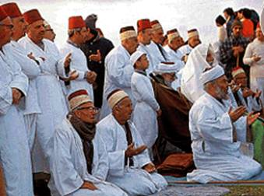
Samaritans, today.

Find in John 4:25-26 what Jesus revealed to the Samaritan woman about his identity.

Find in John 4: 24 what Jesus said about the way believers should worship.
During the week…
- Evangelize any people or cultural group in your area that has yet to know about Christ.
- Make plans to send workers to other cultures that needs the gospel.
During worship…
- Tell the story of the Samaritans, and ask the same questions as above.
Encourage believers to discuss the answers.
- Commission with laying on hands workers that your church is sending to neglected people.
- Pray for guidance in the power of the Holy Spirit, to do your duty as a church.
- Ask the children to present what they have prepared.
- Memorize John 4:35, which tells us to look upon the ripe fields.
Advanced Study
- Find in Matthew 28:16–20:
a) In verse 18, where Jesus wanted his Good News to go.
b) In verses 19 & 20, what we are to do for new disciples in every ethnic group.
c) In verse 20, for how long we believers should keep taking the Good New to other ethnic groups.
[Answers:
a) To every ethnic group.
b) Baptize them and teach them to obey Jesus just as we do with our own people.
c) Until the end of the age when Jesus will return.]

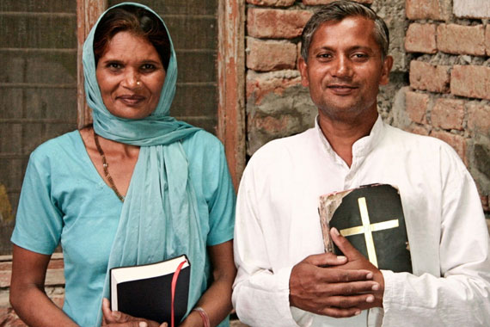
Indian missionaries
- God’s people should are to take the Good News to four places.
Find in Acts 1:6–11 where Jesus commanded his followers to go.
a) Where should we start making new disciples?
b) Where should we go next?
c) Where should we go after that?
d) Finally, where should we go?
[Answers (in verse 8):
a) Jerusalem corresponds to our own town and ethnic group.
b) Judea is our own ethnic group in other towns.
c) Samaria corresponds to any ethnic group, nearby and similar to our own.
d) The ‘ends of the earth’ means any neglected ethnic groups in any nation.]
- Find in Romans 15:14–21 (‘ Gentiles’ are all non-Jewish ethnic groups):
a) In verse 16, what makes other ethnic groups acceptable to God.
b) In verses 18 & 19, where we get power to make disciples of other ethnic groups.
c) In verse 20, where we should go to make new disciples?
[Answers:
a) The Holy Spirit makes them holy when they trust Jesus.
b) From Christ and from the Holy Spirit.
c) Where people do not yet have faith in Jesus.]
- Plan with your co-workers additional activities for the up-coming week.
- Identify the neglected ethnic groups that live near your flock.
- Pray together about what your congregation should do to serve these neglected people, and to share with them the Good News.
- Visit persons who belong to that ethnic group to learn about their material and spiritual needs, and form friendships.
- Learn about neglected ethnic groups in other countries and prepare a report to make to the congregation about them.
- During worship, let workers report what they learned and during the week.
- Pray for neglected ethnic groups and for any missionaries who seek to reach them.
- Ask the Holy Spirit to give to your congregation apostles whom it will send to reproduce your congregation within a neglected people group.
- To introduce the Lord’s Supper…,
- Read from Isaiah 52:13 through 53:6.
- Explain that the Lord Jesus wants his salvation to go to all ethnic groups everywhere.
- Explain also that believers in 1000s of ethnic groups are taking the Lord’s Supper at the same time as your own congregation.
- Those who teach children should read study #74 for children.

