Work with Other Cultures
Anchor command. Christ told his Jewish disciples, who despised Samaritans: “Lift up your eyes and look on the fields, that they are white for harvest.” John 4:35
Anchor story. Paul evangelized Greeks at Athens. Acts 17:15-34
Anchor verse. “A great multitude which no one could count, from every nation and all tribes and peoples and tongues, standing before the throne and before the Lamb, clothed in white robes, and palm branches were in their hands.” Revelation 7:9
Learning goal. Learn what the Bible teaches about dealing with other cultures.
Growth goal. Enjoy working with people of another culture.
Skill goal. Adapt to another culture without prejudice.
Outcome goal. Love and bond with people of a different culture, and bring Christ to them.
Dear Lord, you give apostles to our congregations. Teach us and them to love people of other cultures and to work for you among them.

Basic Study
Learn from Paul as he evangelized Athenians. Acts 17:15-34
- What did Paul see in Athens that made him feel uneasy? Verse 16
- What type of people began conversing with Paul? 17-18
- What did the Athenians normally spend their time doing? 19-21
- Paul got their attention speaking about things they already knew, in their culture.
What inscription did Paul quote after seeing the objects of their devotion? 24-28
- Paul announced the gospel, and some of the Athenians believed.
What part of the gospel message caused some of the Athenians to sneer? 32
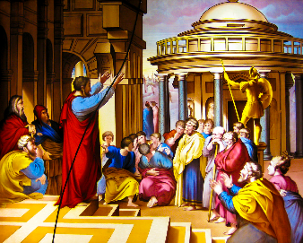
Paul quoted from Greek philosophers while proclaiming to the Good News in Greece.

During the week you and your coworkers discuss other cultures in your area that need the gospel, and make plans to evangelize them.
During worship tell the story of Paul and the Athenians, acts 17:15-34, and ask the above questions. Urge the believers to discuss the answers.
Ask the children to present what they have prepared.
Memorize together Revelation 7:9.

Advanced Study
- God gives to churches apostles (persons that a congregation sends to other areas), Ephesians 4:11.
- In the Bible, non-Jewish people are called Gentiles. Both the Old and New Testaments promised that all Gentile peoples in the world would hear the Good News about Jesus.
- Find in Acts 14:8–14 what can happen if we do not understand other people’s culture. Find what Paul and Barnabas did to show God’s power. (14:8–10)
Who did the Lyconians think cured the lame man? (11–12)
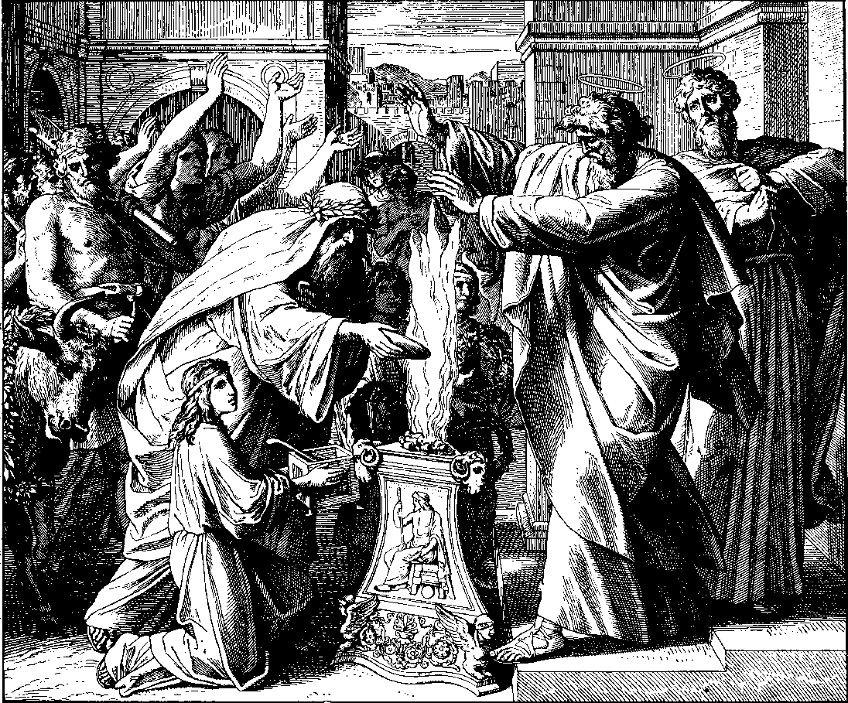
The Lyconians tried to sacrifice to Paul and Barnabas as to gods.
What did the people want to do for Paul and Barnabas? (13)
What did Paul and Barnabas explain to them?? (14–15)
- Find in Genesis 12:14 God’s unchanging purpose for all peoples, tribes and cultures. (Answers follow each question.)
Where God told Abraham to go. (Verse 1)
What Abraham was going to become there. (2)
What groups of people would be blessed in relation to Abraham. (3)
What Abraham did so that God’s promise would be fulfilled. (4)
- Find in Galatians 3:8–14 how the promise made to Abraham is fulfilled:
What God wanted to do for Gentile people of all the different culture groups? (3:8)
What must Gentiles do in order to be blessed by God? (9)
What did Christ do so that people can be blessed without keeping Jewish laws? (13)
What aspect of the blessing promised to Abraham do believers in Christ of all nations now receive through faith? (14).
- Find in Acts 10:11–28 what must be the attitude of those who work with another culture group:
What Peter heard though a vision from God. (10:11–16)
How the Holy Spirit wants us to act when we have an opportunity to work with another culture group. (18–23)
What our attitude should be towards ourselves when we work with in another culture. (24–27)
What our attitude should be towards culture groups that our own culture dislikes. (28)
- Find in Acts 15:1-31 how several churches worked together to solve cultural differences.
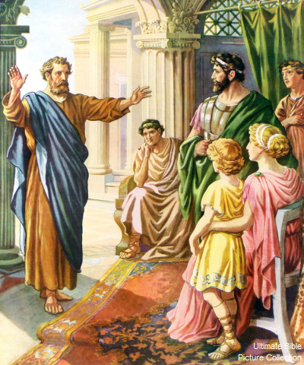
When Peter, a Judean, recounted the Good News of Jesus to Italian Gentiles
in a way that they understood, many believed and received the Holy Spirit.
- Plan with your co-workers additional activities for the coming week.
Identify the various culture groups residing in your town and region.
Discuss which groups are the more neglected by Christian missions and congregations. In what ways are those groups similar to your culture, and how are they different?
- Find out important information about each of the culture groups in your area:
- How many people are in the group?
- What proportion of them are Christians?
- How many Christian congregations and cell groups do they already have?
- What missions and congregations, aside from your own, could work with the culture group with your cooperation?
- How are the beliefs and customs of the group similar to yours?
Different from yours?
Discuss and plan:
- Which workers in your congregation could be sent by it to work with each of the neglected culture groups.
(Who has the ability and desire to work with other cultures?)
- Who will coach them in their work?
- How will they be supported in that work? Can some of them be self-supporting, as Paul was, when he made tents in Corinth (Acts 18:1-3)?
When will your congregation send them?
Arrange to supply coaching and Paul-Timothy materials to the coaches.
- Plan with your co-workers additional activities for the up-coming congregational worship.
Explain:
- What happened in Lystra when Paul and Barnabas worked there (Acts 14:8-14)?
- What God promised Abraham concerning all nations (Genesis 12:1-4)?
- How we receive God’s Holy Spirit because of this promise (Galatians 3:8-14)?
- How God changed Peter’s view of a culture group that the Jews disliked (Acts 10:11-28)?
Explain from Acts 15 why Christians of Jewish culture thought that Gentiles had to adopt Jewish customs before they could be saved, and how they solved this problem:
- The elders of several congregations met with the apostles to discuss the disagreement.
- Peter told how Cornelius’ Gentile family and friends received the Holy Spirit without becoming like Jews (15:8–9).
- Barnabas and Paul reported how God did miracles for Gentiles (verse 12).
- James concluded that Gentiles must not be made to change their culture in order to become Christians (verse 19).
Let anyone who has worked recently with another cultural group tell what God is doing with it.
To introduce the Lord’s Supper read Isaiah chapter 53.
Have the believers form small groups to intercede for other culture groups to be saved and for workers to take the Good News to them.
Those who teach children should read study #76 for children.

