Carry the Good News to Neglected Places

Introduce the First Missionaries to Children
Choose any of these children's learning activities.
- An older child or teacher reads or tells the story the Church of Antioch sending missionaries
(Acts 13:1-16 & 32-52).
Tell how the Church sent Paul and Barnabas to take the Good News about Jesus to other places.
Ask these questions. (See an answer in verses following each question.)
What were the believers doing when God said to set apart Saul and Barnabas? (See verse 2)
What did the believers do before they sent off Saul and Barnabas as their missionary team? (Verse 3)
How did God stop a sorcerer who tried to keep people from knowing Jesus? (11)
How can people have their sins forgiven? (38)
Which group of people rejected the Good News? (45-46)
What did Paul and Barnabas do when they were expelled from the city? (51)
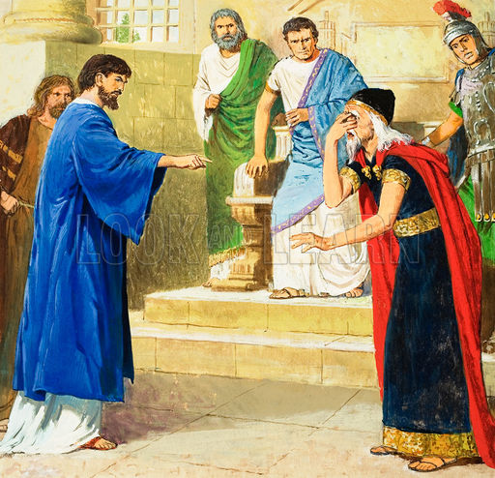
Paul struck blind a magician who opposed the Word of God.
- Dramatize parts of the story.
Arrange with the main worship for the children to present this drama.
Use your time with the children to prepare the drama.
You do not have to use all the parts.
Let older children help prepare the younger children.
Older children or adults play these parts: Paul , Narrator
Younger children play these parts: Barnabas, Proconsul, Sorcerer, Christians, Jews, Gentiles
Narrator Tell the first part of the story from Acts 13:-3. Say,
“Hear what the Christians say.”
Christians (Some say) “It is good to fast and pray to God together.”
(Others say) “The Holy Spirit is telling us to send missionaries.”
(Others say) “God is telling us to send Paul and Barnabas!”
Barnabas “Yes! We will take the good news to other places.”
Christians (Some say) “Kneel here.”
(Others say) “We will pray for you and lay hands on you.”
(Others say) “This is to send you where God wants you to go.”
Paul and Barnabas
Kneel.
Christians Lay hands on Paul and Barnabas as you would if praying for them.
Paul and Barnabas
Walk to one side.
Narrator Tell the 2nd part of the story (Acts 13:4-12). Say,
“Hear what the Roman Proconsul says.”
Proconsul “Go get Paul. I want to hear about Jesus.”
Sorcerer “No, Sir. Do not get Paul. You should not listen to his false message.”
Paul “Sorcerer, you are trying to deceive this man.
God will strike you blind!”
Sorcerer Stagger around; covering your eyes. Say,
“I cannot see. Please take my hand!”
Proconsul “Paul, your God is more powerful than the gods of this sorcerer.
I want to hear more about your God!”
Narrator Tell the third part of the story, Acts 13:13-16 & 32-52. Say,
“Hear what Paul says.”
Paul “Listen to the good news about Jesus.
God raised him from the dead. He will forgive your sins.”
Jews “Do not listen to this crazy man!”
Barnabas “We had to speak to you Jews first. But you reject Jesus.
Now we will talk to the Gentiles, the people who are not Jews.”
Gentiles (Some say) “We are glad that God sent you to us.”
(Others say) “Tell us more about Jesus.”
(Others say) “We believe in Him!”
Jews “We must get this man out of our town!”
(Push Barnabas and Paul away.)
Barnabas and Paul
Shake dust off your feet and walk away.
Narrator Thank everyone who helped with the drama. Thank the adults for listening.
- Draw a Picture of feet, and let the children copy it.
They can show their pictures to the adults at the next worship time
and explain that this illustrates how God sends us to new places
to find people who are ready to listen to the good news about Jesus.
Let older children help the younger ones.
Some children may like to copy or to colour the picture found at the end of this lesson.
- Ask questions about the story of Paul and Barnabas:
Ask the children, “What are other examples of people who have gone to new places
to take the good news to them?”
Let the children give examples.
- If the children dramatize this story for the adults, then let them ask the adults
the questions under #1 above.
- Memorize Joshua 1:9”
“Be strong and courageous! Do not tremble or be dismayed, for the Lord your God is with you wherever you go.”
- Let four children each recite one of the verses from Psalm 29:1-4.
- Let the older children write a poem, song or short story about people taking the Good News to faraway places. They might do this during the week.
- Let an older child pray:
“Dear Lord, You want to send many people like Paul and Barnabas to those who do not know you. Help us to hear your voice when you tell us to go. Fill us with your Spirit, so that we can speak your Good News with the boldness of Paul and Barnabas.”
A more detailed drama, about an event that took place during one of Paul’s journeys:
http://biblestoryskits.com/009-paul-frees-a-slave-girl-from-a-demon-inciting-a-violent-mob-2/

Paul, Barnabas and other missionaries often travelled by ship to neglected lands where they told the good news about Jesus to folk who had never heard about Jesus.

