Spread a Vision of Widespread Outreach
Anchor command. “Behold, I say to you, lift up your eyes and look on the fields, that they are white for harvest.” John 4:35
Anchor story. Saul, who was also named Paul, receives his natural sight and a vision from God through Ananias. Acts 9: 1-28
Anchor verse. “Behold, a great multitude which no one could count, from every nation and all tribes and peoples and tongues, standing before the throne and before the Lamb, clothed in white robes, … and they cry out with a loud voice, saying, ‘Salvation to our God who sits on the throne, and to the Lamb’.” Revelation 7:9-10
Learning goal. Find out whom God has promised to call to repentance throughout the earth.
Growth goal. Rejoice in the precious truth that God is saving people of all tongues and tribes.
Skill goal. Help others to see the many communities of the world as God sees them.
Outcome goal. Believers reach out to other ethnic communities.

Dear Lord, please help us to obey your Great Commission and send workers to people without the Good News of salvation in Christ.

Basic Study
Learn from the account of Saul’s conversion on his way to Damascus, Acts 9:1-28
- With what purpose was Saul traveling to Damascus? 1-2
- Whom did Saul meet on the way, and what happened to him? 3-9
- What did God tell Ananias to do for Saul? 10-14
- What did God say that Saul would do, besides suffering for the sake of Christ? 15-16
- What did Saul begin to do after he had received his sight and was baptized? 20-22
- Why did they have to lower Saul in a basket from the city wall? 23-25
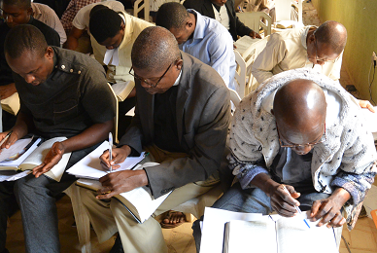
Shepherds learn, pray and plan to reach out to other communities.
During the week, meet with believers who are eager to go to other places to win people to Christ, and explain that it is God’s will for his churches to spread the gospel nearby and afar.
During worship.
- Tell the account of Saul’s conversion, Acts 9:1-28, and ask the same questions as above. Let the people discuss the answers.
- Ask the children to present what they have prepared.
- Memorize Acts 1: 8 “but you will receive power when the Holy Spirit has come upon you; and you shall be my witnesses both in Jerusalem, and in all Judea and Samaria, and even to the remotest part of the earth.” Acts 1:8

Advanced Study
- Multiply new leaders and congregations.
- Memorize 2 Timothy 2:2. “The things which you have heard from me in the presence of many witnesses, entrust to faithful men who will be able to teach others also.”
- The Apostle Paul and his coworkers began such a chain reaction while working In Ephesus. Find in Acts 19 how long it took them by working this way to plant new congregations throughout all of Asia Minor (Western Turkey).
- Throughout the history of the church, God has raised up believers who have had a great vision for reaching the lost of other lands to Christ.
- As a result, of this God-given vision, more people are coming to Christ around the world now than ever before in history. Churches are multiplying rapidly on every continent except Antarctica.
- To bring about this tremendous multiplication, God is mainly using house churches modeled after the New Testament churches, not after old denominations. (There were no church buildings in the New Testament, nor in church history until about 300 years after Christ.) However many old denominational churches are now sending missionaries trained to start house churches.
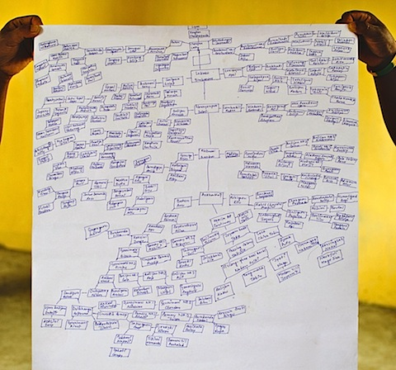
Shepherds draw maps of where believers start new churches.
- Learn from Ephesians 4:11-16 how God enables each believers to do a specific ministry.
- Some believers are gifted by the Holy Spirit to serve as apostles. These will be eager to go to other places where Christ is not known, and plant new congregations. Find who these believers are in your congregation, and arrange to send them in the power of the Holy Spirit.
- Commission these modern apostles to start congregations nearby and among neglected peoples, Acts 1:8
- Train these leaders in a way that they can imitate as they train newer leaders, 2 Tim. 2:2.
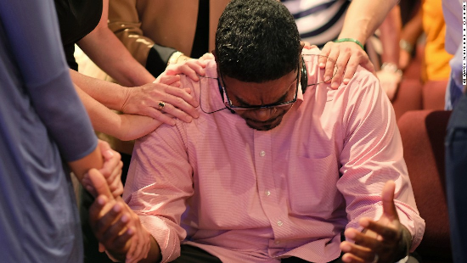
Congregations commission apostles to go to neglected communities.
- Additional activities to do during the week …
- Prayerfully plan with your coworkers to multiply congregations widely, nearby and afar.
- Visit believers and find those who are eager to take Christ to other areas.
- Additional activities to do during the upcoming worship…
- Pray to the Lord of the harvest to send workers to neglected peoples, nearby and afar.
- Recognize and begin training believers who are eager to go.
- Before the Lord’s Supper, read Jeremiah 31:31-34.
Explain that the prophet foretold a New Covenant (Agreement) based on Jesus’ blood that we celebrate when we break bread.
- Form groups of two or three persons, to pray and discuss plans to send workers.
- Those who teach children should read study #77 for children.

