Recognize and Follow Good Leaders

## Teach children the right kind of leadership

Lord, help us to work together as a well-organized body.

Choose any of these children's learning activities.

Nehemiah said, “Wherever you hear the sound of the trumpet, join us there.   
Our God will fight for us!”

1. Let an older child or teacher read or tell the story of Nehemiah, *Nehemiah 4:1-23*.

Ask the children first to listen to find out how a godly leader organized his people to do a big building project that brought glory to God.

After relating the story, ask these questions. (*Tell answers only if the children cannot*.)

* What did Israel’s enemies say about the wall around Jerusalem? [*See verse 2*]
* To whom did Nehemiah go for help when his enemies threatened him? [*Verse 9*]
* What did Nehemiah do to protect the wall, after he prayed to God? [*Verse 13*]
* How hard did the Israelites work on the wall? [*Verse 6*]
* What did Nehemiah do while the people worked? [*Verse 23]*
* How did Nehemiah encourage the people to work with all their heart?   
  [*Answer: Nehemiah got the people to pray.   
  He then organized their work, reminded them of God’s power,   
  and served as an excellent example of a hard worker.]*

*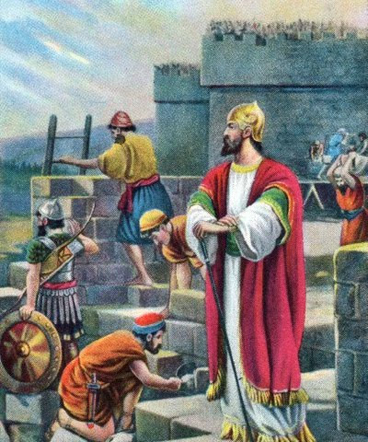  
Nehemiah and the Israelites prayed, set to work and kept a guard against enemies.*

1. Draw a Picture of a ram’s horn and have the children copy your drawing.

ram's horn

Explain that Israelite trumpets were simply hollow horns from sheep.

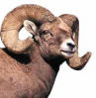

* Let older children help the younger.
* Let the children show their pictures to the adults at the next worship time and let them explain that this illustrates how God uses godly leaders to call his people to work in unity.
* Some children might like to copy or colour the picture found at the end of this lesson.

1. Dramatize part of the story of Nehemiah, Nehemiah 4:1-23.

* Arrange with the main worship leader to present this drama during worship.
* Use part of your time with the children to prepare the drama.
* Let the older children help prepare the younger.
* Older children or adults play these parts:

**Narrator**. Summarize the story and help the children remember what to say.

**Nehemiah**. Hold a spear (long stick) in one hand and a hammer or some other tool in the other.

Younger children play these parts:   
**Israelites**. Hold both building stones and spears.   
**Enemies**. Hold spears.

Narrator *Tell the* ***first part of the story****, from Nehemiah 4:1-2*.

Israelites *Pretend to carry and place large rocks or bricks to build a wall.*

Narrator “Nehemiah and the Israelites are building a wall around the city of Jerusalem.   
Their enemies make fun of them. Hear what the enemies say.

Enemies (*Some say*) “What are those silly Jews building now?” (Laugh)  
(*Others s*ay) “Is that a wall?”  
(*Others s*ay) “It looks like a heap of stones!”  
(*Others s*ay) “Even a little fox could knock it over!”

Narrator *Tell the* ***second part of the story****, from Nehemiah 4:6-14. Then say,*   
“Hear what Nehemiah says.”

Nehemiah “First let us pray to God together for help.   
‘God, help us finish this work for you.’   
Now, people, do not listen to our enemies.   
Let us organize to do this job and keep working for God!”

Israelites “We will work with our whole heart.”  
(*Speaking to each other*)   
“If you will build this part of the wall, then I shall work over there.”

Narrator *Tell the* ***third part of the story****, from Nehemiah 4:15-23. Then say,*   
“Listen to what Nehemiah says.”

Nehemiah “Everyone, keep your weapons near you.   
When you hear the trumpet, come help protect the wall.   
Be ready all the time.   
We will all work on the wall with one hand   
and hold our swords in the other hand!”

Israelites(*Some say*)“Look, the wall is strong!”  
(*Others s*ay) “We have almost finished.”  
(*Others s*ay) “Look how hard Nehemiah is working.”  
(*Others s*ay) “He is a good example to us.”

Narrator Thank everyone who helped with the drama.

1. If the children dramatize this story for the adults, then let them also ask the adults the questions under #1 above.
2. Let four children each recite a verse from Psalm 2:1-2 and verses 10-11.
3. Have the children give examples of when we need godly leaders like Nehemiah   
   to help us do a great work together for God.
4. Memorize together John 17:23: “I in them and you in me, that they may be perfected in unity, so that the world may know that you sent me, and loved them, even as you have loved me.”
5. Older children write poems, songs or short dramas about working together for Jesus.

They might do this during the week.

1. Have an older child pray:

“Dear Lord, you are King over all. No one can defeat you. With your help, we can overcome our problems and find how to help each other, too. Help us to remember to ask you for help first. Help us to serve each other with our whole heart.”

A more detailed drama, about Nehemiah organizing the people to work together, 5 minutes.  
<http://biblestoryskits.com/010-gods-people-rebuild-jerusalem-after-painful-exile/>

