Serve God with our Various Spiritual Gifts
Anchor command. “Since we have gifts that differ according to the grace given to us, each of us is to exercise them accordingly.” Romans 12:6
Anchor story. Workers coordinate their diverse skills to build God’s tabernacle, Exodus 36:1-7
Anchor verse. “The whole body, being fitted and held together by what every joint supplies, according to the proper working of each individual part, causes the growth of the body for the building up of itself in love.” Ephesians 4:15-16
Learning goal. Find what the New Testament teaches about believers’ spiritual gifts.
Growth goal. Learn what one’s spiritual gifts are, and use them in the power of the Holy Spirit.
Skill goal. Coordinate the use of the diverse gifts, so that all work together in a unified body.
Outcome goal. Believers use their spiritual gifts and natural talents in loving harmony to edify the body.

Lord Jesus, please let all the members of our congregations and cells discover the power you have put within them to serve you and others joyfully

Basic Study
Learn from the construction of the Old Testament Tabernacle, Exodus 36:1-7

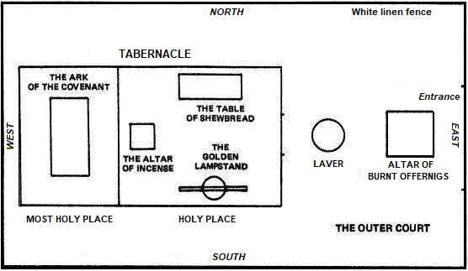
Diagram of the ancient Hebrew Tabernacle
- The elaborate furnishings of the ancient Tabernacle pictured Christ. The altar for animal sacrifice corresponded to the cross. Only priests could enter the Holy Place; its sacred bread pictured Christ the bread of life, and its golden candlestick pictured Christ the light of the world. The altar of incense signified prayers ascending to heaven. Only the High Priest entered the Most Holy Place once a year with sacrificial blood. The Ark of the Covenant signified God’s presence: Christ is ‘Emmanuel,’ meaning God with us.
- What type of people did Moses have construct the tabernacle, its elaborate furnishings and the priests’ intricately decorated garments? Exodus 36:1-3
- What did the people do that caused the workers to become concerned? 4-5
- What did Moses command that was very unusual? 6-7
- It required many workers with very different skills to prepare the tabernacle, with its elaborate carvings, tapestries, utensils of gold, skillfully hand-crafted furnishings and varied coverings. In the same way, to do God’s work now requires believers with very different spiritual gifts
During the week…
- Discuss together the spiritual gifts of each member of the flock, if you know them.
- Observe and listen to the believers, to discover the spiritual gifts of each one.
- Urge the believers to serve each other, using their spiritual gifts and natural talents.
During worship…
- Tell how workmen with different skills built God’s tabernacle, Exodus 36:1-7. Ask the same questions as above, and Let the believers discuss the answers.
- Ask the children to present what they have prepared.
- Memorize together Romans 12:10-11.

Advanced Study

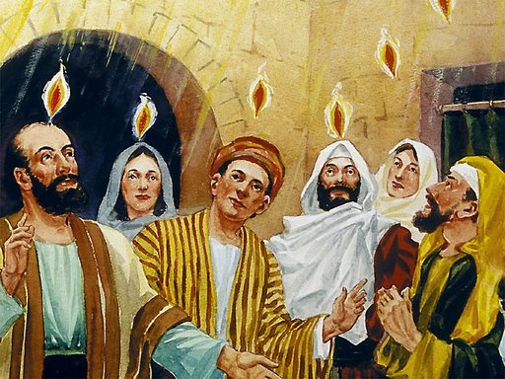
At Pentecost the Holy Spirit came like flames of fire to dwell in believers,
uniting them with Christ and distributing various spiritual gifts
- Let all believers lovingly serve one another, each with their special gifts from God.
Find in Romans 12:4–8:
- Who should benefit from other believers’ spiritual gifts? Verse 5
- How does God decide which gifts to give to each believer? 6
- What are two kinds of speaking gifts? 6-7.
- What are three kinds of serving gifts? 7-8
Find in 1 Corinthians chapter 12 how the Holy Spirit gives powerful abilities to every believer to serve one another.
- Who gives spiritual gifts and abilities? Verses 3–6
- Which believers receive spiritual gifts? 7-11
- For what purpose does the Holy Spirit give gifts? 7
- Who chooses which gift a believer will receive? 11
- Which Christians have God’s Holy Spirit? 12-13.
Find in 1 Corinthians 14:24–26:
- In what ways can every believer serve others in meetings?
- What should be every believer’s purpose in using spiritual gifts?
Find in Ephesians 4:10–16:
- Who gives gifted people to congregations? 10-11
- What five kinds of gifted persons does Christ give to congregations? 11
- What should gifted persons do with their spiritual gifts? 12
- What happens when congregations exercise their spiritual gifts? 13-16
Find in 1 Peter 4:7–11:
- What attitude should we have towards one another as we use our gifts? 7–9
- What are believers to do with their spiritual gift? 10.
- What are these two main kinds of spiritual gifts? 11
- Where do gifted servants find strength to use their gifts? 11
- Whom should believers glorify with their spiritual gifts? 11
Find how Barnabas used his gifts of giving (Acts 4:32-37), of encouragement (9:22-27), of faith (11:22-66), of teaching (13:1), and of apostleship (13:2-4).
New Testament Spiritual Gifts
Romans 12 | 1 Corinthians 12 |  | Ephesians 4 | 1 Peter 4
Encourage  Give  Lead  Mercy  Prophesy  Serve  Teach | Administer  Discern  Heal  Interpret  Languages  Prophesy  Apostle | Faith  Help  Speak knowledge  Speak wisdom  Work miracles  Teach | Apostles  Prophets  Evangelists  Shepherds  Teachers | Serve  Speak
There are two main kinds of gifts: (a) those that enable believers to serve
each other, and (b) those that enable believers to speak helpful messages.
- Guidelines to operate by spiritual gifts
- As people serve one another in small groups their spiritual gifts become apparent, and others will recognize them.
- Let new believers serve and discover their gifts.
- Provide opportunities for all believers to use their spiritual gifts. This is best done in small groups. Do not limit meetings to simply listening to talented people.
- Remind believers that they must have love for people when they use their spiritual gifts. When people are angry or unloving, then their gifts can harm people.
- Let people have responsibilities and ministries according to their spiritual gifts. Do not assign people to jobs for which they lack the corresponding gift.
- Elders should have a speaking gift, and deacons should have a serving gift.
- Small groups and ministry teams should have members with different gifts that the Holy Spirit can harmonize. Avoid grouping persons who have the same gift, has that limits the ways in which they can serve each other.
- Having a spiritual gift does not confer authority over other believers. Rather, spiritual gifts must be used to serve the Body of Christ in a manner that seeks the benefit of others.
- Since every believer has spiritual gifts that benefit others, every believer is important to the others regardless of their ethnicity, educational level, caste or social class.
- Plan with your co-workers additional activities for the coming week
- Review together Paul-Timothy study #86 “Understand Better God’s Spiritual Gifts”. Plan to review both that study and this one with all small group shepherds.
- Visit believers to help them put into practice their spiritual gifts.
- Plan with your co-workers additional activities for the up-coming worship.
- Tell how Barnabas used his gifts, and find why they changed his name (Acts 4:36).
- Explain that God determines the spiritual gifts that a believer receives, with what motive we are to use them and the other guidelines (See Part 1.)
- Let believers tell how others have helped them by using their spiritual gifts.
- Read together 1 Corinthians 14:24–31, and let believers tell about how they have seen any of those gifts exercised in the congregation or small groups.
- To introduce the Lord’s Supper, read 1 Corinthians 11:23-34. Explain how the Corinthians misused the Lord's Supper and why the Lord let some get sick and die.
- Have the believers form small groups of two or more to talk about their spiritual gifts, to listen to each other, to encourage one another, and to pray one for another.

