Pray with Effective Faith
Anchor command. “Until now you have asked for nothing in my name; ask and you will receive, so that your joy may be made full.” John 16:24
Anchor story. Daniel survives in a lions’ den. Daniel, chapter 6
Anchor verse. “Hear my prayer, O God; Give ear to the words of my mouth.” Psalms 54:2
Learning goal. Be familiar with scriptural teaching about prayer.
Growth goal. Prayer includes praise, confession and thanksgiving, as well as petitions.
Skill goal. Pray constantly for definite things, such as healing, more workers, etc.
Outcome goal. All believers and their families pray daily with fervent faith.
Basic Study
Heavenly Father, please, give us wisdom and faithfulness to lead your flock to seek you and to talk to you often about everything we need.
Daniel prayed daily.
Learn from Daniel 6…
- Why did King Darius plan to appoint Daniel over his other government officials? Verse 3
- What was the trap that the jealous commissioners plans to set for Daniel? Verses 4-9
- In what way did Daniel defy the king’s edict? Verses 10-11
- What was the king forced to do to Daniel because of his own edict? Verses 12-16
- What did God do for Daniel? Verse 22
- What did the king do to Daniel’s false accusers? Verse 24
- What did King Darius decree as a result? Verse 26
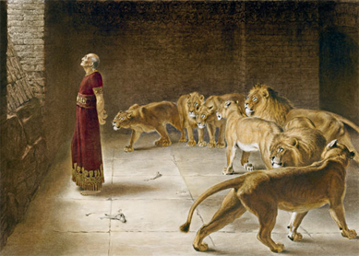
Daniel in a lions’ den
During the week…
- Meet with believers who have not yet learned to pray as they should, and help them to do so, praying with them, setting an example.
- Meet with your coworkers to pray for specific needs and people.
During worship…
- Tell the story of Daniel in the lion’s den, and ask the above questions. Urge the believers to discuss the answers.
- Pray for any who need healing or some other help from God.
- Ask the children to present what they have prepared.
- Memorize 1 Thessalonians 5:17, “Pray continually.”
Advanced Study
- Find the way each of these believers prayed to God and write down something different about each one:
- Solomon, 2 Chronicles 6:12–17.
- Jabez, 1 Chronicles 4: 9 & 10.
- Hannah, 1 Samuel 1:9–13.
- David, 2 Samuel 7:18–22.
- Daniel, Daniel 9:3–19.
- Christians, Acts 4:24–30.
Note: We may pray to God standing, sitting, kneeling or lying down, with our voice or silently.
- Find how God wants us to pray:
- In secret, Matthew 6:5–8. Note: Christians are always supposed pray in order to be seen and heard by God, never to be seen and heard by other people.
- Forgiving others, Matthew 6:9–15. Note: Christians make many mistakes and commit many sins, so they need to pray to be forgiven by God. But God only forgives us when we forgive others who have offended us.
- With repentance, Luke 18:10–14. Note: No one is good enough to make God answer his prayers. So, we must admit our faults when we pray and never brag about how good we think we are.
- As submissive wives and as gentle husbands, 1 Peter 3:1–9. Note: Our heavenly Father will treat us the same way that we treat our mate.
- With thanks, 1 Thessalonians 5:16–18. Note: God is always good and always answers sincere prayer in a way that is good for us.
- Find how Christian prayer is different from the prayers of other religions:
- Using Jesus name, John 15:16; 16:24.
- By the Holy Spirit, Jude 20 & 21.
- Calling God ‘Father’, Matthew 6:9.
- Find and write down some things God wants believers to ask from him:
Matthew 6:9-13.
Acts 4:27-30.
Ephesians 1:15-20.
James 1:2-5.
James 5:13-16.

Plan with your co-workers additional activities to do during the week.
- Arrange to visit congregation members who have needs and pray with them
- Walk through places where there are few or no Christians, praying for the people. Ask God to bless them and to show you which homes are ready to believe the Good News.
- Visit new believers and show them how to pray daily as a family and in private.
Christian families pray together in their home.

Plan with your co-workers additional activities to do during worship.
- Have the congregation recite together the prayer Jesus taught in Matthew 6:9–13.
- Teach the flock to pray by explaining the above truths about prayer.
- Bible texts like those in section 1, and lead the flock to pray about things they need.
- Encourage the believers to pray daily as a family and in private.
- To introduce the Lord’s Supper: ·
Tell from Daniel chapter 1, how Daniel’s three friends chose better food than that which God's laws forbade at that time.
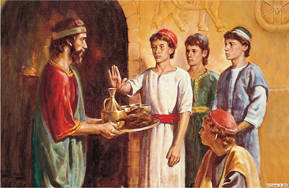
Daniel and his friends chose not to eat or drink food that God had forbidden.
With only vegetables and water, they remain strong and grew wise.
Explain that we eat the best food of all at the Lord’s Supper.
- Have the believers pray, thanking God for Jesus, the Bread of Life, for His blood that cleanses from all sin, and. for the other good things they have received from God.

