Heal in Jesus’ Name
Anchor command. “Heal the sick.” Matthew 10:8
Anchor story. Jesus heals blind Bartimeus, John 9
Anchor verse. “By the name of Jesus Christ the Nazarene, whom you crucified, whom God raised from the dead--by this name this man stands here before you in good health.” Acts 4:10
Learning goal. Discover the scope of God’s instruction for physical healing.
Growth goal. Have confidence in Jesus’ powerful name, to heal.
Skill goal. Command sicknesses in Jesus’ name to leave the victims.
Outcome goal. Believers commonly heal the sick in Jesus’ name.
Heavenly Father, your love for us believers never wanes. Help my flock to trust you when they are sick and when they suffer.

Basic Study
Learn from the account of Jesus healing blind Bartimeus, John 9.
- What false assumption did Jesus’ disciples make about blind Bartimeus? Verses 1-3
- What did Jesus tell Bartimeus to do, after applying mud to his eyes? 6-7
- What was the Pharisees’ complaint? 13-16
- Why were Bartimeus’ parents afraid to say that Jesus had healed him? 18-23
- What things did Bartimeus say to those who questioned him that angered them and moved them to throw him out of the temple? 34-34
- Why did Jesus say he had come into the world? 39-41
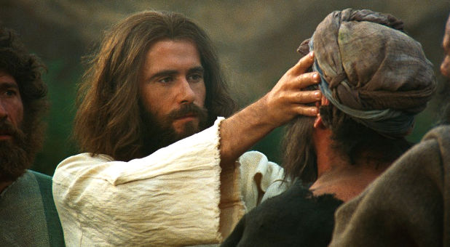
By healing the blind and others, Jesus showed his divinity, his authority and his compassion.
During the week visit people who are sick and heal them by the power of Jesus’ name.
During worship…
- Tell the account of Bartimeus’ healing, and aske the same questions as above; let believers discuss the answers.
- Ask the children to present what they have prepared.
- Memorize James 5:15: “The prayer of faith shall heal the sick, the Lord shall raise him up, and if he has committed sins, they shall be forgiven him.”

Advanced Study
- Lead your flock to minister to the sick and suffering.
- When believers are sick or suffer, God always has a purpose for it. Our task is to help folks learn God’s purpose and to trust him.
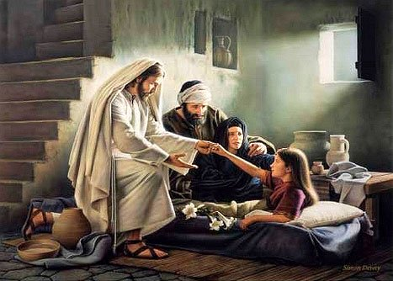
Jesus brought back to life a girl who had died.
Find in Mark 10:46–52 …
- How serious was Bartimeus’ suffering?
- What did Bartimeus believe that Jesus can do for people?
- What was Bartimeus’ request?
- What did Jesus see in Bartimeus that moved Jesus to grant Bartimeus’ wish?
Find in John chapter 9…
- What was God’s purpose for letting the man be born blind? (Verses 1–3)
- What did the blind man have to do to be healed? (6–11)
- What did Jesus want the blind man to believe about him? (35–38)
- What was God’s purpose for those who refused to believe in Jesus? (39-41)
Find in Hebrews 12:5–14…
- How does God look upon believers who suffer? (verses 5–8)
- What good things does God wants to bring out of our suffering? (9–11).
- What kinds of actions should we take if our conduct has been crooked? (13).
- What kinds of actions should we take if we have treated others badly? (14).
Find in James 5:13–20…
- What should believers do when they are suffering? (Verse 13)
- What should believers do when they are sick? (14)
- What should congregational leaders do for sick believers? (14)
- What must sick believers do if they have committed sins? (15)
- What kind of prayer makes sick believers well? (15)
- What happens when a sinner returns to the truth? (19-20).
- Plan with your co-workers additional activities of the coming week.
- Whenever you visit a home and learn that someone there is sick, offer to pray for the sick to be healed as a testimony of God’s mercy and power.
- In Let each church leader obtain a small bottle of clean oil to carry with them to anoint the sick when they go calling at believers’ homes.
- Go and visit the sick and suffering believers of your flock, counsel with them, then pray for them.
- Plan with your co-workers additional activities for the next worship time.
- Explain how God heals the sick in Jesus’ name
- Read the account of the ten lepers from Luke 10:11-19.
- Let the believers give thanks and testimonials about recent healings
- To introduce the Lord’s Supper, read or tell the story of the miraculous bread called manna that God gave to Israel, Exodus 16.
- Explain that Jesus is the true bread that comes down from heaven, and that we enjoy his life-giving power when we take communion with faith.
- Form small groups to encourage, pray and bring healing to one another.
- Those who teach children should read study #92 for children.
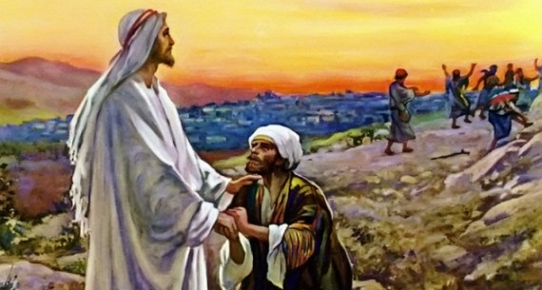
Of then lepers whom Jesus healed, one returned to thank him.

