Three Faithful Men Walked amid Flames
Dear Lord, please prepare our children to face persecution with the same faith and courage that those three devout Jewish men had, when the king threw them into a fiery furnace.
Choose any of these children's learning activities that fit their ages.
- Let an older child or teacher read or tell by memory the story from Daniel chapter 3.
It tells about three brave men who faced death by fire rather than worship an idol.
Ask these questions. [Answers from Daniel chapter 3 appear after each question.]
- What did the king command the people to do in front of his idol? [See verse 5]
- What did he do when he heard that three men did not worship his idol? [Verse 13]
- What did the three men tell the king that God was able to do? [Verse 17]
- Were they willing to die if God chose not to rescue them? [Verse 18]
- What happened to the soldiers who threw them into the fire? [Verse 22]
- How many men did the king see in the fire? [Verse 25]
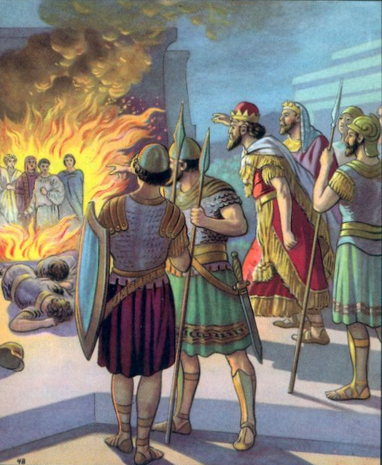
An angel from heaven kept three faithful men sage, when
an evil king threw them into a fiery furnace.
- Dramatize parts of the story about the three brave, faithful men, from Daniel 3.
- Arrange for the children to present this brief drama to the adults.
- Use your time with the children to prepare the drama.
Older children help the younger ones prepare.
- You do not have to use all the parts.
- Older children or adults play these parts: Narrator. Summarize the story and help the children recall what to say and do. King (Nebuchadnezzar). Hold something that represents an idol. Chief Official. Roll up paper to represent a horn.
Younger children play these parts: Shadrach, Meshach, Abednego, Officer (Of the king) Also roll up paper to represent a horn. Soldiers. Hold sticks for spears and string for rope
Narrator Tell the first part of the story from Daniel 3:1-13. Then say,
“Hear what King Nebuchadnezzar says.”
Nebuchadnezzar Put the idol where everyone can see it. Then say,
“I command all of you to worship this idol that represents me.
If you do not bow before it when you hear the music
then I will have you thrown into a fiery furnace!”
Officers and Chief Official
Blow the horns noisily. Then bow to the idol.
Shadrach, Meshach and Abednego
Walk in front of the idol but remain standing.
Soldiers Bow down until the horns stop blowing.
Officers Stop blowing the horns, and go to the king.
Chief Official “Great King, three of your officials refuse to bow to your idol.”
King (Angrily) “Soldiers! Go and bring those traitors to me at once!”
Narrator Tell the second part of the story from Daniel 3:14-23. Then say,
“Hear what King Nebuchadnezzar asks the three men.”
King “Why did you not worship my idol?”
Shadrach Point up and say, “We worship only the one true God.”
Meshach “The Almighty can rescue us if he wishes.”
Abednego “Even if God lets you throw us into the fire,
we will not worship your idol.”
King (Shout) “Soldiers! Make the fire seven times hotter!
Throw them into the flames!”
Soldiers Pretend to tie up the three men and push them into a corner
representing the furnace.
Then scream in pain, drop your spears and fall down dead
from the heat.
Narrator Tell the third part of the story from verses 24-30. Then say,
“Hear what King Nebuchadnezzar says.”
King Look into the furnace.
“We threw three men into the furnace but I see four!
The fourth man looks like the Son of God!
Shadrach, Meshach and Abednego, come out!”
Chief official “Look! Their ropes burned off,
but they do not even smell like smoke!”
King “Shadrach, Meshach and Abednego, now I see that
your God is more powerful than any idol.”
Narrator Thank all who helped with the drama.

- If the children dramatize this story for the adults then let them also pose to the adults the queries listed under #1 above.
- Draw a picture of three men standing in flames, and let the children copy it.
Children might like to copy or colour the picture found at the end of this lesson.
Have the children show their pictures to the adults at the next worship time,
and explain that this illustrates how God helps us to face persecution.
- Have the children tell other examples of when God’s people have suffered persecution.
Tell about times also when God has rescued them.
- Smaller children memorize James 1:2; older ones memorize James 1:2-4.
- Let four children each recite one of the verses from Psalm 138:4-7.
- Older children write poems or songs about the week’s topic.
- Have an older child pray:
“Dear Lord, we do not always feel brave like the three Israelites. Help us to trust you when we face persecution. You can rescue us. But even if we suffer for you, we want to be faithful to you always, because you will always be with us.

