Jesus Taught with Stories
Dear God, help us all to learn to forgive others, from Jesus’ story about the unforgiving servant.
Use any of these learning activities that fit current needs.
- An older child or adult tells the story of an unforgiving servant. Matthew 18:21-34.
Then ask:
- What command of God did Jesus illustrate with this story? Verse 21.
(Answer: to forgive.)
- Should we ever stop forgiving people? 21-22. (Answer: We must always forgive.)
- What did the master do for the servant who could not pay his debt? 23-27
- What did that servant do to another servant who owed him a little money? 28-30
- How did the master respond to the unforgiving servant’s refusal to forgive? 31-34
- How does our Lord in heaven want us to treat those who do us wrong? 35.
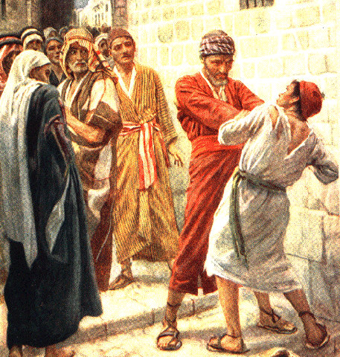
An ungrateful man who had been forgiven
a big debt would not forgive another
man that owed him a small debt.
- If the children present the drama to the adults then let the children also ask the adults the questions under #1 above.
- Older children write poems, songs or brief skits about Jesus’ story of the forgiving servant.
- Memorize Matthew 13:34:
“All these things Jesus spoke to the crowds in parables, and he did not speak to them without a parable.”
- Children may copy this picture of an unforgiving servant.
- Some children may like to copy or colour the picture found at the end of this lesson.
Copyright © Gospel Light. Used by permission.
- Dramatize the story of the unforgiving servant.
- Arrange for the children present this drama for the adults.
- Use your time with the children to prepare the drama.
Let older children help younger ones to prepare.
- Older children or adults play these parts:
Narrator,
Master (with paper],
Selfish Servant.
Younger children play these parts:
Poor Servant
King,
Jailer
Narrator: Tell the 1st part of the story, verses 21-27.
Explain that Peter asked Jesus how many times
he should forgive someone. Then say,
“Jesus answered with a story about a Master whose servant
owed him a lot of money. Listen to the Master.”
Master: “This paper is your loan agreement: you owe me a very large debt.
Pay me what you owe me, or I will sell you and your family as slaves!”
Selfish Servant: Kneel and beg, “Have mercy! I will pay. Please have mercy!”
Master: Tear up the paper and say,
“I will have mercy on you. I forgive all your debt.”
Narrator: Tell the next part of the story, verses 28-35. Then say,
“See what the Selfish Servant does.”
Selfish Servant: Leave the king; go and shake the Poor Servant and say,
“Pay what you owe me! Now!”
Poor servant: (Kneel) “Please have mercy, master. I will pay you soon.”
Selfish Servant: (Shout) “No! Jailer, come and take him away!”
Jailer: Drag the Poor Servant away, and say,
“You will stay in jail until you pay your debt.”
Friends: Go to king and say,
“Master, that servant that you forgive won’t forgive others!
He had a man jailed who owed him a very will small amount of money.”
King: (Call to the Selfish Servant.) “Come here, you!”
Selfish servant: Run to the Master, bow and say,
“I am at your service, great and generous Master!”
Master (Angrily), “Why did you not forgive like I forgave you?
Jailers, take him away!”
Jailer: Drag away the Selfish Servant saying,
“You will stay in jail until you pay.”
Narrator: Thank those who helped with the drama.
- Ask the children to give other examples of stories that Jesus told to teach us
about the kingdom of God.
- Draw a king’s royal crown and let the children copy it.
Have the children show their pictures to the adults, or to their parents,
and explain that the king’s crown illustrates Jesus’ story about the two debtors.
- God is our spiritual King. We owe him everything.
Sometimes we do not serve him as we should, but he forgives us.
- We should forgive others just as Jesus our Master has forgiven us.

A King’s Crown
- Three children each recite one of the verses from Psalm 45, verses 1, 2 and 4.
- Have an older child pray:
“Dear God, help the children repeat Bible stories to their friends in the way that their friends will pass the stories on to others to learn important truths.
A more detailed drama dealing with what Jesus taught about forgiving others:
http://biblestoryskits.com/014-jesus-tells-peter-how-many-times-to-forgive-2/
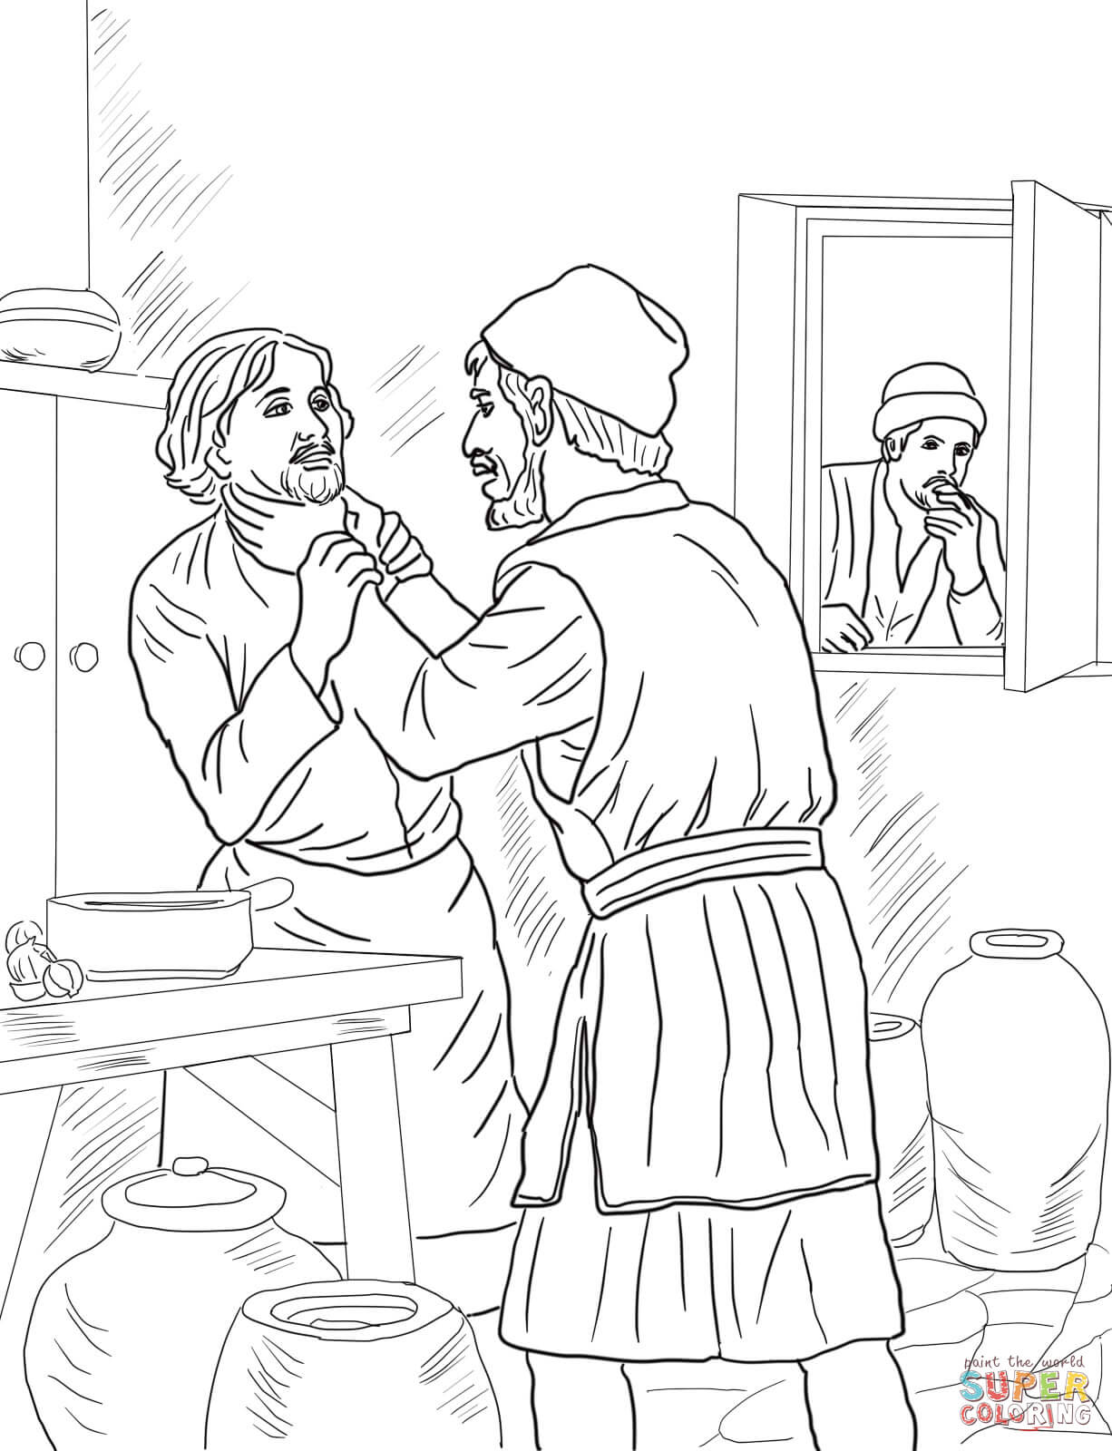
A king forgave a man his big debt, but the man would not forgive
another man his little debt.

