John the Baptist Baptized Jesus
Dear Lord, please use this study to help the children to see that you are One God and that you are also three Persons, which believers call the Holy Trinity.
Choose any of these children’s learning activities that fit their ages and needs.
- An older child or teacher reads or tells by memory about Jesus’ baptism, Matthew 3:1-17.
Explain:
- Jesus’ baptism showed the three Persons of the Trinity working together.
- The three Persons are one God and work as one; they are not three gods.
- This truth of three Persons in One God is a mystery that only God fully understands.
Ask these questions [Answers appear after each question]:
- For whom was John preparing the way? [See verse 3]
- What did folks do when John baptized them? [They confessed their sins, verse 6.]
- Of what did John warn religious people who did not confess their sins? [8]
- With what would Jesus baptize people who repented? [With the Holy Spirit, 12]
- Why did Jesus ask to be baptized? [To do what was right, as a model for sinners, 15]
- In what way did each Person of the Trinity appear at the baptism?
[The Son was baptized, the Spirit descended on him, and the Father spoke, 16–17.]
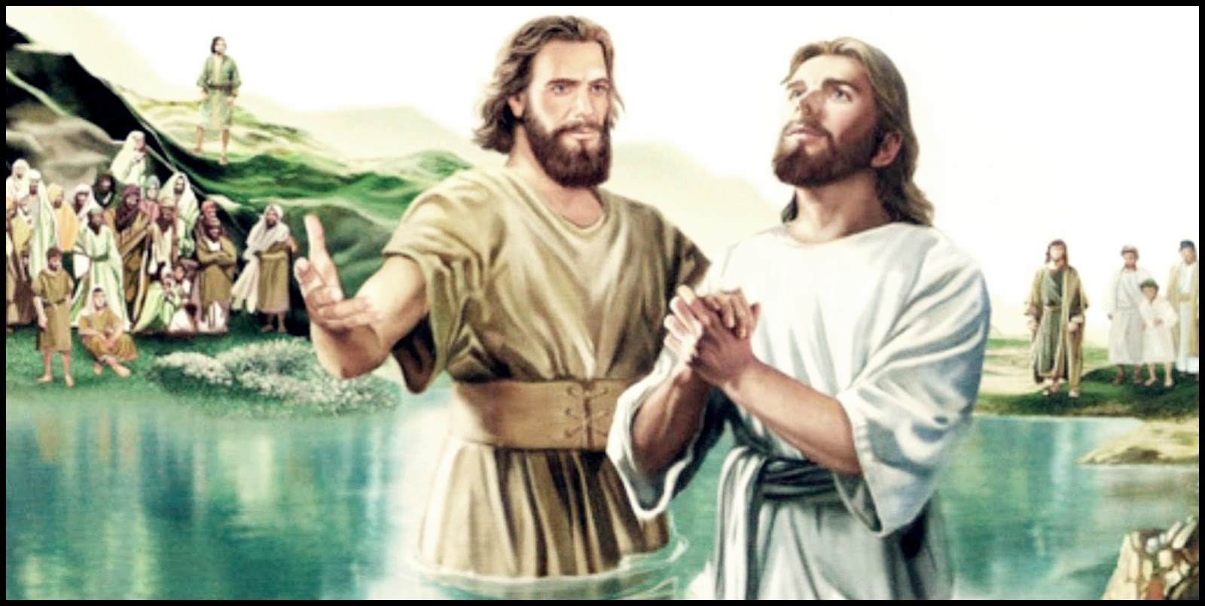
Jesus came to John, asking him to baptise him. We follow Jesus by asking to be baptised.
- Dramatize the story about how the Trinity appeared at Jesus’ baptism (Matthew 3:1-7).
- Arrange with the worship leader for the children to present this drama.
- Use your teaching time with the children to prepare the drama.
Let older children help the younger ones to prepare.
- You do not have to use all the parts of the drama.
- Older children or adults play these parts:
John the Baptist, Jesus, Narrator
Younger children play these parts:
Observers, Pharisee, Sadducee.
Narrator Tell the 1st part of the story from Matthew 3:1-12. Then say:
“Hear what John the Baptist says.”
John (Shout) “Prepare for the Lord’s coming by repenting of your sins.”
Observers (Some say) “I repent of my sins.”
(Others say) “Please baptize me.”
Pharisee “I am a very religious Pharisee. I do not need to change my life.”
Sadducee “I, a Sadducee, will be baptized to show how good I am.
I need not repent!”
John (Shout) “You Pharisees are snakes! Change your hearts!
Soon someone is coming who will baptize you with the Holy Spirit.
Obey God or you will face judgment fire.”
Narrator Tell the 2nd part of the story from Matthew 3:13-17. Then say:
“Hear what Jesus says to John the Baptist.”
Jesus “John, you must baptize me.”
John “But Jesus, I am not worthy to do so.
It is you who should baptize me!”
Jesus says, “This is necessary, to do what is right.
I must serve as an example to sinners.”
John Pretend to baptize Jesus. Then point up and say:
“Look! The Holy Spirit is coming down from heaven
like a dove, upon Jesus.”
Observers (Point upward)
(Some shout) “Listen!”
(Others say) “A voice from Heaven!”
John “Did you hear what God the Father said from heaven about Jesus?
He said, ‘This is my Son, whom I love’.
God spoke to us!”
Narrator Thank everyone who helped with the drama.
- If the children dramatize this story for the adults, then let them also ask the adults the questions under #1 above.
- Ask:
What are other examples of ways the Persons of the Trinity work together,
since they are one God?
Let the children give examples if they can.
[Examples include creation, Jesus’ resurrection, and our salvation.]
- Memorize Luke 9:35:
“Then a voice came out of the cloud, saying, ‘This is my Son, my Chosen One; listen to him!’”
- Let four children each recite a verse from Psalm 2:7, 8, 10 & 11.
- Let the children draw a picture of a dove descending.
- Show the pictures to the adults during worship and explain that it shows how Jesus baptizes us with the Holy Spirit when we ask God to save us from our sins on.
- If older children prefer, let them draw a chart of the Persons of the Trinity.
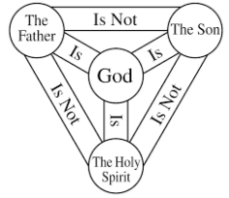
- Some children might like to copy or colour the picture found at the end of this lesson.
- Let older children write a song or poem about Jesus’ baptism or the Trinity.
- Have an older child pray:
“Holy God, You are the One, True God. We praise you for being Three in One, Father, Son, and Holy Spirit. We do not understand this, but we believe in you. Thank you for baptizing us with your Spirit into the life that Jesus gives, so that we can be your children.”
A more detailed drama, about the three persons of the Trinity taking part in Jesus’ baptism:
http://biblestoryskits.com/002-john-baptizes-jesus-and-the-three-that-are-one-take-part/

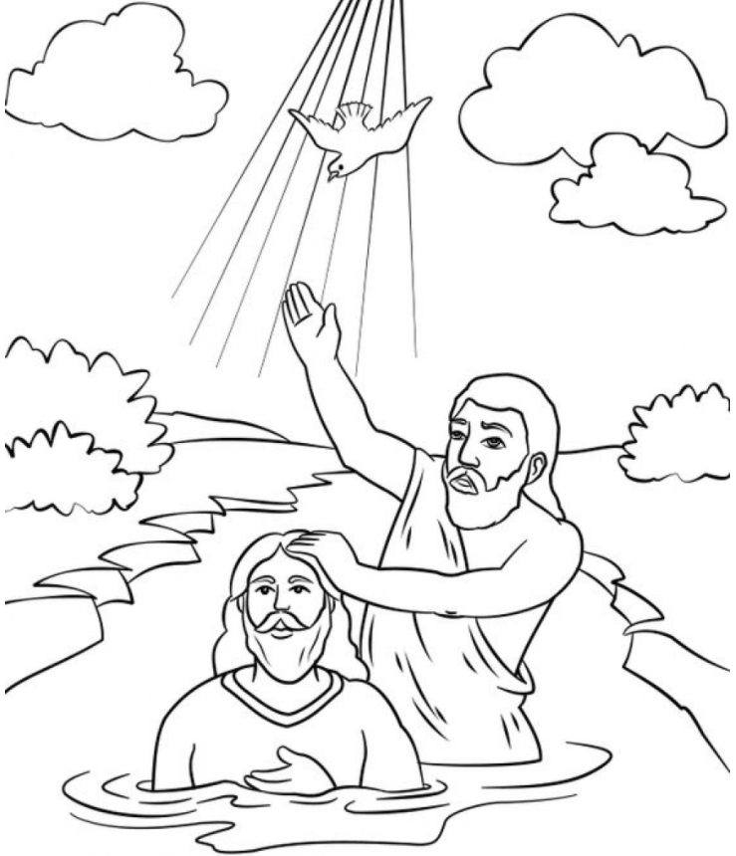
Jesus came to John, asking him to baptise him. We follow Jesus by asking to be baptised.

