The Father, the Son and the Spirit
Are One God
Anchor command. “Go therefore and make disciples of all the nations, baptizing them in the name of the Father and the Son and the Holy Spirit,” Matthew 28:19
Anchor story. John the Baptist baptizes Jesus, and all three persons of the Trinity appear. Matthew 3
Anchor verse. “After being baptized, Jesus came up immediately from the water; and behold, the heavens were opened, and he saw the Spirit of God descending as a dove and lighting on Him, and behold, a voice out of the heavens said, “This is my beloved Son, in whom I am well-pleased.” Matthew 3:16-17 [Notice that all three persons of the Trinity are present.]
Learning goal. Find the biblical basis for belief in the Trinity.
Growth goal. Believe in the Trinity, even though no one can explain its mystery of three-in-one.
Skill goal. Defend the truth of the Trinity when people deny or question it.
Outcome goal. Believers love all three persons of the Trinity, and discern their different roles and operations in Scripture.

Dear Lord, help us to value what Jesus and His apostles taught, that the Heavenly Father is God, that God came to us as Jesus, and that the Holy Spirit is God’s all-powerful Spirit.

Basic Study
Learn about the Trinity from the account of John the Baptist and Jesus’ baptism, Matthew 3.
- Where was John and what was he doing, when Jesus came to be baptized? Verses 1-13
- Why did John not want to baptize Jesus at first? 14-15
- Upon being baptized, what did Jesus see descend from heaven? 16
- What did the voice from heaven say? 3:17
- Notice that all three persons of the Trinity took part in Jesus’ baptism.

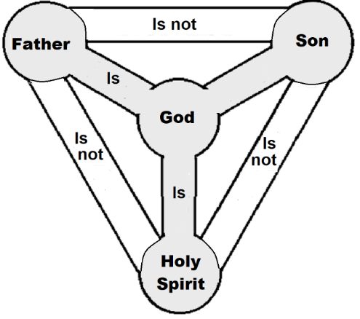

The One True God is three distinct Persons
During the week.
- If believers have trouble understanding the Trinity, or have been confused by false teachers, then visit them and explain these truths:
- Jesus is eternally the Son of God, became human and will forever be God and human.
- The Trinity is not three gods. It is One God who is Father, Son and Spirit. This reality is more like multiplication than like addition. 1 × 1 × 1 = 1
- God is One and is also three Persons. This is a mystery that no human can explain. We do not add them as though they were separate persons, for they remain forever united.
During worship.
- Tell the account of Jesus baptism, and ask the same questions as above.
Let believers discuss the answers
- Ask the children to present what they have prepared.
- Memorize together Matthew 3:16-17. “After being baptized, Jesus came up immediately from the water; and behold, the heavens were opened, and he saw the Spirit of God descending as a dove and lighting on Him, and behold, a voice out of the heavens said ‘This is my beloved Son, in whom I am well-pleased’.”
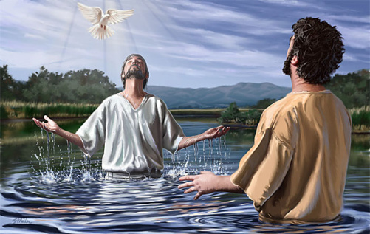
When John baptized God’s Son Jesus, he heard God’s voice and saw God’s Spirit.

Advanced Study
- Roles of each member of the Trinity.
All three persons of the Trinity share the same divine attributes, but do different operations.
The Father’s eternal decrees proceed from his loving authority.
The Son – the creator and eternal Word in the flesh – reveals and submits to the father.
The Holy Spirit carries out what the Father and son want done.
- All three persons of the Trinity cooperate in carrying out every aspect of God’s saving work, as seen in Romans 1:1 and many more Bible passages:
The father decrees our salvation from before the foundation of the world;
The son died and rose again in our place to make our salvation possible;
The Spirit applies Jesus’ resurrection power and forgiveness to born-again believers.
- Learn what Scripture teaches about the Trinity.
- Find in John 14:23-26 what Jesus said about the Father, the Holy Spirit and himself?
- Find in John 5:19-30 who we honor when we honor the Son, and why this is so.
- Remember these important truths:
- The Trinity is eternally God who exists beyond the material world with its time and space.
- God became human in the persons of Jesus by entering time (at his birth) and at a place (Bethlehem).
- Jesus was born as a human. He showed both divine power and human weakness.
- Test yourself: Which of these ideas are true according to Jesus and the New Testament?
- Jesus does work that only God can do. [ ] True; [ ] False.
- Jesus speaks to the Father and the Father spoke to Jesus. [ ] True; [ ] False.
- Jesus sends the Holy Spirit to us, and Jesus comes to us as a Spirit. [ ] True; [ ] False.
- When we honor Jesus we honor God. [ ] True; [ ] False.
- We can pray to the Father and to the Son and to the Spirit. [ ] True; [ ] False.
[Answer: All of these ideas are true.]
- It took Christians over three centuries to agree on the truth of the Trinity.
- Two fourth century Egyptian theologians argued about who Jesus was:
- Arius denied the Trinity and emphasized God’s unity. He said that the Word of God came down on Jesus at his baptism, making him the Messiah, called “the Son of God.” His teaching spread widely in the Roman Empire.
- Athanasius taught that the Son of God is the Living Word who was with the Father even before Jesus was born and baptized, and that the One God is eternally Two, Father and Son. Then he saw that the Holy Spirit is also God, and taught that the One God is eternally Three, the Father, Son and Spirit.
- In AD 325 leaders from churches across the Empire met in Nicaea and most of them recognized that Athanasius’ teaching was more biblical than Arius’ ideas. So, they approved Athanasius’ definition of Trinity. Today, most Christians accept Trinity as true. Those who deny it are called Arians.
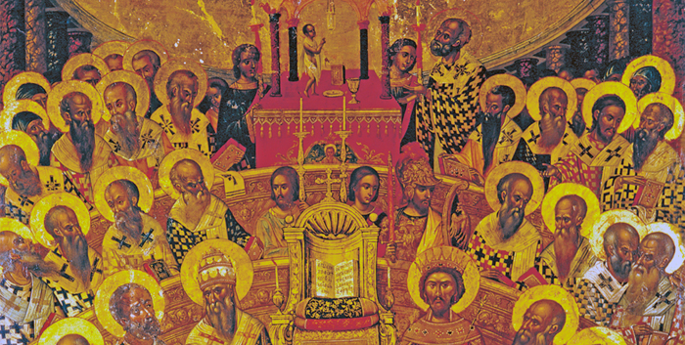
An ancient artist portrayed the Council of Nicaea

- Some false religions say they are Christian, yet they refuse to honor Jesus as God.
- Jehovah’s Witnesses deny that Jesus was God and that he rose from death in his body.
- Mormons say that Jesus became a god after he died and that Mormons will become gods.
- Islam teaches that Jesus never was God and that He did not die and rise again.
- None of these honor the Son the way the Bible commands, giving him the same honor we give to the Father (John 5:19-30).
- Plan with your co-workers activities for the coming week.
- If believers in your flock have trouble understanding the Trinity, or have been confused by false teachers, then visit them and explain these truths:
- Jesus is eternally the Son of God, became human and will forever be God and human.
- The Trinity is not three gods. It is One God: Father, Son and Spirit.
This reality is more like multiplication than addition: 1 × 1 × 1 = 1
- God is One and is also three Persons. This is a mystery that no human can explain. We do not add them, as though they were separate persons; they are united.
- Jesus is eternal God, and he became a human. He is both God and human. It is false to say that Jesus was only human and that Christ was a spirit sent from God to be in Jesus.
- The Father and Son communicate and cooperate eternally. After the Son became human, he and the Father continued to communicate and cooperate. Thus, it is false to say that if Jesus were God, He would not have to pray to the Father.
- The word ‘Trinity’ is not found in the Bible. We use it to describe what we find in the Bible, that is, the Unity of the Father, Son and Spirit. It is false to say that the Trinity was invented by Roman Catholics.
- Plan with your co-workers additional, optional activities for the upcoming worship.
- Read Romans 1:1-4 and explain how the Trinity is involved in our salvation, in our holiness, in our testimonies for Jesus, and in everything we do for God.
- Explain what you have learned in this study.
- Tell about the debate between Athanasius and Arius.
- To introduce the Lord’s Supper, read Matthew 3:13-17. Explain that God the Father, God the Son and God the Spirit work together in the Lord’s Supper just like they did in Jesus’ baptism. The Father decrees that innocent blood be shed to cover sins; the Son shed His blood; the Holy Spirit makes us participate in Jesus’ body and blood when we take the bread and cup (1 Cor. 10:16-17).
- Form small groups of two or three people, to pray, confirm activity plans and encourage one another.
- Those who teach children should read study #98 for children.

