Moses Helped His People Know God
Anchor command. “Hear, O Israel! The Lord is our God, the Lord is one! You shall love the Lord your God with all your heart and with all your soul and with all your might.” Deuteronomy 6:4-5
Anchor story. God revealed himself to Moses from the burning Bush. Exodus 3.
Anchor verse. “With most of them God was not pleased, for they were overthrown in the wilderness. Now these things took place as examples for us, that we might not desire evil as they did.” 1 Corinthians 10:5-6
Learning goal. Know the importance of God’s calling and commissioning Moses.
Growth goal. Appreciate how Moses by knowing God helped others to know God.
Skill goal. Enable believers to discover vital truths about God in the Pentateuch.
Outcome goal. Believers know God by learning from both the Old and New Testaments.
Almighty and merciful God, help me to teach your people what you are like, by telling them how you revealed yourself to people through Moses.

Basic Study
Moses meets God at a burning bush, Exodus 3.
- What was unusual about the burning bush that caused Moses to go see it? 3:1-3
- What did God tell Moses to do when he drew near to the bush? 4-5
- What was happening in Egypt that caused God to take action? 6-9
- What did God commission Moses to do? 9-12
- What was God’s name, by which he would be known to the children of Israel? 13-15
- What was Moses to tell the elders of Israel? 16-17
- What was it that God knew the king of Egypt would refuse to do, except under the compulsion of miraculous plagues? 18-20
- How did God provide for the Israelites to travel a long time in a wilderness? 21-22
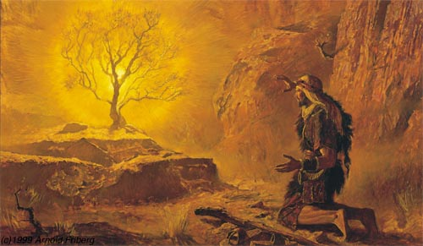
God spoke to Moses through a burning tree, commissioning him to return to Egypt.
During the week visit, counsel and pray with believers who misunderstand basic truths about God, and help new leaders do the same.
During worship
- Tell the account of Moses and the burning Bush, and ask the same questions as above. Let believers discuss the answers.
- Ask the children to present what they have prepared.
- Memorize together John 1:17: “The Law was given through Moses; grace and truth were realized through Jesus Christ.”

Advanced Study
- God revealed himself to Moses and the Israelites.
- Background:
- About 4,000 years ago, God chose the descendants of faithful Abraham to be His holy people, Israel.
- About 500 years later, God miraculously freed Israel from slavery in Egypt and established through Moses the Old Testament covenant of law. They learned to fear and obey the one holy, all-powerful God. Their experiences are examples for us today (1 Cor.10:6).
- About 2,000 years ago, God replaced the old covenant of law with the new covenant of grace for all peoples, when Jesus died and rose back to life for them.
- Find in Exodus 1 why Egypt’s king feared the Israelites and planned to limit their numbers. (Later, similarly, King Herod would kill the boy babies in Bethlehem in his attempt to destroy the newborn king, Jesus.)
- Find in Exodus 2 how God saved baby Moses from death, and what happened when Moses tried to save his people by his own human effort.
- Find in Exodus 3 what God’s holy Name is.
God revealed to Moses his eternal Name, Yahweh, translated in English as the LORD.

- Be prepared to dispel pagan beliefs, some of which persist in modern societies.
- Explain why Christians reject fatalism, the cruel, demonic idea that gods or stars know our destiny in advance, and we cannot change our fate of poverty, pain and failure.
- The eternal I AM lives outside of time; He made time, and it does not rule over Him. Jesus said, “The hour is coming” (man’s view) “and now is” (God’s view) when He will raise the dead to life or to judgment (John 5:25-29). He also said, “Before Abraham was, I AM” (John 8:58).
- God is everywhere in both time and space. He sees what we will do in the future, but He does not always cause us to do it. His foreknowledge does not cancel our freedom to make life-changing decisions.
- Jesus said, “The truth will make you free” (John 8:32). Free your flock from the cruel chains of fatalism! God knows us, loves us and listens to us. He will intervene in ways that will be good for us and bring honor to him.
- Genesis 1 reveals that our ancestors were men, never gods, spirits or animals, and that God made the stars to mark times and seasons, not to control our destinies
- Explain why we are free from demonic powers.
- When Egypt’s king would not free God’s people from slavery, God enabled Moses to send plagues that revealed God’s power over the false Egyptian gods (Exodus chapters 7–11). The Egyptians believed that their great river, the Nile, had supernatural powers, so God turned its water to blood! They worshipped the sun, so God darkened it. They worshipped animals, so God used cows, lice, flies and frogs to bring pain. Ask Jesus, the one all-powerful God, too free your flock from the fear of false spirits!
- Plan with co-workers additional, optional activities for the next worship time.
- Have believers discuss the truths that you have learned about God.
- Ask and discuss what Egypt’s king did that was similar to Herod’s slaying little boys in Bethlehem.
- Explain why we reject fatalism, and why we are free from demonic powers.
- Ask and discuss how God’s Holy Name, “I AM”, reflects His eternal being.
- Ask and discuss why God’s foreknowledge, since He lives outside of time, does not destroy our freedom of choice. (He sees but does not cause what we decide to do.)
- Ask and discuss what Jesus meant when He said that the truth will set us free.
- Explain how knowing the five books written by Moses (Genesis, Exodus, Leviticus, Numbers, and Deuteronomy) laid a foundation for the rest of the Bible:
Genesis reveals how God created everything from nothing, and how Satan tempted man to disobey, corrupting the world, bringing pain, punishment and death.
Exodus reveals the all-powerful, all-holy God who is supreme over all spirits. God gave to His people the ancient law with the Ten Commandments.
Leviticus reveals how God forgave people’s sins through the blood sacrifice of an innocent victim.
Numbers describes how people failed to obey God’s laws. Thus, God did not allow that generation to enter into the Promised Land.
Deuteronomy reveals that God punishes sin and blesses obedience.
Those ancient laws and events help us understand the great New Testament truths
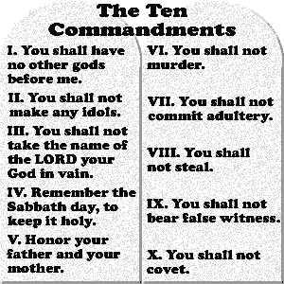
God graciously gave to Israel many laws, including these Ten Commandments.
- Let believers give testimonials about how Christ has freed them from the paralyzing ideas of fatalism, and from being slaves to evil spirits and false gods.
- To introduce the Lord’s Supper, read Exodus 7:17, and explain that Moses' first miracle was to turn water to blood, a curse that was typical of the Old Covenant. Under its laws people obeyed or died; for the letter of the law kills (2 Cor. 3:6). In contrast, Jesus’ first miracle was to turn water into wine to bless people (John 2:1-11). Jesus said of the Communion cup, “This is the New Covenant in my blood” (Luke 22:20).
- Form groups of two or three, to pray for one another and make plans to teach the basic truths about Jesus to friends.
- Those who teach children should read study #99 for children.

