FIRST JOHN 5:1-5
“We love God and keep his commandments”
17 & 20 May 2024
Download from http://1john.currah.download
Discourse structure of 1 John
Part 1: Our Fellowship with God 1.1 – 2.17
Part 2: Our Adversaries 2.18 – 3.18
Part 3: Our Christian Faith 3.19 – 5.5
VIII. We Have Assurance 3.19-24
ΙX. We have God’s Spirit 4:1-6
X. We Have God’s Love 4.7-12
XI. We Have the Savior 4.13-21
XII. We have the Christ 5.1-5
Part 4: Our Confidence with God 5.6-21

1 John 5:1-5, Chiastic structure
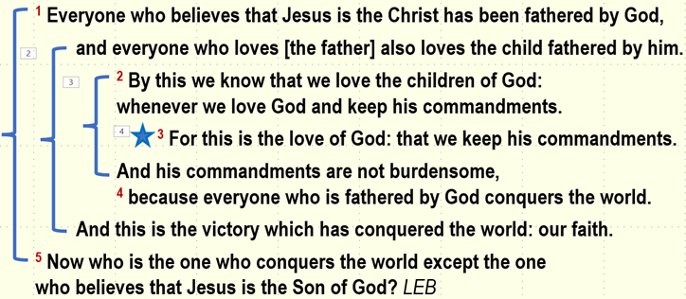
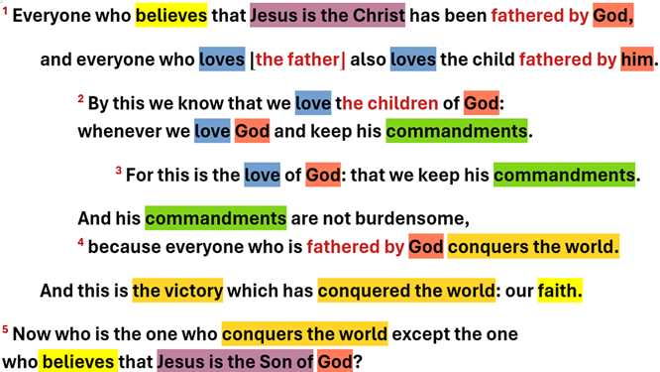

1 John 5:1
¹ Everyone who believes that Jesus is the Christ has been fathered by God. LEB
Who is the Christ (=Messiah)? — 7 views:
● The Christ has not yet come.
● The Christ came but is not human.
● The Christ has come and is Jesus.
● Christ is Jesus’ last name.
● There are many Christs.
● There are no Christs.

‘Fathered by God’
● Loved by God
● Adopted by God
● Made alive by God
● Provided for by God
● Protected by God
● Instructed by God
● Inheritance from God.

1 John 5:5
¹⁴ Now who is the one who conquers the world except the one who believes that Jesus is the Son of God? LEB
What does it mean to conquer the world?
● Free from spiritual oppression.
● Free from cultural trends and obsessions.
● Free from addictions and perverse desires.
● Free from fear false teachers, their doctrines, and their authority.
What is the world?
● Fallen spirits who dictate godless ideas and actions to pagan world leaders.
● Religions, philosophies and ideologies.
● False teachers who deny that the human Jesus is the divine Christ.
● Political officials, administrators, courts, military and police officers.
● Popular media influencers, politically-correct ideas, fashions and memes.
1 John 5:1b
… and everyone who loves [the father] also loves the child fathered by him. LEB
Who is the child?
● [the father] = ‘the begetter’.
● General principle: any father’s child.
● Jesus whom the Father ‘begot’? Matt 1:20 = same Greek verb (gennáō).
● All Christian believers? John 1:13 (gennáō).

1 John 5:4b
And this is the victory which has conquered the world: our faith. LEB
What is ‘our faith’
● Contemporary Christian faith?
● Historical Christianity?
● A theistic worldview?
● Confident trust in Jesus’ promises?
● That the human Jesus = the divine Christ?

1 John 5:2
² By this we know that we love the children of God: whenever we love God and keep his commandments. LEB

● To know: by experience.
● Children of God: See verse 1a.
● Hendiadys: When two verbs describe the same thing: ‘We show our love for God by obeying his commands.’

1 John 5:3a
³ For this is the love of God: that we keep his commandments. LEB

● Love of God: His love for us? Our love for him? Godly love towards others?
● Keep: Obey, continuous present tense.
● Commandments: Old testament contains 613 commands. Jesus gave more than 200 commands (imperatives or ideals).

Seven commands for all Christians
1. Repent and believe! (Mark 1:15).
2. Love! (Mk 12:30; 12:31; Jn 13:34; Lk 6:27).
3. Pray! (Matt. 6:9).
4. Remember! (Luke 22:16).
5. Forgive! (Luke 6:37).
6. Give! (Luke 6:38).
7. Baptize! (Matt. 28:19).

1 John 5:3b-4a
³ And his commandments are not burden-some, ⁴ because everyone who is fathered by God conquers the world. LEB

● His: Whose? (Acts 15:10. ‘heavy yoke’)
● not burdensome: Light yoke. (Matt 11:30)
● Everyone: You and I, too.
● Is fathered: Perfect tense = lasting effect.
● Conquers: Continual present tense.

Assignment: Read 5:6-13 three times in different versions (www.netbible.org).

