FIRST JOHN 5:5-12
“God has given us eternal life”
23 & 26 May 2024
Download from http://1john.currah.download
Discourse structure of 1 John
Part 1: Our Fellowship with God 1.1 – 2.17
Part 2: Our Adversaries 2.18 – 3.18
Part 3: Our Christian Faith 3.19 – 5.5
Part 4: Our Confidence with God 5.6-21
XIII. God’s Testimony 5.6-13
XΙV. Answered prayers 5.14-17
XV. Reasonable conclusions 5.18-21

1 John 5:5-12, Chiastic structure
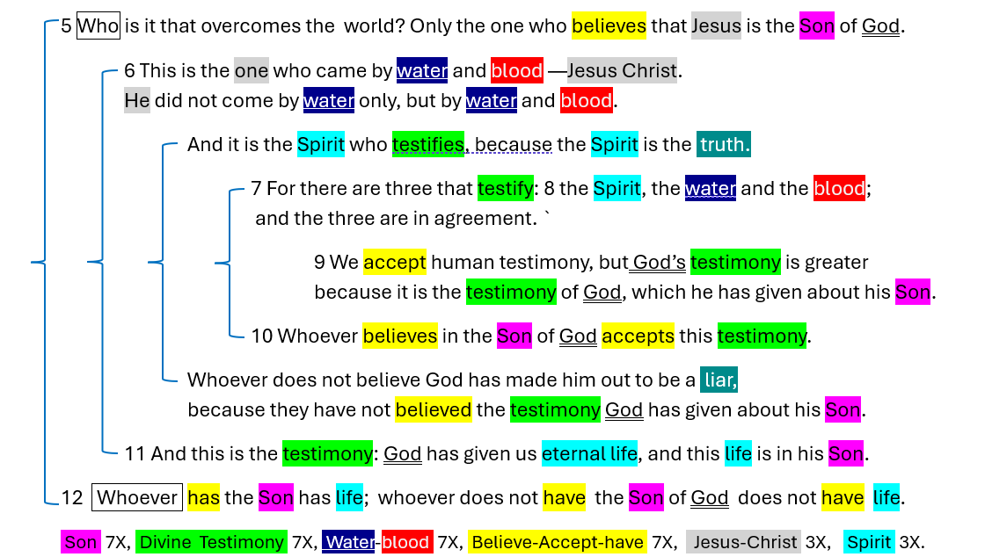
1 John 5:5
⁵ Who is it that overcomes the world? Only the one who believes that Jesus is the Son of God. NIV
● Overcomes: False teachers, persecution, martyrdom.
● Son of God: (1) Virgin born. (2) God’s Messiah. (3) God incarnate. (4) Trinity.

1 John 5:6a
⁶ This is the one who came by water and blood —Jesus Christ. He did not come by water only,
but by water and blood.
● Water: Baptism, when the Holy Spirit descended on Jesus.
● Blood: Cross. The human Jesus = the divine Christ who died a physical death.
1 John 5:6b
And it is the Spirit who testifies, because the Spirit is the truth.
● Spirit: The Holy Spirit who descended on Jesus and empowered him.
● Testifies: (1) Jesus’ miracles. (2) Coming at Pentecost. (3) Jesus’ apostles’ witness.
(4) Witness to us Christians.
● The truth: Jesus’ promise (John 16:13).

1 John 5:7-8
⁷ For there are three that testify: ⁸ the Spirit, the water and the blood; and the three are in agreement.
● Testify: Tell factual truth.
● Agree: Support the same factual truth.
● Spirit: The Holy Spirit = the amazingly-powerful presence of God living in Christian communities.

1 John 5:7-8 (Textus Receptus, KJV)
⁷ For there are three that testify {in heaven: the Father, the Word and the Holy Spirit, and these three are one.} ⁸ {And there are three that testify on earth:} the Spirit, the water and the blood; and the three are in agreement.
● Latin: Added in the 6th century.
● Greek: Added in the 16th century.
● If original, no one would have removed it.

History of New Testament copies
1st century  Originals written, copied, distributed. | 2nd to 15th  Copied, carried  to cities. Ancient versions translated. | 16th to 18th  Printed, published, revised, translated in European languages. | 19th to 21st  Ancient copies compared, edited, translated everywhere.

1 John 5:9
⁹ We accept human testimony, but God’s testimony is greater because it is the testimony of God,
which he has given about his Son.
● Human: Jesus’ apostles (including John) …
● Greater: testified to what they had seen, heard and touched (1:1-2).
● Given: A voice heard at Jesus’ baptism, transfiguration, cross (Jn 12:28).

1 John 5:10a
¹⁰ Whoever believes in the Son of God accepts this testimony.
● Believes: (1) Trusts in the veracity of the apostles’ witness, (2) obeys Jesus’ commands, (3) lives for resurrection and eternal life.
● Accepts: Literally, “continually holds in him,” i.e., ‘as his own’?
● This: The apostles’ factual testimony.

1 John 5:10b
Whoever does not believe God {~in the Son} has made him out to be a liar, because they have not believed the testimony God has given about his Son.
● Believe: Continuous: keep on believing.
● Liar: A deceiver? Or deceived? To deny Christ = unpardonable.
● Has given: Perfect tense = lasting result.

Three ancient errors
● Cerinthus: The Spirit came on Jesus at his baptism, making him the Christ, but departed from him before his death.
● Docetists: Jesus, being eternal, was neither human nor able to die.
● Islam: “The Messiah, Jesus … they slew him not nor crucified him, but it appeared so” (Quran 4:157-158).

1 John 5:11
¹¹ And this is the testimony: God has given us eternal life, and this life is in his Son.
● Has given: Aorist tense: timeless. Translate past, present or future.
● Us: (a) Human beings. (b) Christian believers. (c) Who remain faithful.
● Eternal: Everlasting, ‘in the age to come’.
● Life: Intimacy with God.
● Is in: “comes by faith” in his Son.

1 John 5:12
¹² Whoever has the Son has life; whoever does not have the Son of God does not have life.
● Has: Keeps on holding to, believing.
● Not: Never believed or has turned away.
● Son: Human Jesus = The Divine Messiah who suffered a physical death.

Discussion
What did you learn from this passage, this week?
What does this passage urge us to believe, and to do?
What will you do about it, this week?
Whom will you tell about it, this week?

Assignment
● Read 5:13-17 three times in different versions (www.netbible.org).
● Visit http://1john.currah.download
● Compile your own insights to share with others next time.

