FIRST JOHN 5:13-17
“You have eternal life”
30 May – 02 June 2024
Download from http://1john.currah.download

Discourse structure of 1 John
Part 1: Our Fellowship with God 1.1 – 2.17
Part 2: Our Adversaries 2.18 – 3.18
Part 3: Our Christian Faith 3.19 – 5.5
Part 4: Our Confidence with God 5.6-21
XIII. God’s Testimony 5.6-13
XΙV. Answered prayers 5.14-17
XV. Reasonable conclusions 5.18-21
1 John 513-17, Chiastic structure
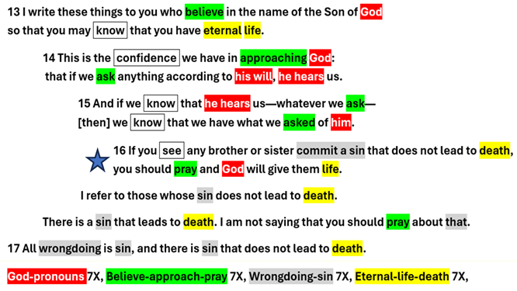
1 John 5:13
¹³ I write these things to you who believe in the name of the Son of God, so that you may know that you have eternal life. NIV
● Believe:  ● Name:  ● Know:  ● Have:  ● Eternal:  ● Life: | Trust, to rely on, be loyal, affirm.  The person himself  Factual knowledge (“see”).  Present tense: Already  "Eons" = all ages to come.  Intimacy with God, growth, action.
1 John 5:14
¹⁴ This is the confidence we have in approaching God: that if we ask anything according to his will,
he hears us.
● Confidence:  ● Approach:  ● Ask:  ● Will:  ● Hear: | Boldness  "Facing" him.  Make requests.  (a) Decree, (b) standards, laws, (c) promises, (d) guidance.  Listen, pay attention, ‘obey’.

“According to his will”
What is always his will, that we can count on?”
● Life for sinning Christians. 1 Jn 5.13
● Our daily food. Mt 6.11
● Forgiveness of sins. Mt 6.12, 1 Jn 1.9
● Wisdom for how to live. Js 1.12
● The Holy Spirit’s ‘fruit’, ‘gifts’. Lk 11.13
● Personal peace anytime. Ep 4.6-7
● Urgent needs. Ph 4.19
● Answers for hostile opponents. Lk 12.12

1 John 5:15
¹⁵ And if we know that he hears us—whatever we ask—we know that we have what we asked of him.
● Know:  ● Hear:  ● Whatever:  ● Have:  ● Asked: | Factual knowledge.  Pays attention.  Freedom to ask for anything.  Received, secured.  Specific, identifiable.

1 John 5:16a
¹⁶ If you see any brother or sister commit a sin that does not lead to death, you should pray, and God will give them life.

● Brother:  ● Lead to:  ● Death:  ● You:  ● Life: | Fellow Christian.  Consequence.  (a) Spiritual, (b) emotional, (c) physical, (d) everlasting.  Singular, 'anyone': Christian.  Fellowship with God and with us.

1 John 5:16b
I refer to those whose sin does not lead to death.

● Immaturity: juvenile attitudes.
● Bad habits, compulsive behavior.
● Addictions (sugar, vices, alcohol, porn).
● Neglect of spiritual disciplines.
● Repented and confessed sins.
● Denominational or political beliefs.

1 John 5:16c
There is {a} sin that leads to death. I am not saying that you should pray about that.

What sins cause everlasting death?
● Disbelief in God or in Jesus Christ.
● To refuse the truth and God's salvation.
● Willing service to Satan or to demons.
● Kidnapping, human trafficking.
● Mass murder, genocide, depopulation.

Sin and death
● "The wages of sin is death, but the free gift of God is eternal life in Christ Jesus our Lord." Romans 6:23
● "Each person is tempted when he is lured and enticed by his own desire. Then desire when it has conceived gives birth to sin, and sin when it is fully grown brings forth death. James 1 : 14-15
● "This is the second death, the lake of fire." Revelation 21 :8

1 John 5:17
¹⁷ All wrongdoing is sin, and there is sin that does not lead to death.
● Wrong:  ● Sin:  ● Excuses: | Violation of law, norms, morals.  Resultant offense, guilt, shame.  “It was a mistake.”  “He/she was misled.”  “They didn’t know any better.”  “This is our culture.”

When you see a Christian in a sin
● Do not tell others (gossip).
● Silently pray for God to give them "life".
● If they sinned against you, then go talk with them in private. They will usually repent.
● Check your own similar behavior.
● Seek an opportunity to offer help, counsel.
● If you only 'hear' about a Christian's sin, then stay quiet. It may no longer be true.

If a Christian denies Jesus Christ
● Treat them as you would any other non-believer: respectfully, cautiously, righteously.
● If they tell you why, then go learn how to answer their reasons or objections.
● Redouble your loyalty to God the Father, to Jesus the Son, and to the Holy Spirit.
● Teach fellow Christians how to avoid being deceived in the same way.

