FIRST JOHN 5:18-21
“This is the True God”
06 & 09 June 2024
Download from http://1john.currah.download
Discourse structure of 1 John
Part 1: Our Fellowship with God 1.1 – 2.17
Part 2: Our Adversaries 2.18 – 3.18
Part 3: Our Christian Faith 3.19 – 5.5
Part 4: Our Confidence with God 5.6-21
XIII. God’s Testimony 5.6-13
XΙV. Answered prayers 5.14-17
XV. Reasonable conclusions 5.18-21
1 John 5:18-21, Chiastic structure
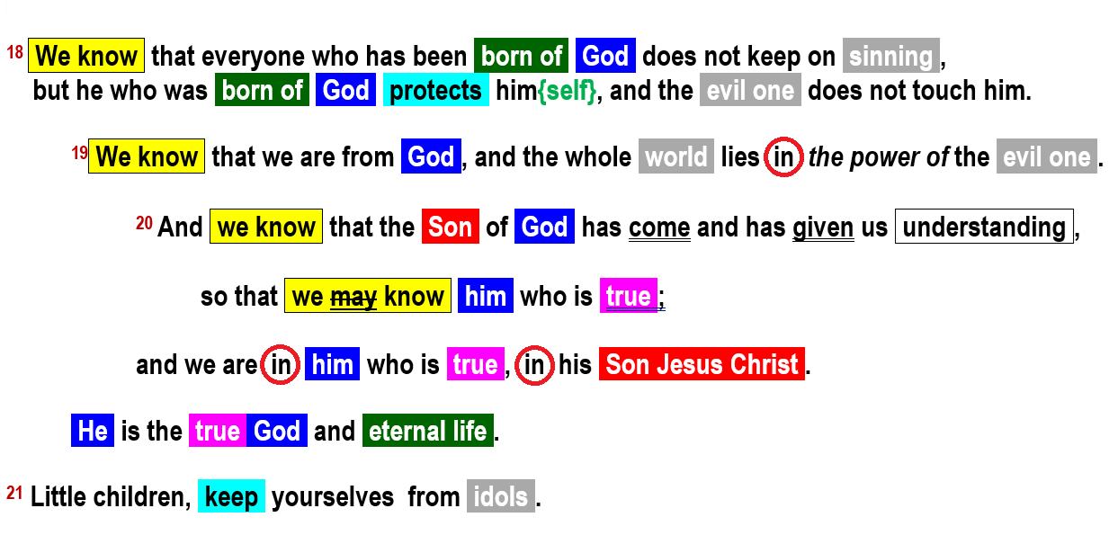
1 John 5:18a
¹⁸ We know that everyone who has been born of God does not keep on sinning, … NIV
● We know:  ● Born:  ● Keep on:  ● Sinning: | First of four ‘conclusions’. To know = “to see” (oida).  New start, supernatural new life.  Continuous tense. We change!  In 1st John, sinning = denying that the human Jesus is the divine Christ = ‘Son of God’.
1 John 5:18b
We know that everyone who has been born of God does not keep on sinning, … NIV
● Him:  ● Born:  ● Protect:  ● Evil:  ● Touch: | Two manuscripts and Latin read ‘him’, the rest: ‘himself’.  Jesus ‘him’. Believer ‘himself’.  Keeps (safe).  “The” + adjective noun.  ‘Keep a hold on.’ Continuous tense. Middle voice = ‘for himself’.

Keeps him? Or keeps himself?
Codex Sinaiticus, 4th century: ^{Ⲉ}AΥΤΟΝ
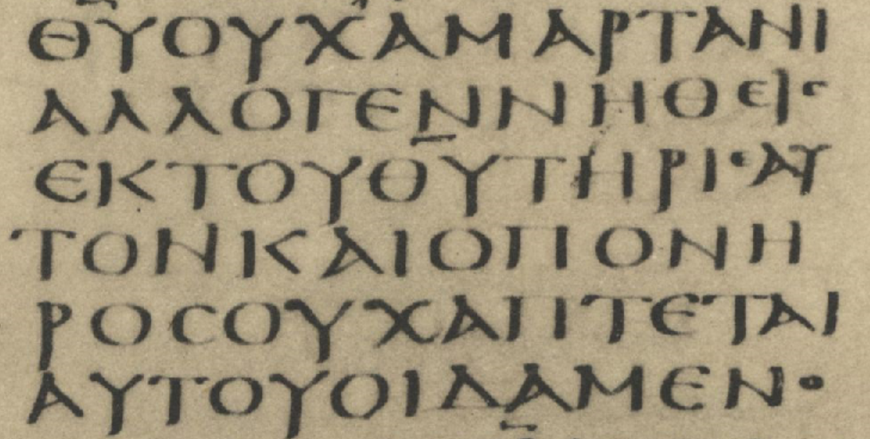
Codex Alexandrinus, 5th century ⲀΥΤΟΝ
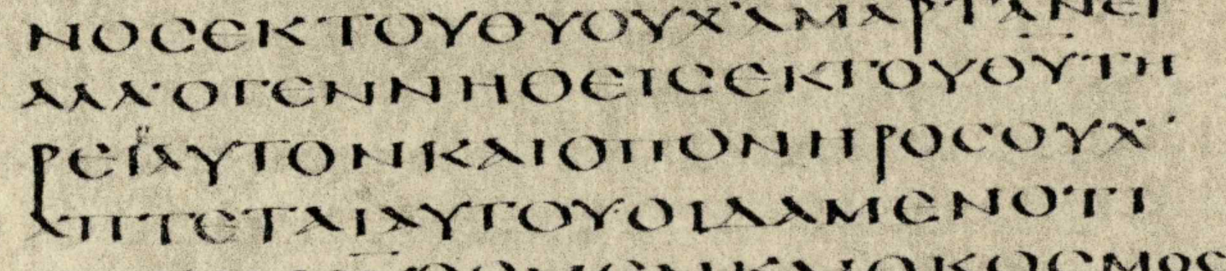
1 John 5:19
¹⁹ We know that we are from God, and the whole world lies in the power of the evil one
● Know:  ● From:  ● World:  ● Lies in:  ● Evil: | Second ‘know’ = ‘see’ factual know.  Origin = reborn (verse 18).  Creation, human system.  Under domination  Pernicious: active, intentional evil.
1 John 5:20a
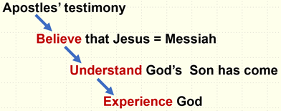
²⁰ And we know that the Son of God has come and has given us understanding, so that we may know him who is true…
● Know:  ● Son:  ● Understanding:  ● Know:  ● True: | Third ‘know’ = ‘see’ factual know.  Messianic title. Jesus = the Christ.  Mind, intelligence, thinking. “Love the Lord with your … mind” Mk 12:30  Fourth know = by experience (gnosko).  Contrast idols and religions.
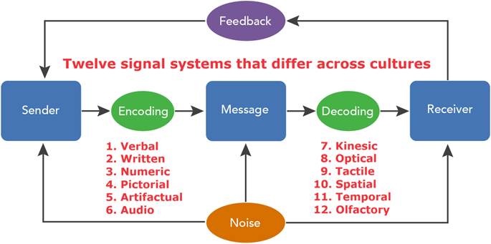

“The Communication Process”
by Lumen Learning, CC BY 4.0

1 John 5:20b
… and we are in him who is true, in his Son Jesus Christ.
● In:  ● Him:  ● True: | En = a relational particle with no specific meaning.  To be ‘en’ a person = to be in relation with, to belong to.  God (5:19)? Or his Son (5:20)?  The unique, invisible Creator?  Or the crucified, risen Messiah/Christ?
●We:  ● Son:  ● Jesus:  ● Christ: | (a) Jesus’ apostles,  (b) Ephesian Christians,  (c) Christian believers  Psa 2:7; Mk 1:11; Jn 1:14; Hb 1:2.  Human name: Joshua in Hebrew, Iésous in Greek, Jesus in English.  Divine title: the final prophet, priest & king.
1 John 5:20c
… He is the true God and eternal life.
Jesus Christ “is” (In 1 John; John 1):
● Word of life  ● True Light  ● Human flesh  ● Only Son  ● The Christ  ● Lamb of God | ● Word of life  ● True Light  ● Human flesh  ● Only Son  ● The Christ  ● Lamb of God

View 99 NAMES OF JESUS https://youtu.be/6oLjc-1dOmU at double speed.
1 John 5:201
²¹ Little children, keep yourselves from idols.
● Childen:  ● Keep:  ● Yourselves:  ● Idols: | Susceptible to deceit.  Keep away from, be on your guard.  Plural = help each other.  - Roman & Greek gods  - Roman emperor’s image  - Local sprites and deities  - Religions and philosophies  - Ourselves or our possessions

Governor Pliny (the Younger), in Epistles 10.96, wrote to Emperor Trajan in about AD 110:
“I have asked them if they were Christians. If they confessed, I asked them a second and third time, threatening them with punishment. If they persisted, I commanded them to be led away for punishment. There was no doubt that pertinacious and inflexible obstinacy ought to be punished, regardless of their confession. Some Roman citizens afflicted with a similar insanity were sent to Rome.”

