FIRST JOHN 3:19–4:6
‘We know that we belong to the truth’
25 & 28 April 2024
Download from http://1john.currah.download
Discourse structure
Part 1: Our Fellowship with God 1.1 – 2.17
Part 2: Our Adversaries 2.18 – 3.18
Part 3: Our Christian Faith 3.19 – 5.5
VIII. We Have Assurance 3.19-24
ΙX. We have God’s Spirit 4:1-6
X. We Have God’s Love 4.7-13
XI. We Have the Saviour 4.14-21
XII. We have the Christ 5.1-5
Part 4: Our Confidence with God 5.6-21

A. We Have Assurance, 3.19-24
The troubled heart, 3.19-20
Jesus said, “Let not your hearts be troubled. Believe in God; believe also in me. … My peace I give to you. ... Let not your hearts be troubled, neither let them be afraid.” John 14:1, 27 ESV
● We may believe truth, but we do not own it.
● It is natural to feel shame or guilt,
● because we can hide nothing from God.
● But we calm those feelings with God’s help

The confident heart, 3.21-22
Jesus promised, “If you love me, you will keep my commandments. And I will ask the Father, and he will give you another Helper, to be with you forever, even the Spirit of truth” John 14:15-17 ESV
For power through prayer:
● Get confidence before God.
● Keep his commands.
● Do what pleases him.

His commandments, 3.23-24a
● Command: How are two actions really only one command?
● Name: Son (unique) = Jesus (human) = Christ (king forever).

The Spirit whom he gave to us, 3.24b
Jesus promised, “The Spirit of truth… he dwells with you and will be among you.” John 14:17
● Lives: ~Dwells. Real Presence. He likes us.
● Spirit: What are some ways in which God’s Spirit operates among us?
● Dwells: What are some ways in which our church could experience more of this?
B. We have God’s Spirit, 4:1-6

Test the spirits, 4.1
Paul exhorted, “Do not quench the Spirit. Do not despise prophecies, but test everything; hold fast what is good. Abstain from every form of evil.” 1 Thess. 5:19-21 ESV
● Test: How?
● The spirits: What are these?
● False prophets: Who were and are some of these?

The Spirit of God, 4.2
Paul asserted, “No one can say "Jesus is Lord" except in the Holy Spirit.” 1 Cor. 12:3
● Alternatively: Jesus is Christ come into the world in the flesh.
● Grammar: One confesses what a person is, not only something about that person.
● Logic: To say that Jesus Christ came in the flesh would hardly be a confession of faith, for even atheists and antichristian religions will admit that much.

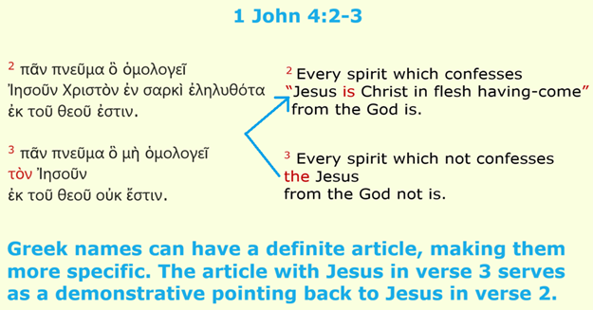
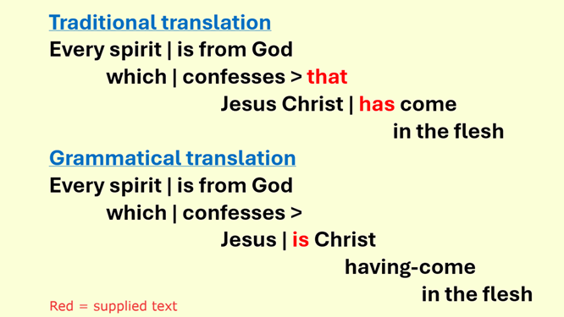

The antichrist, 4:3
Paul warned, “In later times some will depart from the faith by devoting themselves to deceitful spirits and teachings of demons” 1 Tim 4:1
● spirit: prophets, preachers, teachers, their message, and their inspiration.
● Grammar: “the Jesus” ➔ the Jesus who is Christ come in the flesh (verse 2).

The one who is in you, 4:4-5
Jesus warned, “Many false prophets will arise and lead many astray.” Matthew 24:11
● You: who confess that Jesus is the Christ.
● They: who deny that Jesus is the Christ.
● We (4:6): who teach that Jesus is the Christ.

We recognize the Spirit, 4:6
Jesus promised, “I will ask the Father, and he will give you another Helper, to be with you forever, even the Spirit of truth.” John 14:16-17
● We: Jesus apostles who lived with Jesus.
● Cerinthius (c. 50-100 CE): taught that (a) Jesus was only human, (b) received the Christ at baptism,
and (c) lost the Christ at his crucifixion.

